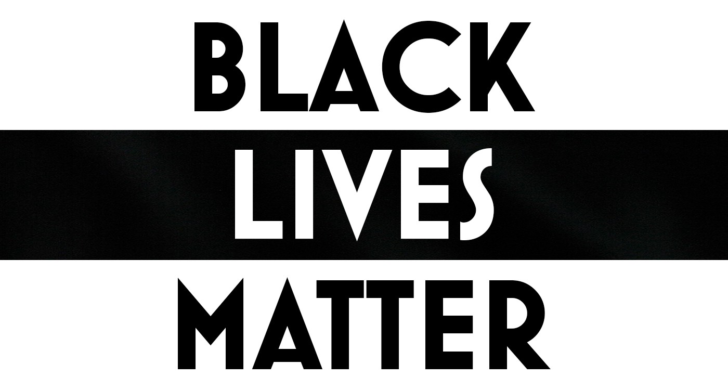

FAUQUIER COUNTY DEMOCRATIC COMMITTEE
MEETING AGENDA: Nov 17, 2020
Virtual Meeting
- Call to order
- Nubmers from 2020 Election
- Candidates Time
  - Thanks to all 2020 Candidates for their well run campaigns and all their hard work
  - 2021 Candidates
- Comments from the Chairs, Vice Chair, Treasurer and Secretary
- Political Director and Precinct Operations reports
- New Business:
  - Lesson Learned from 2020 Election
    - Share your thoughts (please be thinking about them, and be short and sweet)
    - Don’t crtiticize or disagree with others, just gathering ideas at this point
  - Budget Subcommittee – we need to establish one
  - Fundraising Subcommittee – we need to establish one
  - Christmas Parade, Dec 4th Warrenton
    - Bealeton and Marshall?
  - Voter outreach efforts – continuous efforts
    - Black and Latino community
    - Young people
    - Unknown voters
  - Holiday Party – ideas?
    - Outdoor event
    - Daytime
    - Contingency plans
    - BYOF
- Additional Topics
- Adjourn

