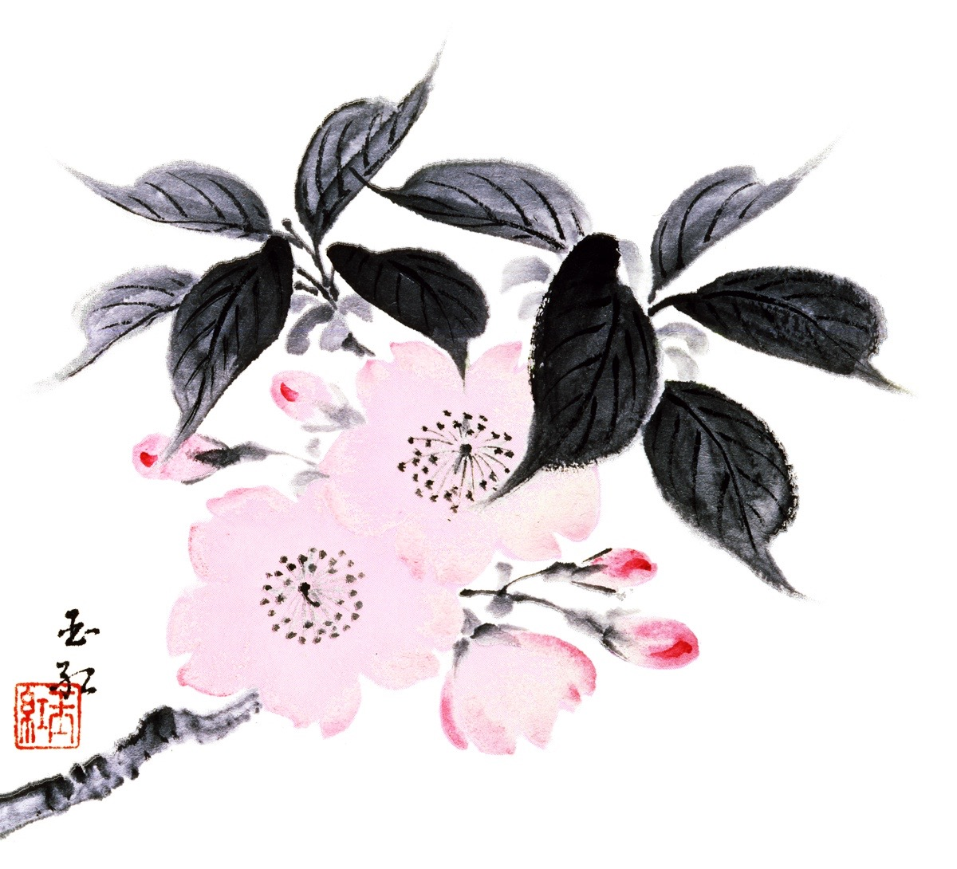

Naples Florida Chapter #160
Membership Application

Please fill out this Application and contact us at ikebananaples@gmail.com for an address to mail or scan and email to ikebananaples@gmail.com. On receiving this application the Membership Chair will contact you and advise on where to send your $85 dues check payable to I.I.#160.

Name and Date

Spouse’s Name (if applicable)

E-mail (all correspondence is done via e-mail)

 |  | Florida Address | Alternate Address
Street
City, State, Zip
Mobil Phone
Approximate dates at each address
If you are a member of another recognized chapter you may join as an Associate Member for a $40.00 fee. If applying for Associate Membership please supply the following information:
Chapter name and number and your membership number.
Former I.I. Member (Yes) (no)
If yes, Chapter Name & number:_____________________

We encourage all members to volunteer on a committee, project and or share any special skills that would benefit our chapter. Volunteering is the best way to meet other members and make the most out of your membership to I.I. Naples #160.

Please mark the boxes that are of interest or skills you process. We look forward to enjoying your special skills!

 | Computer Skills |  | Ikebana Sensei |  | Large Event planning
 | Publicity |  | Photography |  | Greeting our guests (hostess)
 | Jewelry Making |  | Painting |  | Pottery/ceramics
 | Calligraphy |  | Ikebana Demonstrations |  | Japanese arts and crafts
 | Plan Summer Events |  | Accounting background |  | Serve on the Board
 | Website Administrator |  | FB Administrator

You have my permission to use my likeness or pictures of my work on the I.I. #160 website or Facebook. (Yes) (No) Twitter or Instagram (Yes) (No) I have enclosed/attached a likeness for I.I. Naples #160 to use.

I was introduced to I.I. Naples #160 by Name:_________________________________

Or Exhibit (Yes) (No) or through FB or Website (Yes) (No)

We encourage the taking of Ikebana lessons to enhance your I.I. Naples #160 experience. If you would like one of our Sensei to contact you please circle one of the below. If you are new to Ikebana you may not know which school fits your “personality” feel free to circle more than one.

Ikenobo Kado Sensho Ikenobo Sogetsu Ohara

