original Spark
  - Build Your Dream Practice
Deborah Cox, Ph.D., ABPP
We’re super busy being successful. We work hard. We help people. That’s all good.
But sometimes we get too busy being busy . . . we get too serious. We stop having fun. We stop laughing. We forget to notice what we want, what we like, what feels good. When we ignore these creative needs, we get burned out and our practice languishes.
I believe the artist in everyone is the key player in revitalizing and revisioning mental health practice of any kind. And I don’t just mean after-hours coloring. I mean intentional re-invigoration of your creative process – and then infusing it into your clinical or consultation work with people.
Focusing on a part of your practice vision invites the rest to fill in around it. Nowhere is this truer than in your actual work space. Learning your personal style and aesthetics - and creating artistic change - generates a powerful flow of energy into the actual work you do each day.
Yes, more art means more passion means more money flowing toward you.

My name is Deborah Cox and I’m a psychologist who likes to rearrange furniture. Every time I restyle my working environment, my business grows. I’d like to help you get a creative growth spurt for your practice too.

Here’s the basic outline of my program, Original Spark: Building Your Dream Practice. This program is designed for anyone who works in a helping role (coaches, counselors, therapists of all kinds, psychologists, social workers, consultants . . .) and wants to feel better in that role. Spark leads you through a process of discovery – and recovery – for your inner creative.
Finish this program with:
- A better sense of your original creative genius . . . what led you to what you do now.
- A refined sense of your own aesthetic or style.
- A workspace that better suits your style and what you’d like to be doing.
- A practice mission and plan for building your dream practice.
- A custom fun-and-self-care program that gently teaches you to allow abundance into your experience.
- A deeper connection with your inner artist and methods for letting that creative spark into the services you deliver every day.
SPARK can be taken as an online course or as a one-on-one, mentoring, wraparound, intensive experience. SPARK can be a half-day on-site, personal workshop, or a CEU course for licensed professionals. You decide what works best for you.

phase one

Taking Stock (2 hours)
In phase one, we assess your space and what you’d like to do with it. We’ll find out what’s been frustrating you most about your space and get ideas about how to change that.
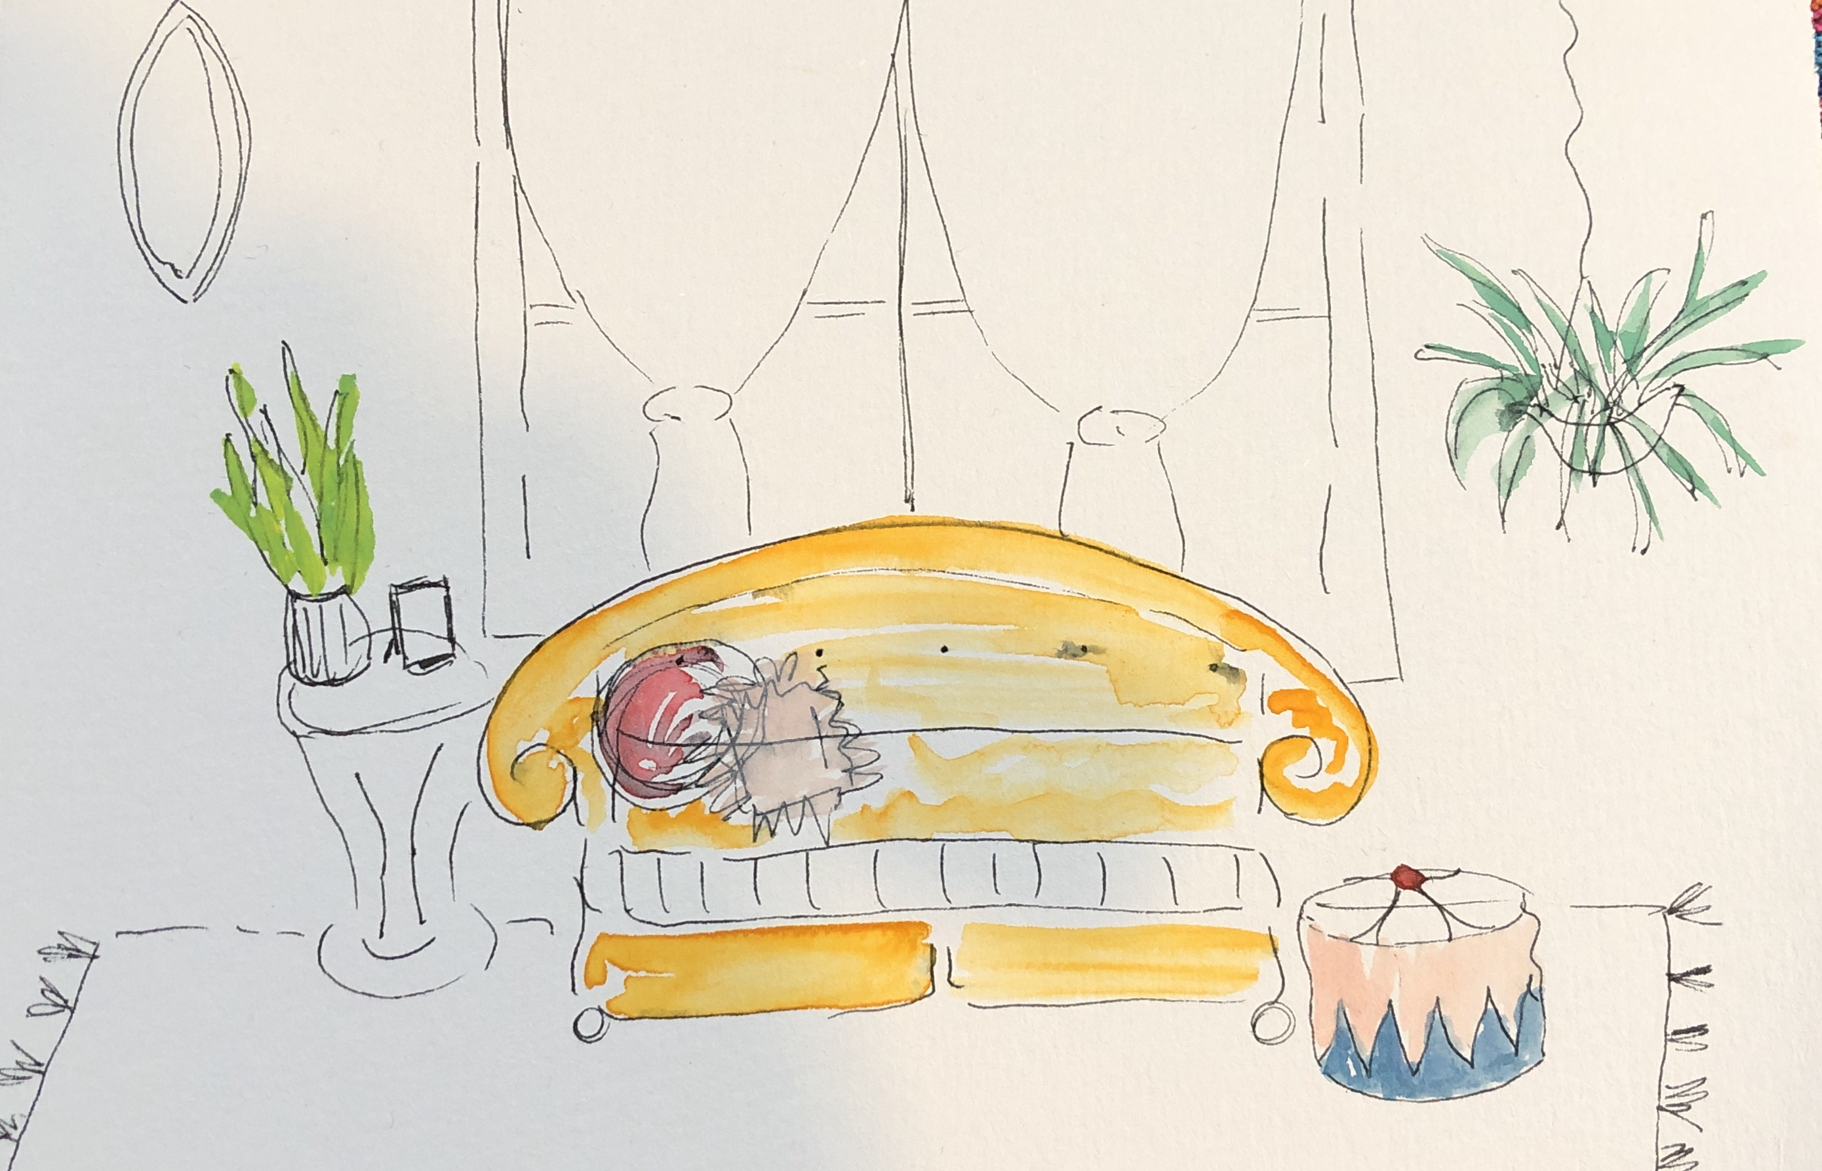
- Meeting in Your Space: This means standing in your office or other work area and assessing how it works for you, what you want, and the easiest path to achieve that.
- Questionnaires: I give you lots of questions to find out who you are, aesthetically speaking. At the end of this two-hour phase, we’ll have a much clearer idea of your tastes, your wants, and your style.
- Photos and Videos: We’ll do a photo shoot from various angles in your workspace to capture what’s there (and what’s not), giving you insight about how the space helps or hinders your creative flow.
- Writing Exercises: We’ll use writing prompts to gently nudge you toward life-writing, a discovery process that lets you see your original sparks of genius and creativity.

phase two

your original spark story (2 hours)
Helpers come into their work through experience. We were all once kids, but kids who grow up to be therapists or coaches usually go through difficulties that show them how they want to change the world. All kids are natural artists too. So, your younger self got downloads of inspiration all the time. You played them and painted them and sang them and danced them.
In phase two, we write that story. Your original spark. How you got here and what you dreamed you’d make out of this station in life.
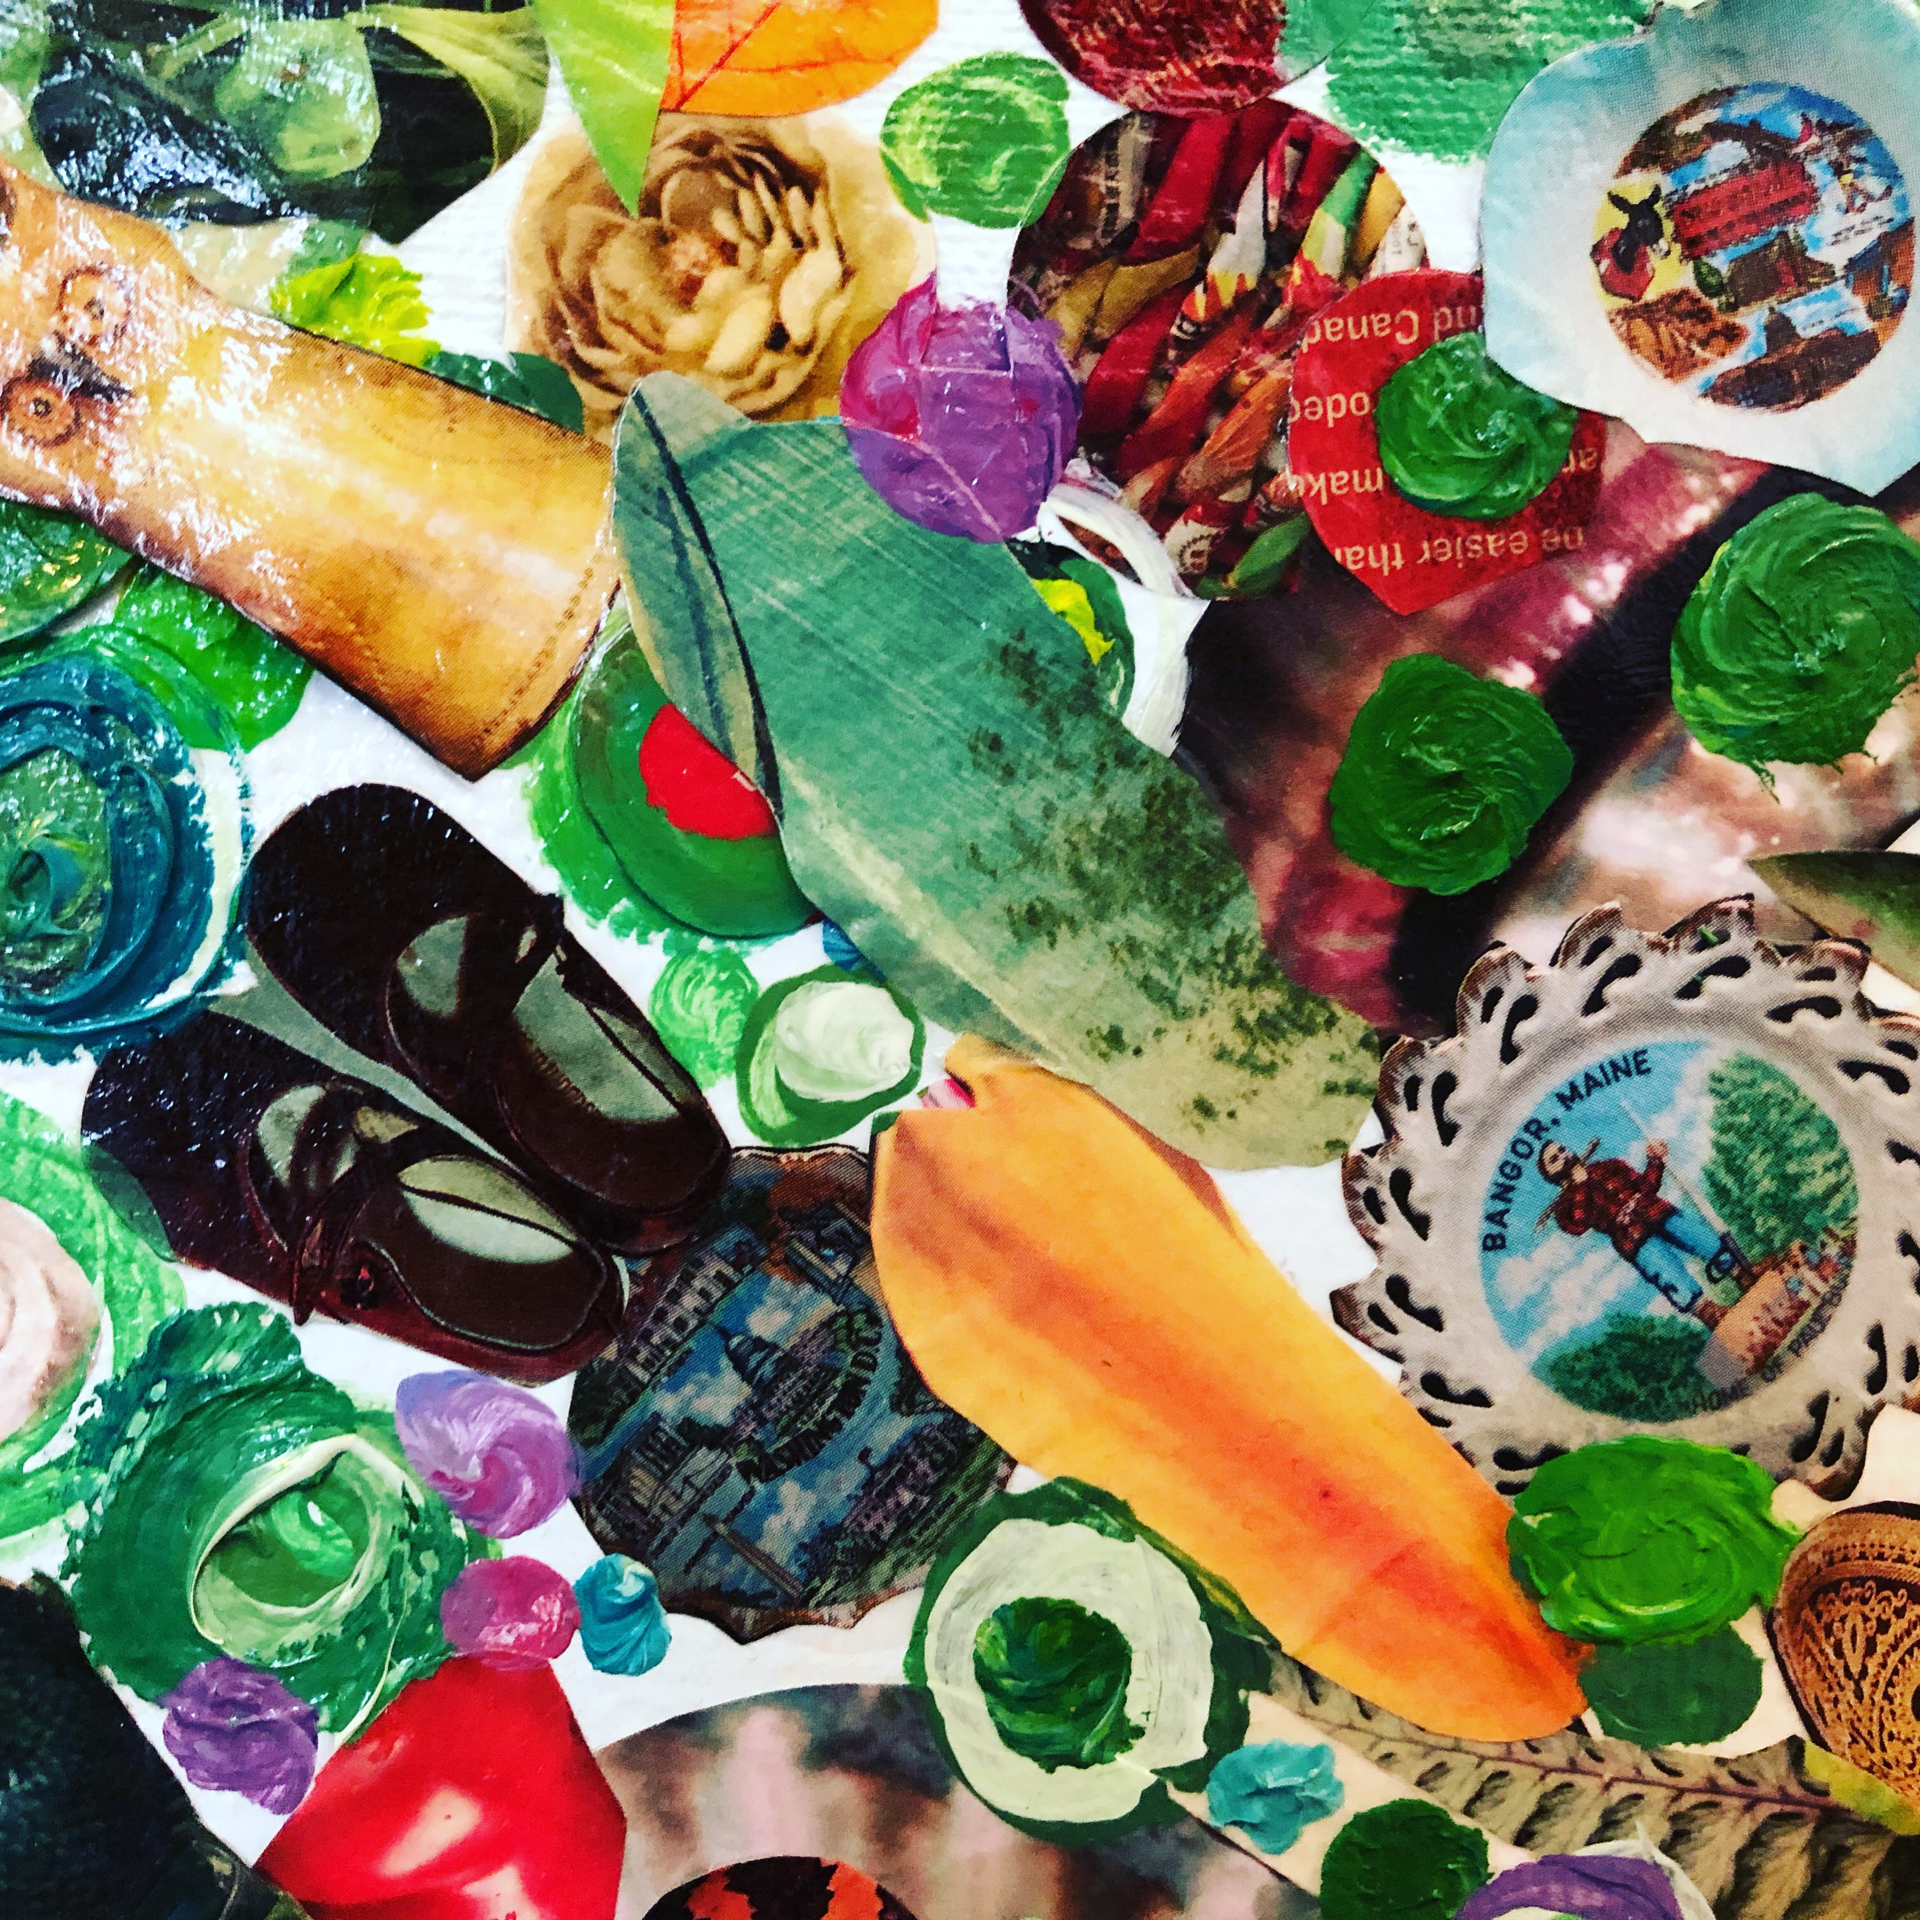
- Life Writing Exercise: You write your original spark story, with lots of help and guidance from me.
- The Inspired Child Identity: We’ll get you reconnected with the sparky little you who dreamed big.
- Artwork by the Inspired Child You: Yes, your inner kid will help us understand your creative style, your deepest interests and wants.
- What Made You Laugh? We’ll spend time reacquainting you with things that used to bring you laughter, fun, and pure joy.

phase three

The art and science of your spark (nine hours)
Here, we’ll use the research on creativity, health, art, and humor to help you design the practice of your dreams and the plan for sustaining it with joy.
- Flow: We’ll learn about the state of being in flow and how to achieve this easily.
  - Julia Cameron, The Artist’s Way series
  - Getting in the Flow
  - Art & Well-Being
  - Writing & Health
  - Humor & Healing
- Removing the Blocks: We’ll do EFT Tapping to address fears and blocks that may arise as you contemplate growth. And we’ll get started with several tools to use throughout the course – and beyond. The tools include tapping, meditation, exercise, creative journal support, and group visual support.
- Your Artform: Everybody has an art form (yes, everybody). Through this process, we’ll get more specific about your own art form. Yours may be songwriting or sculpture or collecting gum wrappers. We’ll figure it out. It’ll be good.
- Infusing your Practice with Your Art: I promise, whatever your art form, your clients need to know about it. That’s why they picked you.

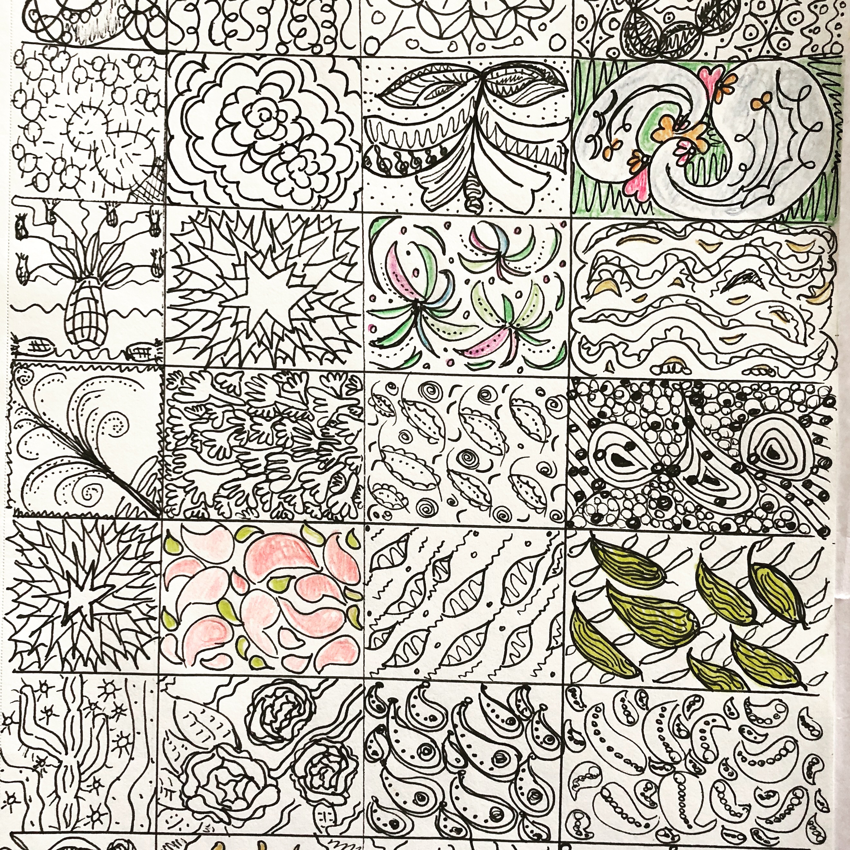

visioning (three sessions/hours)
What do you really, really want? In phase four, we’ll cover all those bases: physical, financial, spiritual, emotional, relational, creative.
Then we’ll get up and move furniture! After some initial drawings, we’ll roll up our sleeves and make real changes in placement, color, texture, and even the substance of your room(s).
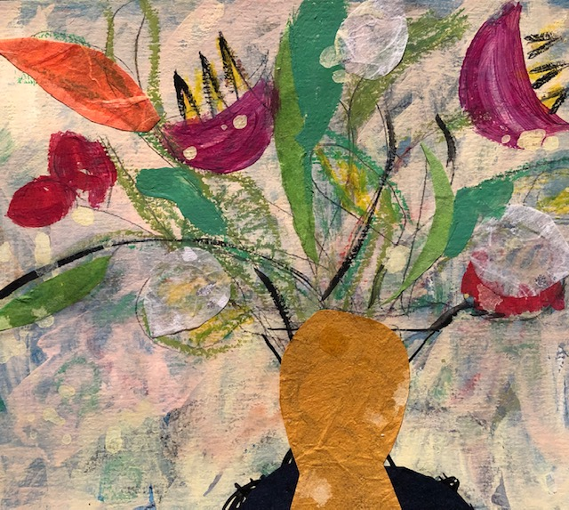

phase five

momentum
In phase five, we’ll put all the pieces together to bring your art form into your practice. What kinds of work and clients bring you the most joy? What do you most want to do with your time? We do a mashup of your values to design your ideal practice.
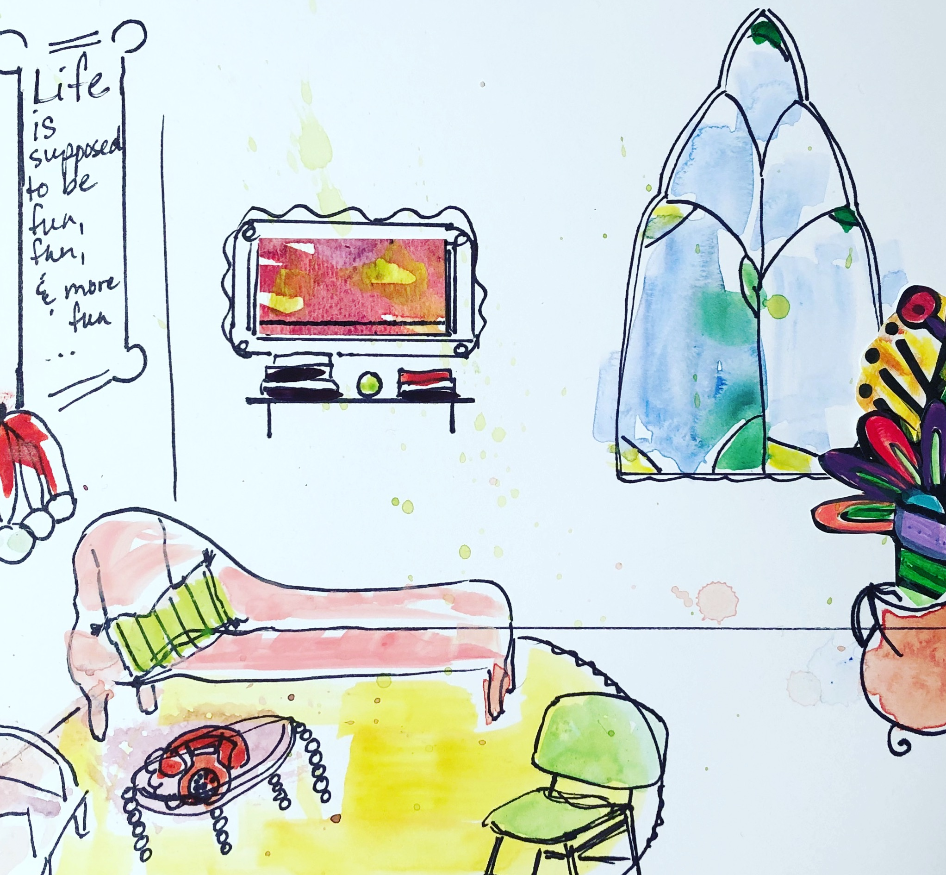

phase six

celebration
This is a party designed by you that launches your newly designed work. By this point, you’ll be itching to DO all the things you’ve been learning about and practicing on yourself. You’ll teach a group of your closest colleagues/friends a little of your vision by guiding them through a therapeutic art project in your restyled space. They get to sample your redesigned approach and you get to collect feedback, make final tweaks, and feel strong. Social media opportunities abound in this christening party to get the word out!

