Describe a time you were not allowed to use a mobile phone. 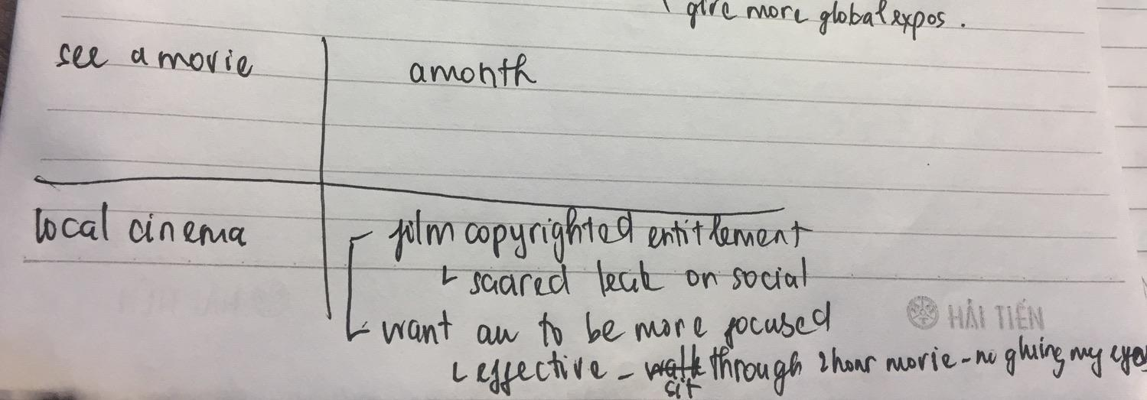
You should say:
* What did you do?
-> Well, I want to talk about a time I was prohibited to use my phone. If memory serves me right, it was a month ago when I went to see a movie with my friends.

* When it was? ( a month ago)
* Where it was?

-> At that time, we decided to go to a cinema which was about a 10-minute walk from my house.

* Why you were not allowed to use a mobile phone?

-> Unfortunately, before going to our seats, our phones were taken away. This is because the movie had copyrighted entitlement, and the cinema manager was scared that the audience might illegally leak it on social media, which can have a negative impact on the place. On top of that, I supposed another reason behind it was that they wanted people watching the movie to be more focused, and I had to say it was quite effective since I was able to sit through a 2-hour movie as well as pay more attention to its content and understand the meaning behind it without distracting or gluing my eyes to my phone screen. All in all, that was my experience without permission to use my phone.

Tham khảo thêm https://www.ieltsdanang.vn/blog/tu-vung-topic-mobile-phone
- Where was it?
  - I had to be apart from my phone when I was sitting my high school graduation exam 2 years ago, and I have to say it was quite uncomfortable.
- When was it?
  - my high school graduation exam is a mandatory examination that students have to take at the end of grade 12 to get their diploma and their score is what determines their ability to enter into university.
- What did you want to do with your cell phone?
  - I constantly had a burning desire to reach for my phone, but obviously I didn’t dare to do it.
- Why you were not allowed?
  - There are several reasons why they didn’t allow me to use my phone. For one thing,….. For another thing, ……
    - Idea 1: cell phones are not allowed in the test, to ensure that no one gets an unfair advantage by cheating.
      - Supporting idea: If your phone makes a noise, or if you are seen using it at any time, you will be dismissed from the examination immediately, and your scores will be cancelled without exception.
    - Idea 2: the government does not want students rely too much on their phone
      - Supporting idea: Although it’s a great tool to assist studying I do think we should learn how to be more confident in ourselves and our knowledge without having to look at our phones all the time.

