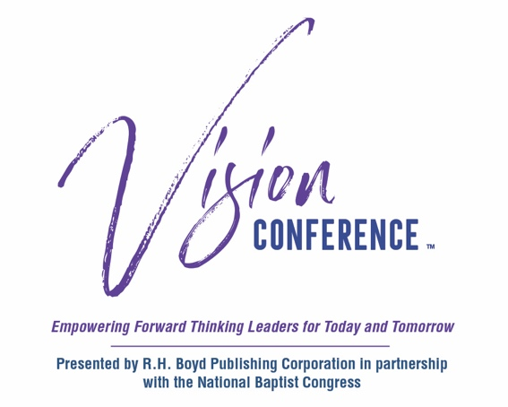
R.H. Boyd Publishing Corp.
Monique Gooch
(615) 350-8000
marketing@rhboyd.com

Release Date:
April X, 2021

VISION CONFERENCE: THE VIRTUAL EXPERIENCE
Empowering Forward-thinking Leaders for Today and Tomorrow

NASHVILLE, TN—April X, 2021

R.H. Boyd Publishing Corp. will host our virtual 2021 Vision Conference™ in conjunction with the 115th Annual Session of the National Baptist Congress, June 16–18. For decades, thousands of attendees have gathered in cities across the country to take part in this premiere training event. Due to the COVID-19 pandemic, however, the second Vision Conference™ will launch virtually on June 16, 2021. Our theme is: Reset, Renew, and Rebuild. (1 Peter 5:10).
“The COVID-19 Pandemic most certainly disrupted life as we knew it. As we began planning this year’s conference and as the grip of the pandemic seemed to be loosening, we felt it necessary to shift our mindset to refocus on what is important. Our goal to help us begin to reset our lives beyond quarantines, political unrest, and the uncertainty that we have lived through within the past year,” says Dr. LaDonna Boyd, president/CEO of R.H. Boyd Publishing Corporation.
In 2020, R.H. Boyd and the National Baptist Congress®, a consortium of churches and organizations focused on Christian education and leadership, birthed the Vision Conference™ to meet the needs of today’s believers. Both entities founded by Dr. Richard Henry Boyd in 1896 and 1906, respectively, view this partnership as an essential resource for the community.
The Vision Conference is a premier leadership event offering a multitude of resources, including strategy sessions, business advice/mentorship, sermons, workshops, secular employment requirements, and continuing education credits for seminary, with access to the Urban Leadership Program Seminary Now™ at Northern Seminary™.
The three-day experience will feature webinars, panels, prayer calls, online courses, and resources crucial to our community—targeted youth engagement, women’s empowerment, and financial literacy. As the wage gap continues to widen in this country, RHB believes that it is imperative that our community feels empowered and knowledgeable about its financial future.
“This annual assembly is an important fixture in the culture and life of the African-American community and has been since it was instituted by my great-great grandfather,” says Boyd. “We are at a pivotal time in our nation’s history when our narrative and our voice need to be heard, and it is a great honor to carry the tradition of hosting these events.”

The 2022 Vision Conference is planned as an in-person gathering in Nashville. “This year’s virtual conference will serve as an impetus for our 2022 conference in Nashville,” said Dr. Boyd. “We are excited to be able to gather again safely in 2022 and hosting the conference in Nashville will be the best strategy to reunite as we refocus following the COVID-19 pandemic.”

Conference sponsorship opportunities are available at many levels. All sponsorship funds support the R.H. Boyd Company and the R.H. Boyd Family Endowment Fund, both of which are 501(c)(3) organizations. The fund is the channel through which the R.H. Boyd Company invests resources in churches, organizations, and deserving students to achieve goals and standards for the betterment of their communities. Donations also are encouraged via Givelify (R.H. Boyd, Nashville, TN) to support the Boyd Family Endowment Scholarship program.

To register for the Vision Conference or find out about sponsorship opportunities, please visit visionconference.org for a complete schedule and follow us on Instagram @visionconference_official for additional details.
###

