Transcript Bài Nói Part 1 (Từng câu hỏi bắt buộc phải có Takescript)

Câu hỏi 1: Do you work or are you a student?
4th time:
At the moment, I’m working as an International Project Manager at HST Systemtechnik, which is a technology provider in the watery industry. I’m really enjoy the tasks I’m doing because I can not only interact with people around the world but also travel to different locations.
Câu hỏi 2: Will you continue doing this job in the future?
4th time:
Yes, in short-time, I don’t have any plan to look for a new job because I’m enjoying the tasks I”m doing. The current position offers me good opportunities to expand my professional network and improve my skills such as negotiation or communication skills with international partners.
Hình Take note của Part 2:

Note lần 4:
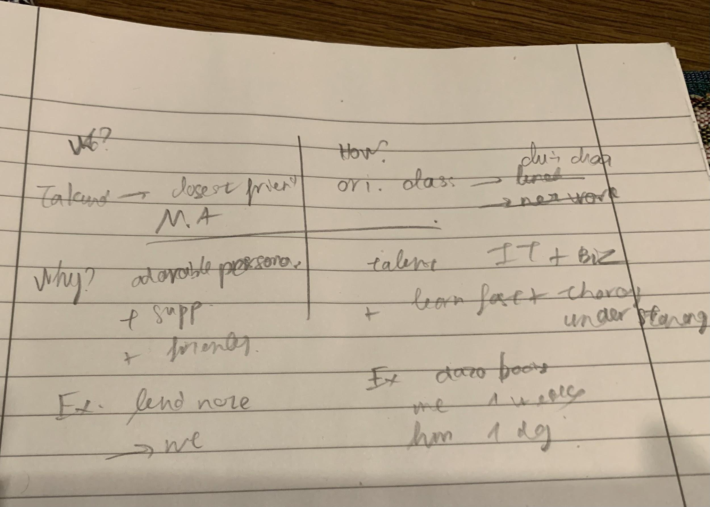
Transcript Bài Nói Part 2 (Sắp xếp theo từng câu hỏi của đề)
Ví dụ:

Describe someone you would like to study or work with
- who this person is
Takunda, closest friend, master’s program
- how you know him/her
orient. Class -> lunch -> network
- why you would like to study or do with him/her
M1: personalities – friendly, supportive, hard-working, well-structured
- S1: save time & efforts, feel comfortable
- E1: took notes + shared to me
M2: talents – good IT proficiencies + business concepts, creativity, lots of experience
- S2: understand lessons faster + more thoroughly
- E2: me 1 week -> him 1-2 days
Thì Transcript sẽ sắp xếp như sau:
- who this person is

4th time:
The person I’m going to talk about is Takunda, who is my closest friend in my master’s program.
- how you know him/her

4th time:
I firstly met him in the orientation class where we sat next to each other and chitchated about various topics.
- why you would like to study or do with him/her

4th time:
    - Cách dùng spend ...doing https://www.ieltsdanang.vn/blog/cach-dung-dong-tu-spend-tieng-anh

There are two main reasons why I like working with Takunda. First of all, he has an adorable personality, which is loved by all of the classmates. He’s very supportive and friendly with everyone no matter who they are or where they come from. For example, he used to lend me his notes right before the marketing exam and it helped me pass the exam successfully. Another reason which distinguish him from other peers is his outstanding talents in IT and business. His logical thinking and practical experience enable Takunda to learn and master the theories and lessons much faster and more thoroughly than other classmates. For example, while I spent more than one week to study the databases, Takunda could finish all of the homework just within two days.
Transcript Bài Nói Part 3 (Từng câu hỏi bắt buộc phải có Takescript)
- Which one is more important, salary or job satisfaction?
M: Job satisfaction
S: JS -> commitment + devotion
E: waitress at coffee shop -> supervisor / managers after many years of dedication
4th time:
S: Job sat. > salary
M1: benefit career development
S1: satisfy -> commitment + devotion
E1: willingness of working overtime to meet deadline -> appreciated by managers
M2: avoid negative impacts from job hopping
S2: loyalty is questioned
E2: more difficult questions in interview rounds
In my opinion, salary is not important as job satisfaction because of two main reasons.
Firstly, deciding the job based on job satisfaction will benefit career development. Employees who are satisfied with their job usually devote their time and efforts to fulfil the tasks they are assigned. For example, satisfied employees may be willing to work overtime to meet the deadline, which is usually appreciated by their managers.
Secondly, it also prevent employees from negative impacts of job hopping. If an employee changes his or her job so frequently, their loyalty may be questioned by the new companies. For instance, they may be asked more difficult questions in the interview rounds or they may be requested to take a longer probation period to test their commitment.
- What are the most popular jobs for young people in your country?
M: various jobs – voluntary & manual, tutor, internship
S: depends on educational level, career objectives & financial situation -> each person has to decide which one is suitable
E: 1st year -> manual work, 4th year -> internships
4th time:
various, depends on edu. level
good qualifications: interns or voluntary work in NGO
students: manual work e.g. construction site, coffees shop
THere are various types of job for young people in Vietnam, but it depends on the educational level to decide which one is suitable for them. For the people who have good qualifications, they prefer working in big corporations as an intern or apply for voluntary work in non-government organizations to earn practical experience and a decent amount of income.
On the other hand, students in the universities who are missing skills and knowledge of business, they tend to take the manual work at the construction sites or coffee shops to afford their monthly expenses
- How have people's ways of studying changed?
M: change dramatically – physically to virtually
S: The advancement of ICT -> new educational models, convenient & online
E: more and more e-learning platforms, providing records or interactive methods
4th time:
S: physical -> virtual
Past: go to class -> obtain knowledge mainly in classes e.g. questions are answered by teachers in classes
Now: online courses (when + where) -> questions are posted & answers by other students
from my point of view, the ways that people obtain knowledge have changed dramatically, mainly from physical to virtual.
In the past, our grandparents and parents used to go the class everyday and asked questions directly in the classes. if they had any questions at home, they would have to wait until the following days to meet the teachers and ask again. Nowadays, thanks to the the advancement of information and communication technology and the popularity of the Internet, there are more and more online courses and e-learning platforms in which students can watch recording videos and ask questions directly. Therefore, students don’t need to wait until they can meet the teach and get the answer. Instead, they can post their questions on the platform, and other students or the lecturers can see their questions and give their feedback about the answers.

