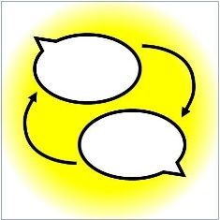
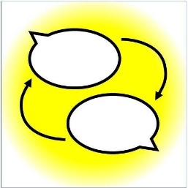
Announcing a Knowledge Swap

Topic
Details
When
Where
Workshop tutor
Places available
Contact to book

What’s a knowledge swap?
It’s a money-free workshop. No money changes hands, the currency is knowledge!
I'll teach you something I know, and in return you commit to running your own workshop on something that you know — anytime, anywhere.
- Knowledge swaps restore community and restore traditional knowledge
- They can be used in professional contexts to re-establish and restore the first principles of domains of knowledge which have had their first [principles displaced by corporatisation and commercification.
- Knowledge swaps undo the fragmentation and loneliness that our contemporary hyper-commercified society creates.
You'll receive a booklet showing you exactly how to run your own knowledge swap.

Learn more at
www.knowledgeswaps.org

