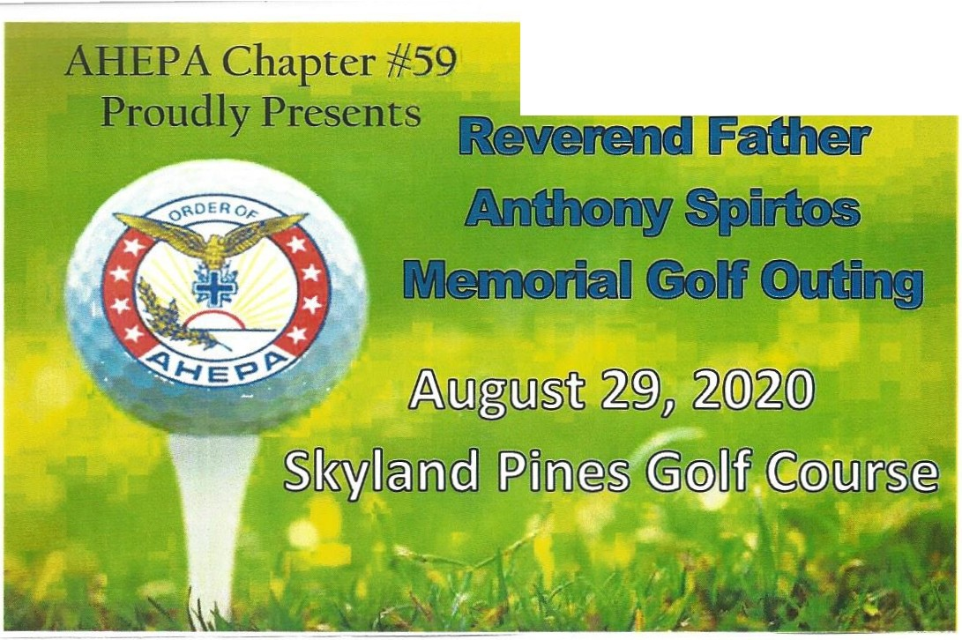W here:
The Annual
Skyland Pines Golf Cours e 3550 Columbus Road, NE Canton, OH 44705
When:
Saturday August 29, 2020 Registration: 8:30am - 9:45am Shotgun Start: 10:00am

Entry Fee:
$300 per Foursome or
$75 per Golfer
Includes: Hot Lunch, Steak Dinner &: Beverages all day, Range Access and Green Fees with Cart (18 Holes)

The Annual Reverend Father Anthony Spirtos Memorial Golf Outing
Thanks to many of you, the golf outing has been a hugesuccessand we offer our deepest appreciation for your support.

It is that time of year again. If you have supported the event in the past, we are asking for your continued support.
If you haven't been a part of this outing in the pa,st pl e ase consider supporting the event. The proceeds from the
Reverend Father Anthony Spirt os Memorial Golf Outing benefit the AHEPA #-5 9 Scholarship Fund.
In 2019 we helped raise nearly $10,000 for the benefit of th e scholarship fund. Help make the annual anniversary of thi s event the best one yet! Signup andsponsor today! {_See Re verse for S ponsorsm p Levels)

To sign up complete the att ached entry form, make checks payable to AHEPA#-59 and send it to:
AHEPA #-59
c/o The Annual Reverend Father Anthony Spirtos Memorial Golf Outing 1906 Spangler Road
Canton, OH 44705 www.ahepa59.org

S onsorshi Levels
D Title Event Sponsor $3,000
D Gift Bag Sponsor $1,500

Company Name_ _ Contact Name_ _ _

_ _ _
_ _ _

_ _ _
_ _ _

_ _ _
_ _ _

_ _ _
_ _ _

_ _ _
_ _ _

_ _ _ _
_ _ _

D BeverageCart Sponsor $1,000
Address_ _
_ _ _
_ _ _ _
_ _ _
_ _ _ _ _
_ _ _
_ _ _

D Golf Car t Sponsor $750
D Golf Ball Sponsor $500
City, State, Zip_ _ _ _ _
_ _ _ _ _ _ _ _ _
_ _ _ _ _ _ _

D Hole Sponsor $100
Pho_ne _ _ _ _ _ _ _
_ _ _ _ _ _ _
_ _ _ _ _ _
_ _ _

Re istration Sli o Foursome Only - Tearn Members

l.

Name
Addre ss Phone Em ail

2.

Name
Add ress Phone Em ail

3.

N ame
Addre ss Phone Email

4.

Name
Ad dress Phone Email

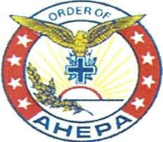
AHEPA Chapter #-59

George Kalantzis 1kalantzis10@aol.com (330) 936 - 4080
Bill Zantopolos
ct fairlawn@gmail .com (330) 284-9586
Mike Paxos
m ike@paxosplat ing .com (330) 327 - 9180
"
Rick Pitinii rickpitinii@yahoo.com (330) 904-8004
I'. | /
,,. | Golf Outing Committee

Kostas Kalantzis kkalan1973@gmail.com (330) 495 - 5390

Competitions Include
•11s--- Closest to the Pin

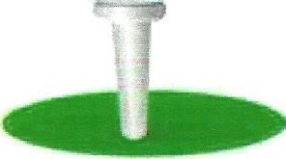
•---Longest Drive
•---Longest Putt
•---Cash Prizes
•---·Senior Prizes too!
Optional Skins Games
&:;

Door Prizes

Title Event Sponsor  $3,000 | ....... ... ..  ,._:.. : _...... ; ; :::: ..... :.,,__....._.,' .:  .._.,_ -"-"'..,;. - - - - | Beverage Cart Sponsor  $1,000
- logo andname on all printed material, including banner at registration, awards program and items  - l Complimentary Foursome  - Special recognition on AHEPA #59 website and monthly newslett er, with distribution to over 280 households | - Name/l ogo recognition on each gift bag given to each golfer at the outing  - Special recognition on AHEPA # 59 website and monthly newsletter, with distribution to over 280 households |  | - Signage on the sides of the complimentary beverage cart  - Special recognition on AHEPA #59 website and monthly newsletter , with distribution to over 280 households
Golf Cart Sponsor  $750 | Golf Ball Sponsor  $500 |  | Hole Sponsor  $100
- Name/l ogo recognition on each golf cart  - Special recognition on AHEPA #59 website and monthly newsletter , with distribution to over 280 households | - Name/l ogo recognition on each golf ballgiven at the outing  - Special recognition on AHEPA #59 website and monthly newsletter, with distribution to over 280 households |  | - Name/l ogo recognition on a sign placed  at one of the 18 hole s

