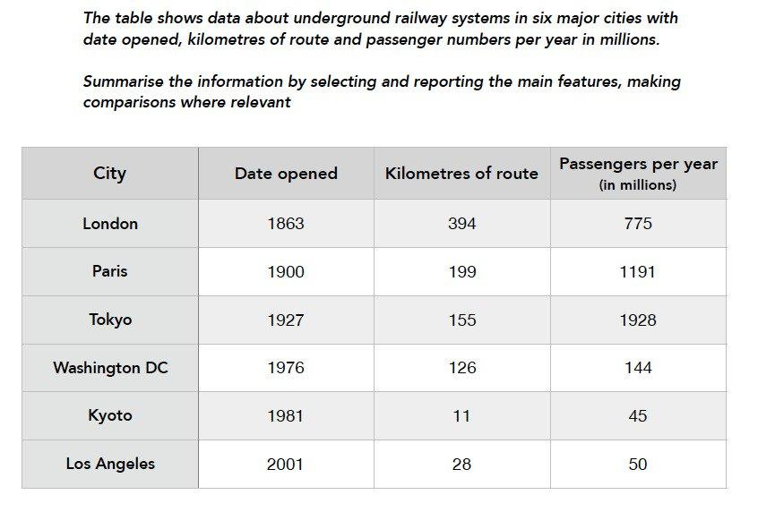

Em học kĩ cách viết dạng table https://www.ieltstutor.me/blog/table
Given is the table comparing the six nations in terms of information about underground train systems namely operating date, kilometres of route and number of commuters per year. Overall, London has the oldest railway systems as well as the longest route among the six cities, and Kyoto train systems provides the shortest route and has fewest commuters per year. Additionally, Tokyo’s underground railway is used the most by commuters per year. =>

As it can be seen from the table, London operated its underground railway system in 1863 and offered 394 kilometres of route, which is the oldest system and has the longest route. However, its number of passengers is at the third place, with only 775 millions, behind Paris (1191 millions) and Tokyo (1928 millions). In addition, Paris, Tokyo and Washington DC have relatively the same length of train route ranging from 126 to 199 kilometres.

Regarding the remaining cities, Kyoto’s train route is the shortest (11 kilometres), and this city’s underground train system is used the least among the other 6 cities, with only 45 millions of people. Additionally, Los Angeles has the newest systems, but this city is reported to have relatively the same number of commuters per year as Kyoto, at 50 millions.

E còn tệ về table quá ạ, e thấy e viết xàm mà mỗi lần nhìn vào cứ bị rối ngang và dọc và bài này e ko biết kịp giờ nữa ☹(((.
lưu ý:
- Bài này sẽ có nhiều cách nhóm số liệu khác nhau, bài này mặc dù có năm nhưng chỉ đơn thuần là năm để báo cáo thông tin, nên vẫn thuộc biểu đồ không có xu hướng ngày tháng
- Có thể chia bố cục 2 đoạn thân bài như sau:
  - Overall
    - It is clear that the three oldest underground systems are larger and serve significantly more passengers than the newer systems. >> IELTS TUTOR hướng dẫn Cách dùng động từ "serve" tiếng anh
  - Body 1: London + Paris + Tokyo (3 nước có date opened lâu đời nhất + số liệu 2 tiêu chí còn lại cao nhất)
    - London: The London underground is the oldest system, opened in 1863. It is also the largest system, with 394 kilometres of route.
    - Paris:
      - The second largest system, in Paris, is only about half the size of the London underground, with 199 kilometres of route.
      - It serves more people per year (1191)
    - Tokyo: While only third in terms of size, the Tokyo system is easily the most used, with 1927 million passengers per year. >> IELTS TUTOR hướng dẫn CÁCH DÙNG "WHILE" TIẾNG ANH
  - Body 2: Còn lại
    - Los Angeles has the youngest underground railway of the 6 cities, dating back to only 2001 and covers the second least railway route of 28 km
    - It is Kyoto that consists of the least number of travellers (45 passengers).

