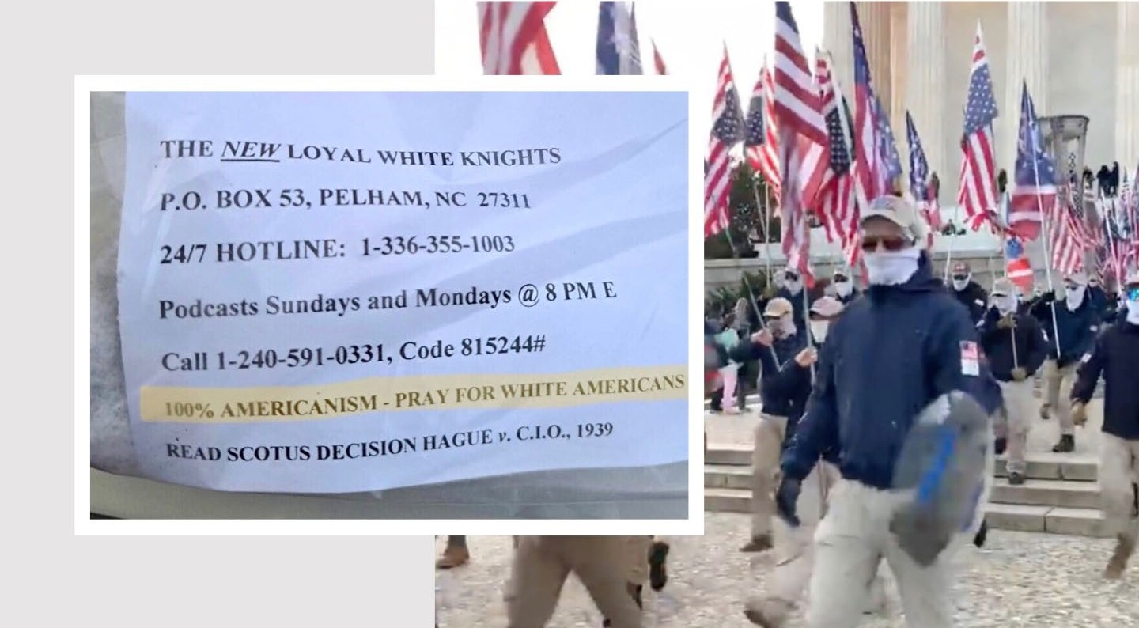

 Menu
Racist by any Name
maxnhall in life  May 17, 2023  784 Words
Follow

The Ku Klux Klan, the New Loyal White Knights, the Patriot Front. There are lots of names for them, but they all fall under the general title of losers. Last week, some of these wack jobs visited both the Virginia countryside where we live and DC. They are cowardly racists, one and all, and only do their work at night, or behind a mask.
Last week, neighbors near here in the Orlean and Hume area of Fauquier County found little baggies on their driveways. Inside the baggies were typed paper messages and white rocks (to keep the baggies from blowing away). These little bags of litter were left by the New Loyal White Knights, a derivative of the KKK. The general message? “100% Americanism – Pray for White America.” They were left on driveways on Route 688 about four miles from our home, and several friends were recipients.

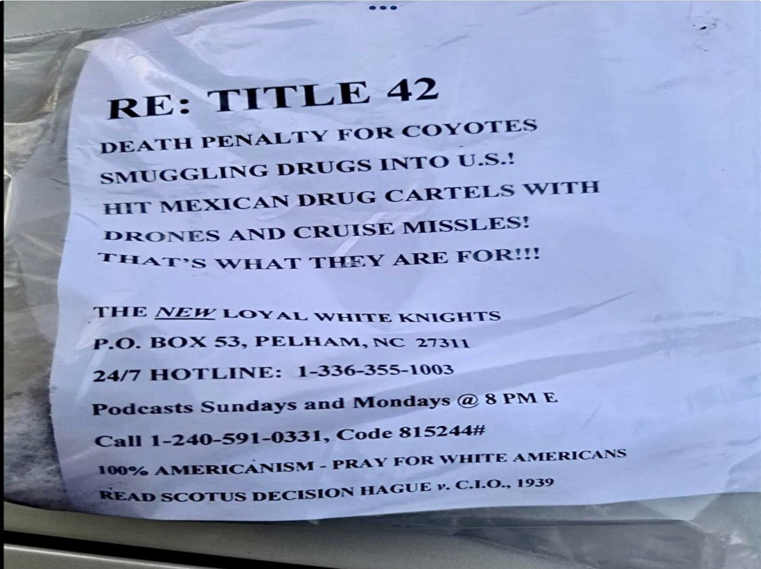

Follow

PRAY FOR WHITE AMERICANS … Indeed.

Yes, as per usual, these cowards did their littering at night, when no one could see them.

Were they locals? Were they from elsewhere? We don’t know, but the incidents have been reported to the County Sheriff, who is a good man and runs a good department.
The Loyal White Knights are considered extreme, even by KKK standards. They accept only “native-born white American Citizens of Christian Faith” who “believe in White Supremacy and 100% Americanism.” (Bolding of native-born is mine.)
It’s interesting to note the reference to the SCOTUS decision in the photo. In Hague v. Committee for Industrial Organization, (1939), the Supreme Court ruled that banning a group of citizens from holding political meetings in a public place violated the group’s freedom to assemble under the First Amendment. Of course these losers aren’t holding any political meeting in a public place. They are just littering our beautiful Fauquier countryside with bigoted and racist white supremacist garbage, all masked under the cover of darkness.
We’ve seen this previously here in Virginia in neighboring Prince William and Loudoun Counties. It always takes place at night. These boys don’t seem too keen to do their work in the light of day.
Our current Fauquier County officeholders and candidates need to speak out publicly and forcefully condemning this white supremacist hatred. Silence is not an option, it is the same as coddling.
On the same weekend, about 150 members of the “Patriot Front” held a protest march in DC. They are another group of losers who were marching in white masks so as to be unidentifiable. They were shouting “RECLAIM AMERICA!”

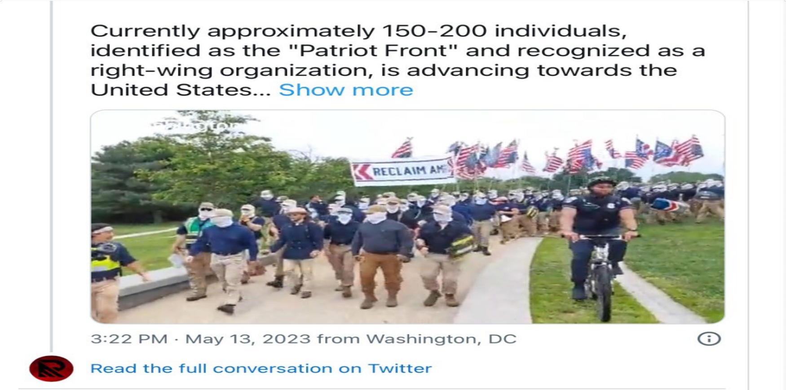

Cowards Wearing Masks

The group formed in 2017 after the ugly “Unite the Right” gathering of neo-Nazis in Charlottesville, Virginia that resulted in three deaths*. Originally called Vanguard America, they rebranded themselves Patriot Front over concerns that Charlottesville might give them a “bad image”. Seriously.
Whether on the National Mall, or the sleepy back roads of Fauquier County, it’s just another week in America, where racism remains alive and well, and extreme racists are here to stay.
Some people say “Oh, just ignore them. They just want attention. They’ll go away.” Those people are wrong. As I wrote in my blog shortly after Charlottesville happened in 2017: “We all need to stand against this type of hatred. Don’t be silent, speak out. Speak out on

Facebook, Twitter, Instagram TikTok and other social media. More importantly, speak out in person, and be the right kind of example. These vile people need to know that there is no place for them or their bigotry in our America.”
In the six years since then, it would appear nothing has changed. That should not deter us. Instead, we need to become more determined and more outspoken. We need to continue to shine a light on these cockroaches, expose them and drive them out. We need to make it so even the darkness of night, or white masks won’t protect them.

* Feel Free To Share This Blog *

Addendum:

Update: In a probably unrelated incident, one week after the white rocks and white supremacist messages were placed on the driveways of many of the homes in the Hume and Orlean areas, a Marshall resident ( adult) and 2 juveniles broke into and vandalized a nearby predominantly African American Baptist Church. Fauquier County sheriff’s deputies have charged a young woman related to the church vandalism, and charges against two juveniles are pending.
* Here’s the blog I did right after the events happened in Charlottesville, VA in August of 2017: This is not my America. A blog about my niece and the KKK and Nazi incidents in Charlottesville, Virginia in August, 2017. https://mnhallblog.wordpress.com/2017/08/14/this-is-not-my-america/
Thanks to my friend Irv for input to this blog. He gets it.

Share this:

 Twitter

 Facebook

 Tumblr

 Email

Loading...

Tagged: #KKK, #losers, #memories, #patriotfront, #racism, #racists, #stories, #WhiteKnights

