Đề bài
The charts (line chart and bar chart) show the average ticket prices and the average percentage of tickets sold in Merrintong theater in the four quarters from 2010 to 2011

The charts (line chart and bar chart) show the average ticket prices and the average percentage of tickets sold in Merrintong theater in the four quarters from 2010 to 2011
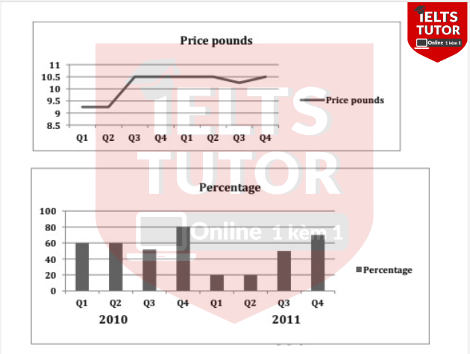

- Hướng dẫn làm dạng Mixed https://www.ieltstutor.me/blog/mixed-chart
- Từ vựng biểu đồ không có thời gian https://www.ieltstutor.me/blog/tu-vung-ielts-writing-task-1-bar-table-pie
Given are the line graph and bar chart illustrating the average price of ticket and the average proportion of tickets sold in Merrington theatre in the four quarters in two years 2010 and 2011, respectively.
⇒ Cần paraphrase 2 cụm này của bài nha vì đang lặp nhiều rồi the average ticket prices & the average percentage of tickets sold
Overall, the average of ticket fees experienced a stability almost all the surveyed period while fourth quarter made up the highest rate in every year of survey. ⇒
In terms of the average cost of ticket, this figure remained static at well over 9 pounds in the first 2 quarters of the year 2010, and then started to leap to 10.5 in third quarter of the same year. This datum underwent the stability at around 10.5 pounds in the rest of the survey.

Regarding the average proportion of tickets sold in Merrington theatre, both the year 2010 and 2011 witnessed the stability in the first and second quarter, at 60% and 20%, respectively. In the third quarter of 2010, this datum climbed drastically to end at 80% in 2010 while this figure increased to around 70% in the last 2 quarters of the year 2011. ⇒ Mình nên đi từ ‘2010- 2011’, với xu hướng được miêu tả cho thông tin nhé.
Nên là lấy so sánh từng đoạn, rồi mình quay lại miêu tả xu hướng thì 1 nội dung thân bài mình đang viết theo nhiều cách khác nhau rồi nè.
VD:
+ remained unchanged in the first 2 quarters in the first year - a decreased before a rise to its peak can be seen in the last quarter
+ However, (đoạn này thì mình sẽ thấy được ở [2011], thì dữ liệu giảm rất mạnh về 2 quý đầu) Q1 & Q2 - Increased and rose to its highest point in the fourth quarter once again

- Overall:
  - Even though there was a significant increase in ticket prices during the third quarter of 2010, there was no corresponding decrease in the percentage of tickets sold.
- Body 1: Viết về biểu đồ 1
  - Năm 2010
    - The average ticket prices remained constant at £9.25 in the initial two quarters of 2010.
    - Subsequently, there was a notable surge, with prices reaching £10.5 during the third quarter of 2010.
  - Năm 2011
    - Afterward, prices stabilized until the second quarter of 2011 when there was a slight decline to £10.25 in the third quarter of 2011.
    - However, prices rebounded and returned to £10.5 in the fourth quarter.
- Body 2: Viết về biểu đồ 2
  - Năm 2010
    - The percentage of tickets sold stood at 60% in both Q1 and Q2 of 2010.
    - Despite the substantial ticket price increase, there was only a minor decline in the percentage of tickets sold (50%).
    - During Q4 of 2010, the highest percentage of tickets sold was recorded at 80%, surpassing all other quarters.
  - Năm 2011
    - The lowest ticket sales occurred during Q1 and Q2 of 2011 (nêu số liệu)
    - Nevertheless, sales figures rebounded, reaching 70% by the end of Q4 2011.

Bài mẫu

Dàn bài lần 2

Bài viết lần 2

Dàn bài lần 3

Bài viết lần 3

Dàn bài lần 4

Bài viết lần 4

