6-Day Tanzania Safari Itinerary
Experience the best of Tanzania’s wildlife and landscapes in a well-paced, immersive safari.

Day 1: June 19 – Arrival in Arusha
- Arrive at the airport and transfer to Arusha.
- Dinner and overnight stay (accommodation arranged separately).

Day 2: June 20 – Tarangire National Park
- After breakfast, depart for Tarangire National Park, known for its large elephant herds, ancient baobab trees, and diverse wildlife.
- Enjoy a full-day game drive, spotting lions, giraffes, zebras, and various bird species.
- Dinner and overnight at Lake Manyara Serena Lodge or a similar accommodation.
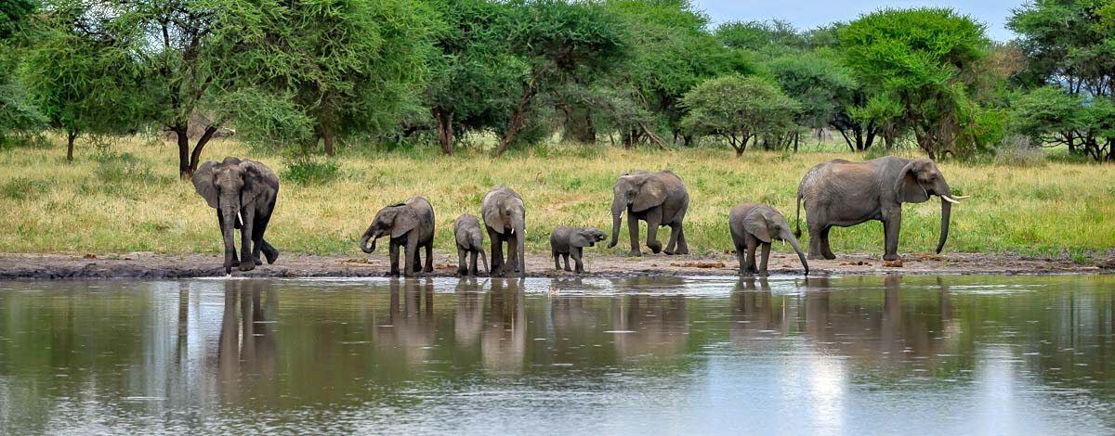
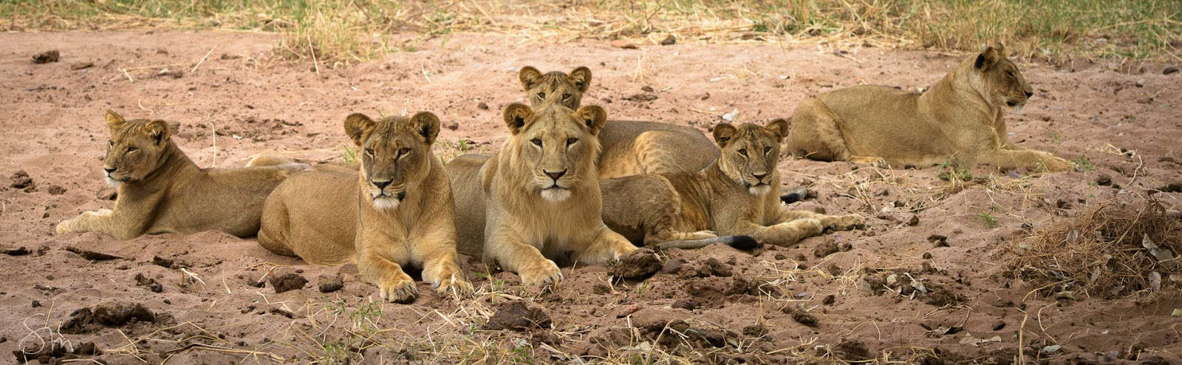
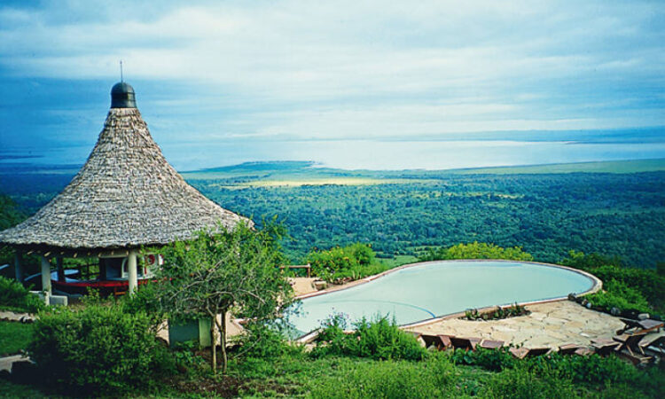
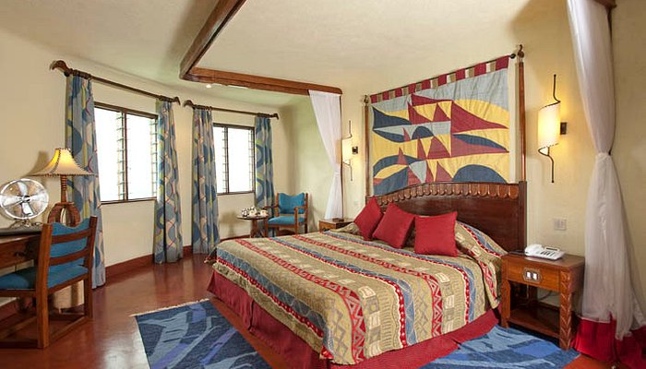

Day 3: June 21 – Serengeti National Park
- After breakfast, drive to Serengeti National Park, home to the world-famous Great Migration and the iconic African savannah.
- Enjoy an en-route game drive before arriving at your lodge.
- Dinner and overnight at Serengeti Serena Safari Lodge or a similar accommodation.
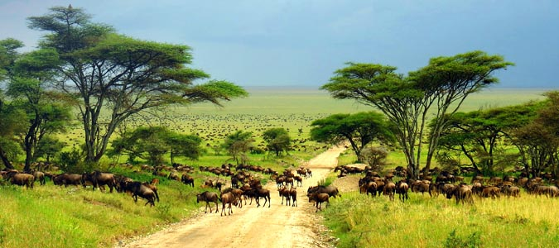
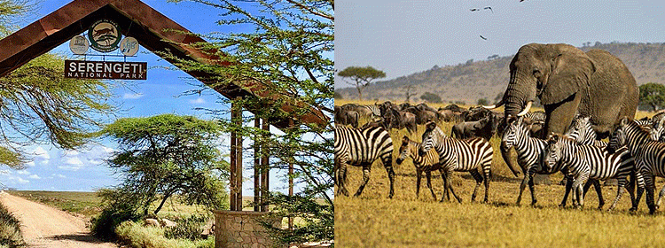
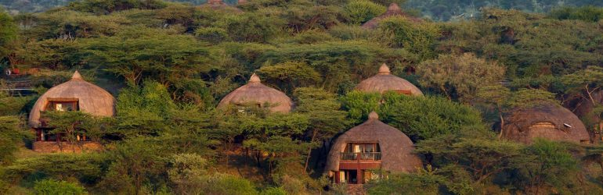
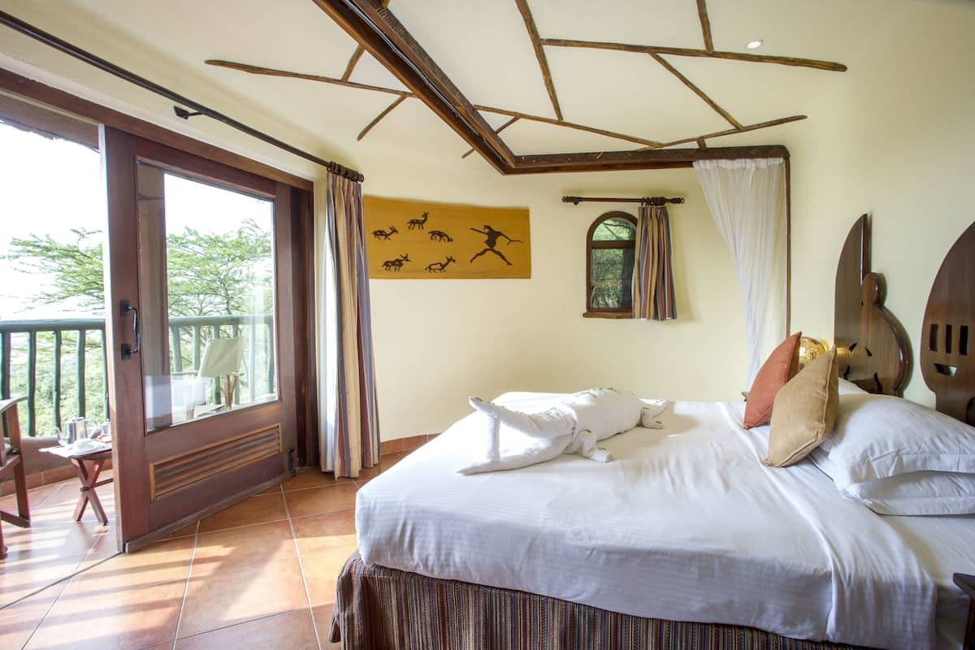
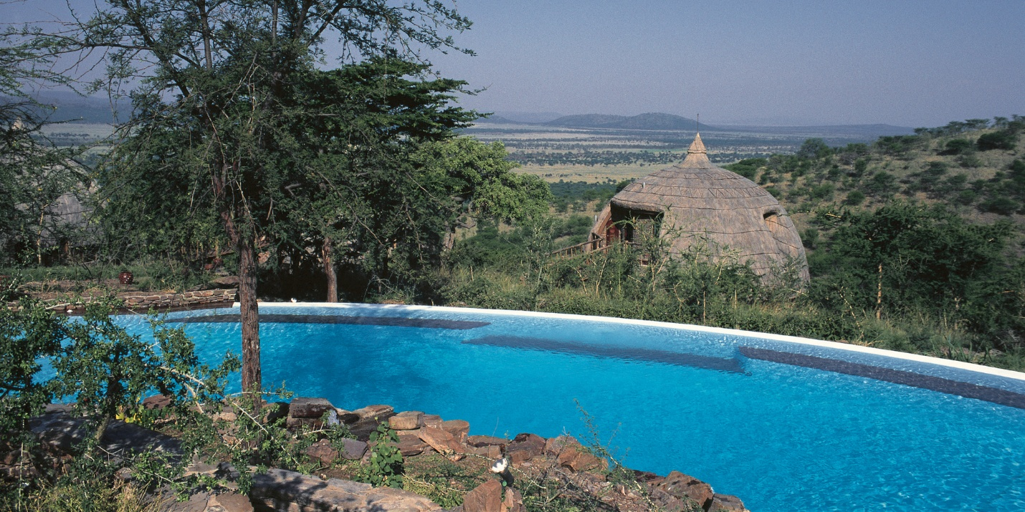

Day 4: June 22 – Full-Day Safari in Serengeti
- Spend the entire day exploring Serengeti National Park, searching for the Big Five (lion, leopard, elephant, buffalo, and rhino), cheetahs, hyenas, and more.
- Witness the breathtaking scenery and abundant wildlife of this vast ecosystem.
- Dinner and overnight at Serengeti Serena Safari Lodge or a similar accommodation.

Day 5: June 23 – En-Route Game Drive & Relaxation
- Depart after breakfast and enjoy a scenic en-route game drive through the Serengeti as you head towards Lake Manyara Serena Lodge or a similar accommodation.
- Arrive in the afternoon and relax at the lodge, enjoying the stunning views over Lake Manyara.
- Dinner and overnight stay.

Day 6: June 24 – Lake Manyara National Park & Departure
- After breakfast, embark on a game drive in Lake Manyara National Park, famous for its tree-climbing lions, large troops of baboons, and diverse birdlife along the alkaline lake.
- Later, drive to the airport for your departure flight.
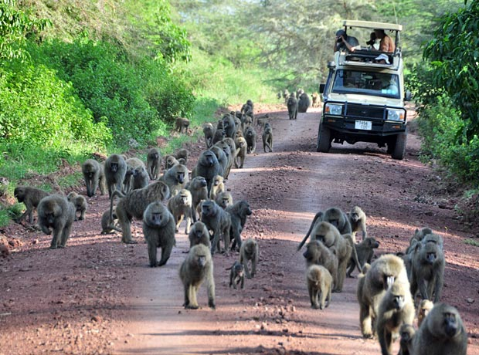
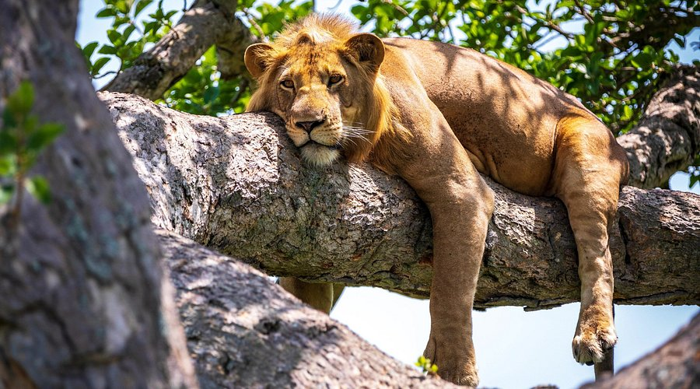

Price: TSH. 5,575,600 Per Person

Safari Inclusions
✔️ Park fees & crater tour fees
✔️ Accommodation & meals as per the itinerary
✔️ Game drives in a 4WD safari vehicle with a professional guide
✔️ Bottled water while on safari

Exclusions
❌ International & domestic flights
❌ Tips, gratuities, & personal expenses
❌ Alcoholic & non-alcoholic beverages
❌ Optional activities (available upon request)

