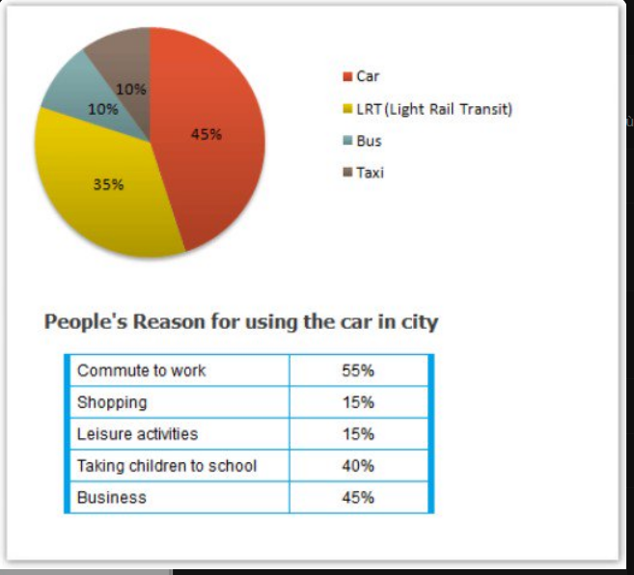
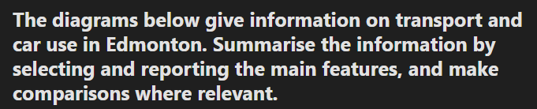
Từ vựng biểu đồ không có thời gian https://www.ieltstutor.me/blog/tu-vung-ielts-writing-task-1-bar-table-pie
Given are the pie chart comparing different means of transportation in terms of their use and the table illustrating public reasons for car use in Edmonton. In general, cars along with Light Rail Transit dominate the transport use in Edmonton, whereas cars are used mostly for daily activities such as business purposes, commuting to work, as well as taking children to schools → Phần nội dung mình miêu tả ổn nha.
Regarding the pie chart first, cars are the most popular vehicles since 45% of trips are made using cars, compared to only 35% of the data on Light Rail Transit. Additionally, the figures for buses and taxis are the same at 10%.
Moving on the table, most people’s purposes for using cars are for going to their workplace, with 55%, in comparison to 40% of the data on taking children to schools. Furthermore, business reasons account for 45%, which is triple the figures for both shopping and leisure activities.

  - Overall:
    - There is a heavy dependence on cars for work. >> IELTS TUTOR hướng dẫn Cách dùng tính từ"dependent"tiếng anh
    - Commuting to work is the principal reason why people use their cars in the city.
  - Body 1: Viết về biểu đồ 1
    - The car is the most popular means of transport in this city, with 45% of the people saying that they prefer to commute by car.
    - The second most popular form of transport is the LRT (nêu số liệu) while busses and taxis are the main means of transport for the rest of the people (nêu số liệu) (IELTS TUTOR gợi ý cách diễn đạt khác: travel by car is the highest figure, at 45%. This is followed by LRT at 35%, while travel by bus and taxi or taxi each represent only 10%) >> IELTS TUTOR hướng dẫn Cách dùng động từ "follow" tiếng anh
  - Body 2: Viết về biểu đồ 2
    - 55% of the people need to commute to work by car. (IELTS TUTOR gợi ý cách diễn đạt khác: In term of reasons for using the car in Edmonton, the reasons given relate mainly to work, with a figure of 55% for commuting to work and 45% for business)
    - Cars are also used a lot for taking children to school or business purposes (nêu số liệu)
    - Only 15% of drivers are doing their shopping, and, similarly, 15% need to travel by car for leisure. >> IELTS TUTOR hướng dẫn Cách dùng danh từ "purpose" tiếng anh

