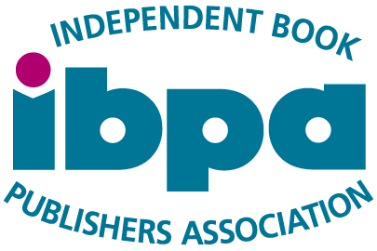

# IBPA Discount for PCPA Publishing Members

The Independent Book Publishers Association (IBPA) is the nation’s largest association for indie publishers. Membership includes:

* 100+ discounts on leading publishing services, including IngramSpark, *Kirkus Reviews*, Bowker, FedEx, and more
* Virtual and in-person opportunities for business and career advancement through programs like IBPA Publishing University, webinars, round tables and more
* A community of 4,000 independent publishers and author-publishers
* Low-cost marketing programs in partnership with Ingram, NetGalley, Library Works, Edelweiss, and others to help reach bookstores, libraries, and readers
* Webinars, articles, and workshops from industry professionals

For more information about membership, visit [**ibpa-online.org**](https://www.ibpa-online.org/).

Learn more about IBPA’s [**member benefits here**](https://www.ibpa-online.org/page/membership)**!**

**Special offer:** IBPA is graciously offering a **$30 membership discount** to all PCPA Publishing Members.

To redeem this special offer, email **info@ibpa-online.org** and note that you are a PCPA Publishing Member requesting the $30 discount. IBPA will send a special promo code for you to use at checkout.