The chart below shows the average monthly contract cost for four different mobile (cell phones) in a European country from January to September 2002, measured in euro.

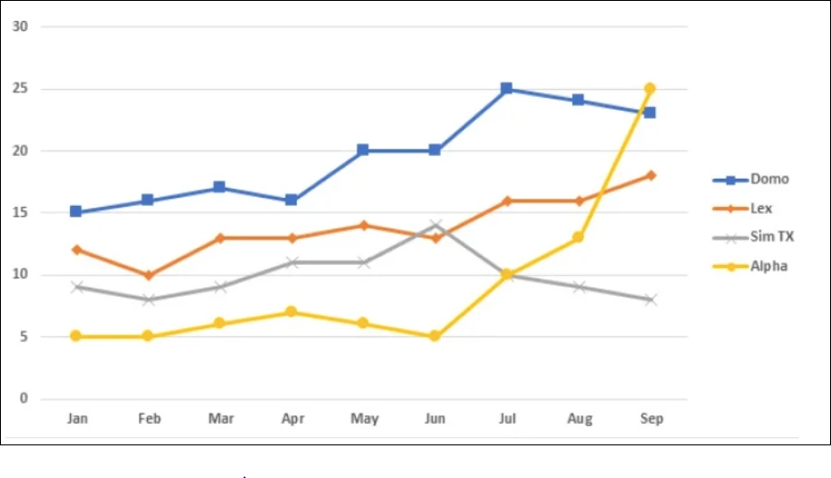

- Dạng line
  - Body 1: Viết về Domo & Alpha
  - Body 2: Viết về Lex & Sim TX

Bài làm
Hướng dẫn làm line graph: https://www.ieltstutor.me/blog/line-graph

Given is the line graph giving information about the average expense of contract every month for the various mobile between January to September 2002 in Europe.
Overall, it is clear that the average expenditure for each mobile rise over the period; however, there is only Sim TX brand decreased at the end of the period shown. Furthermore, although the cost for Alpha mobile is the lowest in January, it jumps rapidly to the highest figure in the chart.
In January 2002, the average cost for Domo mobile was 15 euro, while the figure for Alpha was only 5 euro, which was the lowest point shown on the chart. In September, there was a slight decrease in the cost of Domo cellphone, however, this was opposite to the true, the cost of Alpha was dramatically risen, and reached a peak at 25 euros.
There was not much different cost between Lex and Sim TX mobile at the beginning of the period. After climbing to approximately 12 euros in June, the expenses for Sim TX drop constantly to nearly 7 euros in September. While the cost for Lex mobile increased steadily over the period.
- Bài lưu ý về CHIA THÌ QUÁ KHỨ khi bài ở 2002 nhé
- Vào thân bài thì các số liệu cần phải được miêu tả rõ nữa nha, các câu miêu tả còn thiếu số liệu trong bài rất nhiều nè.
IELTS TUTOR lưu ý:
  - Overall:
    - There was an increase in the figures for all companies, except for Sim TX >> IELTS TUTOR hướng dẫn Phân biệt INCREASE động từ & INCREASE danh từ
    - The monthly cost of Alpha’s contract experienced the most remarkable growth.
  - Body 1: Viết về Domo + Lex
    - Domo:
      - Domo’s users had to pay the highest price for the majority of 2002 as the price rose gradually from January (nêu số liệu) to July (nêu số liệu), followed by a slight decrease to about 23 euros by September. >> IELTS TUTOR hướng dẫn Paraphrase từ "increase/rocket"(Diễn đạt sự "gia tăng"
    - Lex:
      - There was gradual growth in the price of Lex’s contract, from approximately 12 euros in January to 17 euros in September.
  - Body 2: Viết về Sim TX + Alpha
    - Alpha
      - Alpha originally offered the lowest price at the beginning of 2002, at only 5 euros per month.
      - The price remained relatively stable during the next 5 months (nêu số liệu) before a surge to 25 euros in September, which made Alpha the most expensive contractor examined. >> IELTS TUTOR hướng dẫn Cách dùng tính từ"substantial"tiếng anh
    - Sim TX
      - After peaking at 14 euros in June, the average cost of Sim TX decreased and returned to its original price of 8 euros.

