**Check**  what you want to practice:

* Money, saving, banking, financial services

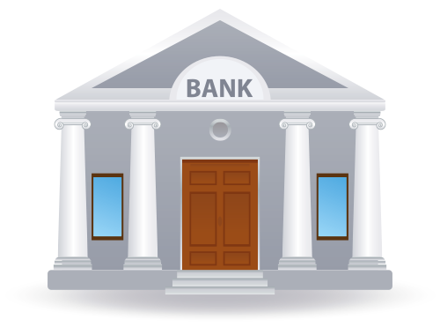

* Shopping, talking to salespeople, reading advertisements
* Time and making plans

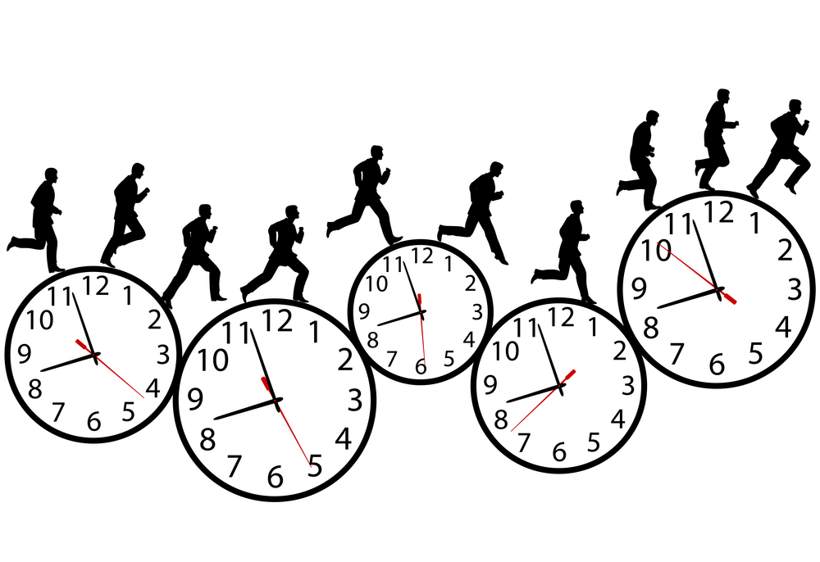

* Food, reading a menu, grocery shopping, reading recipes

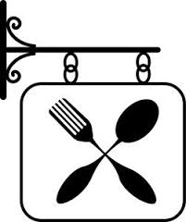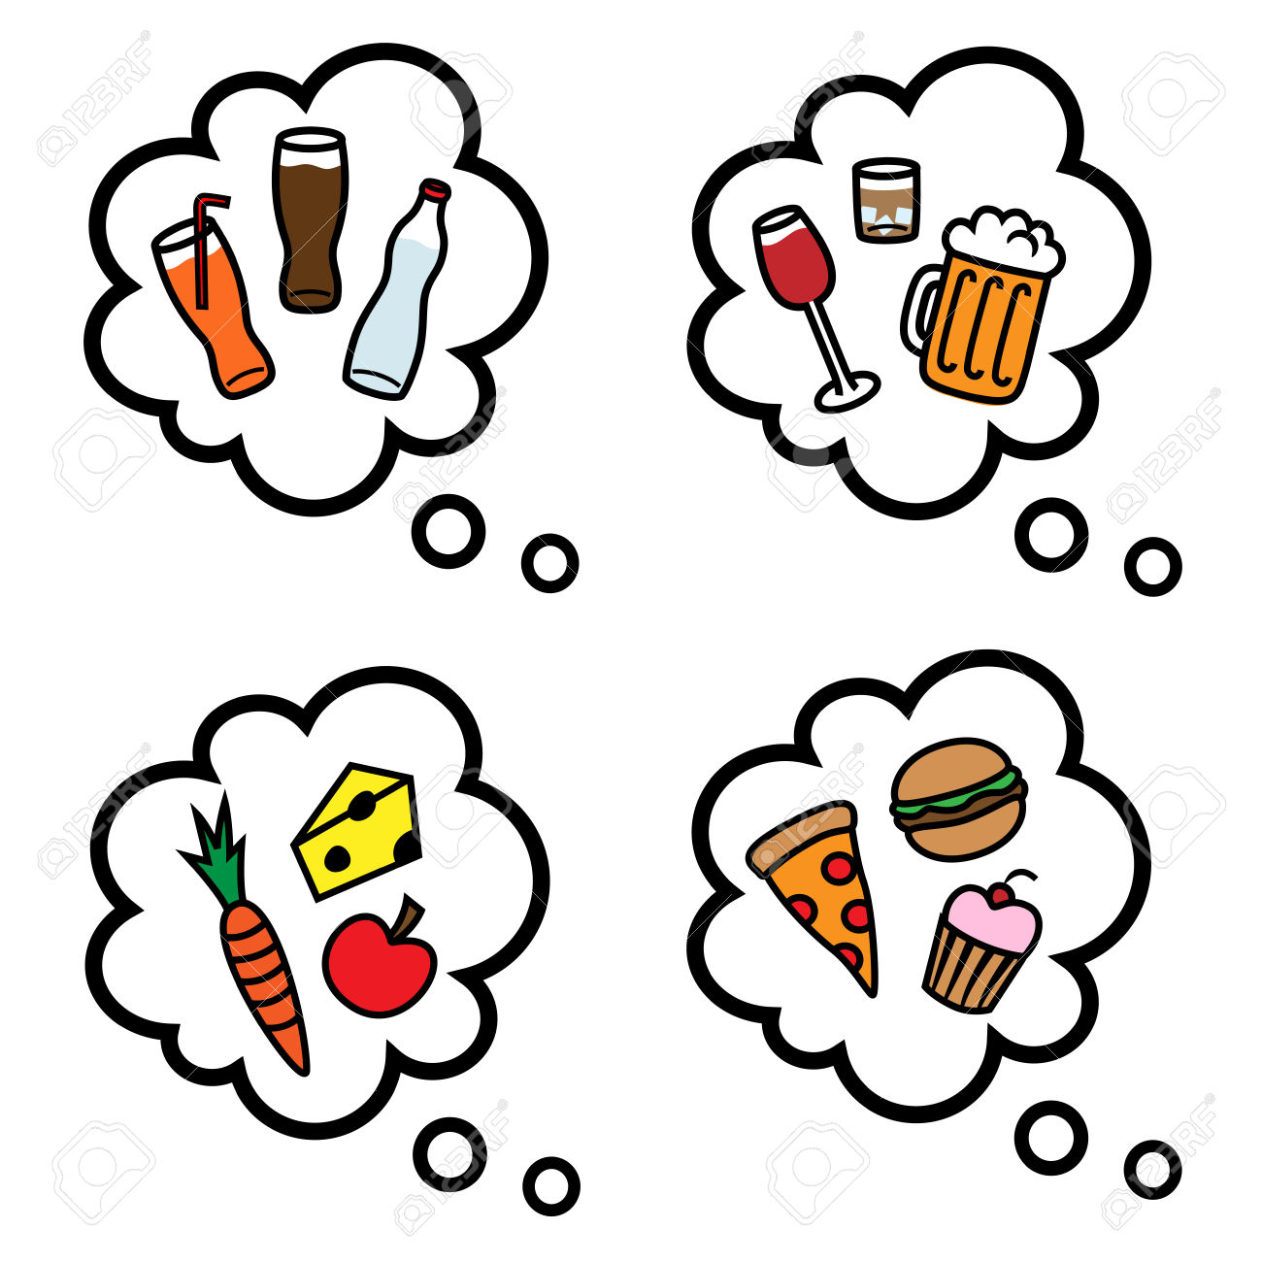

* 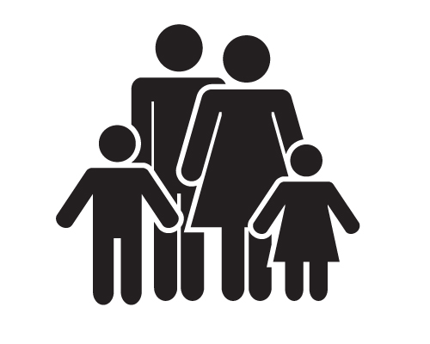Family, friends, relationships, describing people and personalities
* Health, going to the doctor, eating healthy



* Home, hobbies, chores, furniture

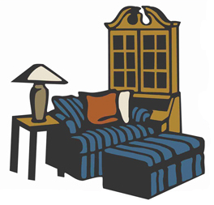

* Work, finding a job, types of jobs



* Greetings, introductions, slang



* US Culture, Spokane & Washington State history



* Talking with child’s teacher, reading forms from school, parent/teacher conferences

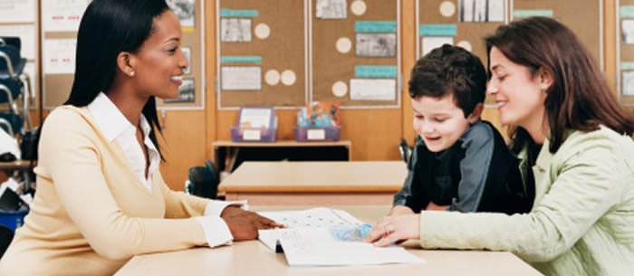

* 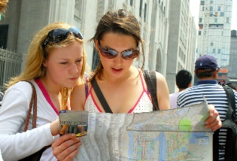Directions, maps, buses, reading a map, places in Spokane

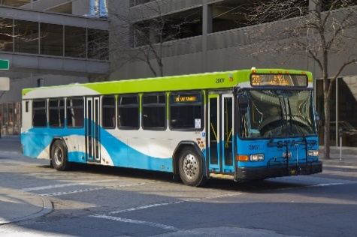

* Citizenship, passing the citizenship test

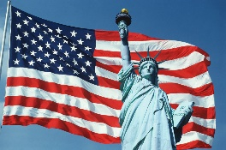

If there are other topics you’d like to learn about, please write them below:

___________________________________________________________________________________

___________________________________________________________________________________

___________________________________________________________________________________