Mentor Guide

Introduction

“The delicate balance of mentoring someone is not creating them in your own image but giving them the opportunity to create themselves.” — Steven Spielberg

Welcome! You are about to be a mentor in Gonzaga ESL Community Outreach. You are an experienced teacher now... really you are! You have completed your practicum and gained valuable knowledge during your graduate courses. It is time to move to the next level, gain skills in mentorship, practice giving constructive feedback, and invest in the education of other future teachers.
In this guide you will find the purpose and goals of the mentor element of GECO. You will also find an outline of your responsibilities and all the checklists and handouts you will need to complete this commitment.

Table of Contents
Purpose 4
Goals of Being a Mentor 5
Requirements of Being a Mentor 5
What the Mentee Expects 5
Timeline of Responsibilities 6
Giving Lesson Feedback 7
How to Observe 8
How to Have a Debrief Discussion 8
Forms 9
Lesson Feedback Checklist 9
Observation/Evaluation Form 11
Debrief Discussion Questions 14

Purpose

The purpose of GECO mentoring is 3-fold. Mentoring will help the mentor, you, become skilled in providing constructive feedback. Mentoring will help the new teacher, the mentee, become confident and independent in a teaching environment. Finally mentoring will provide the G.E.C.O. students with exposure to more teachers while ensuring an experienced teacher is present.
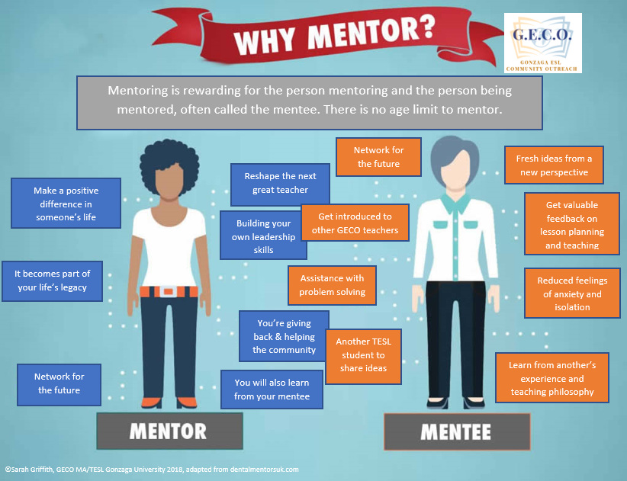

Goals of Being a Mentor

- To gain experience providing constructive feedback that is helpful and encouraging to mentee
- To listen and respond to the concerns of mentee with patience and sensitivity
- To share knowledge and experience with mentee
- To recognize value of knowledge gained through education and experienced while at MA/TESL GU
- To refer students to more experienced sourced if needed

Requirements of Being a Mentor

- Provide guidance to mentee on one two-week unit
- Respond to emails from mentee in a timely manner
- Review a lesson plans carefully and critically
- Provide constructive, helpful feedback in accordance to the lesson plan feedback checklist
- Attend GECO both Saturdays mentees teach
- Observe mentees using observation form
- Hold a debrief discussion immediately after class on both Saturdays
- Be ready to teach if mentee calls out or fails to arrive for any reason
- Inform the GECO coordinator of any concerns or issues immediately

What the Mentee Expects

The Mentor does not plan, does not teach! The mentor is an advisor.
However….
Mentee’s will have one “lifeline” during teaching. That is, one time they feel like they are absolutely drowning and can’t save themselves and need help. First, they should ask their co-teacher to help! But if they still need help they can ask the mentor. The lifeline is limited to 5 minutes or less. The mentor will assist however is needed and then sit back down.
It is important to stick to one lifeline per class per week. Don’t let mentee’s overuse this. They should only use if they absolutely need to.

Timeline of Responsibilities

Weeks leading up to your mentee’s unit : They will plan and might email you with a question. Please respond.
Monday (before the first Saturday to teach) : The mentee’s MUST email you both lessons for their unit and CC the GECO coordinator
Wednesday : You review the lesson and provide feedback- See “Lesson Plan Feedback Checklist”
Thursday- Friday : Mentee’s revise lessons and might email you with follow-up questions. Please respond.
Saturday (Week 1) : You attend GECO, observe and debrief with your mentee’s- See “Observation Evaluation” & “Debrief Discussion”
Sunday- Friday : Mentee’s revise lesson and might email you with follow-up questions. Please respond.

*Saturday (Week 2) : You attend GECO, observe and debrief with your mentee’s- See “Observation Evaluation” & “Debrief Discussion”

Giving Lesson Feedback

You are a mentor to new teachers. This may be their first time planning a lesson and teaching. Be kind when giving feedback. Read the lessons carefully. Don’t make assumptions. You can give feedback in the form of simple suggestions and asking thought-provoking questions. The best feedback is a balance of both.

Remember the sandwich method:
Give positive feedback, constructive feedback, positive feedback.

It should take 1 to 1 ½ hours to review lessons and provide feedback.

No lesson is perfect. Each lesson should have feedback from you.

The best way to give feedback is using the “comment” function on word or google. If you are not comfortable with that you can give feedback in an email. Be sure it’s clear what portion of the lesson your comment is referring to.

Examples of feedback:*

“This is a great activity. But do you want the beginner students to interact more in the class and use more language? I appreciate the idea of working independently and then check the answers in groups. That would work perfect with intermediate level. With beginners it is a little bit hard. Great activity in targeting Reading and Speaking skills! Also, it is a good way to check their comprehension! Good Job!”

“Love it! I love how you keep using the same materials that they just got familiar to it and challenge them gradually! Good technique to use with beginners. However, I didn’t get the part of the questions. Are you going to ask them these questions to check their understanding or are you going to teach them how to ask such questions? If so, that’s great! If you just checking their understanding good but am not sure how you would do it and what is the extra information that they would learn because it was not in the previous activity? Let me know what your intention is here!”

*excerpts from feedback given by mentor Laila Alanazi, 2017

How to Observe

Observing is a skill. As you become a more experienced teacher you will be able to see problems in the classroom much sooner. These problems can arise from how directions are given, for example lack of comprehension checks or modelling. Confusion can occur when teachers don’t understand the question a student is asking, and the teacher answers a different question, or when an activity isn’t scaffolded. As an observer, and prior GECO teacher, it can be difficult to not step in and help. Resist that urge. Teachers learn from making, recognizing, and repairing mistakes. Give your mentee the freedom to make mistakes. If however, you see a GECO student getting frustrated or confused and the teacher does not recognize it then step in for the students best interest. Quickly and quietly inform the mentee what you see and allow them to rectify the problem.

While observing you need to complete the observation/evaluation form. This should be reviewed or given to the mentees during the debrief. You should use the same form in week 2.
*A note about the observation scale: You will see a scale of 1 to 4. Do not rate the mentee all 4’s. In fact, it would be extremely rare for a new teacher to earn a 4 in any category, especially on week 1. Be honest. They should have something to work towards. Rating the mentee all 4’s tells them they don’t need to improve.

How to Have a Debrief Discussion

The purpose of the debrief is the discuss what occurred during the lesson. It is not for the mentor, you, to tell the mentee how they did, what you think they should change or what they did wrong. This discussion is a chance to guide the mentee towards reflective teaching. To help you as a mentor you have been provided discussion questions. Use these to get the conversation going. Ask you mentee what their perception of the lesson was. And listen more then you speak. You are free to give some opinion but try to be sound judgmental. Remember the sandwich method.

Forms
The following pages are the forms and handouts to complete your mentoring role.

Lesson Feedback Checklist
Consider these areas. Ask yourself these questions as you review the lessons. Provide feedback in written form. Send a copy of your feedback to the Mentee/s and GECO coordinator.

2 Week Unit:
- Did the mentee/s send you 2 lessons?
- Are the lessons on the assigned topic?
- Is there a clear connection and cohesion between the lessons creating a “unit”?
Topic:
- Is there a clear sub-topic each week that connects to the overall topic?
- Are the sub-topics appropriate for the level?
- Are the sub-topics helpful for the students’ daily living?
Goals & Objectives:
- Are there goals and objectives on each lesson?
- Are they written clearly?
- Are they measurable? How will the teacher/s know if they are attained?
- Are they realistic (for language level, time restraints)?
- Will the students leave each class being able to use new language in a practical way? (what can they do when they leave that they couldn’t do when they walked in the door)
Timing:
- Are there time estimates for each activity?
- Are they realistic? (Trust your instinct, read it and consider how long the activity will take)
- Do you think activities will take longer or shorter than the estimation? Tell the mentee/s.
- Are there extension activities in case the mentee/s have extra time?
Warm-up:
- Is there a GROUP warm-up designed for all three levels to participate? (This is a requirement)
- Is the warm-up at the high-beginner level?
- Is it connected to the weeks topic?
- Is the warm-up fun and engaging?
New Student Introductions:
- Is there an allotted time for new students to introduce themselves and put a sticker on the class world map?
(This is a requirement, mentee/s should plan for 5-10 mins after the warm-up).
Instructions:
- Are instructions/directions for activities on the lesson?
If not, how will the instructions/directions be given?
- Do they include any mention of modeling?
- Did they consider 3 times 3 ways? (visual, model, written)
- Are there any considerations students with hearing or visually impairments?
- Do the instructions seem appropriate for the level?
Activities:
- Are the activities appropriate for the level?
- Are they scaffolded?
- Is there a variety?
- Do they target different learning styles?
- Are there a variety of student groupings? (individual, pair, trio, small group, class)
- How will the groups be arranged? (counting off, birth month, etc.)
Snack Break:
- Is there a snack break from 11:00- 11:15 am? (this is required)
- Is the activity before snack break easy to stop or carry-over? If not, how will they stop the activity for the required snack break?
Materials:
- Is there a list of materials needed? If not, suggest the mentee/s add that.
- Do you see items mentioned in the lesson not on the materials list?
Target Vocabulary:
- Do they list the target vocabulary words?
- If not, what are they teaching? (Every lesson should include new vocabulary)
- How many words are there? (The target is 7-14)
- Should they add or remove some words?
- Are the vocabulary words related to the topic?
- Are the vocabulary words ones that GECO students can use in daily living?
Other:
- Do you have other questions, confusion or concerns while reviewing the lesson plans?

Observation/Evaluation Form
GECO Observation/Evaluation
Mentee/s: ______________________ Mentor: __________________________
 | 1 | 2 | 3 |  | 4
 | You need to focus on this area. | This area needs work. | You are generally doing quite well in this area. |  | You consistently demonstrate good skills in this area.
 |  |  |  | WEEK 1 |  | WEEK 2
1. PROFESSIONALISM |  |  |  | 1 2 3 4 N/A |  | 1 2 3 4 N/A
- in appearance  - in language (clear pronunciation and appropriate and accurate use of language)  - in manner of relating to students  - collegial and courteous with colleagues  - reflects on teaching and makes necessary modifications  - punctual (arrives well before class begins) |  |  |  | Comments: |  | Comments:
2. CLASSROOM ATMOSPHERE |  |  |  | 1 2 3 4 N/A |  | 1 2 3 4 N/A
Behavior of GECO students with teachers  - engaged (interested, motivated) in activities  - responsive, demonstrating comprehension or seeking clarification  - respectful to teacher and each other  - relaxed  Behavior of GECO teachers  - respectful to students  - appears confident and relaxed  - shows energy and enthusiasm in verbal and non-verbal ways  - friendly, with a good connection with students  - creates a learning environment favorable to mutual trust and open inquiry |  |  |  | Comments: |  | Comments:

3. PREPARATION AND PLANNING | 1 2 3 4 N/A | 1 2 3 4 N/A
Organization of content  - content in accordance with curricular objectives  - classes sequenced and related to long-term goals and projects  - written lesson plan has identified objective  Activities and procedures  - appropriate to level and teaching objectives  - variety of activities, linked, and sequenced  - innovative/creative approach  - appropriate use of technology  - appropriate to age and needs of students  Choice and use of teaching materials  - creation of materials  - selection of materials  - appropriate and effective use | Comments: | Comments:
4. CLASSROOM PROCEDURES | 1 2 3 4 N/A | 1 2 3 4 N/A
Teacher Talk  - ability to elicit questions and student participation  - sufficient scaffolding and frequent checks for comprehension  - clear and concise instructions and explanations  - modifies content and speed of speech appropriately  - not overly teacher-centered  Time Management  - able to balance individual student needs with whole class needs  - effective use of time and appropriate pace of class  - able to modify and repair activities which break down  Lesson Planning  - follows written lesson plan  - able to recognize, extend, and exploit spontaneous teaching opportunities | Comments: | Comments:
COMMENTS
WEEK 1
WEEK 2
Scan a copy of the completed observation form to the GECO Coordinator.

Debrief Discussion Questions

You are the mentor. Ask your teacher/s each of these questions. Use these questions to start a discussion. Remember to listen more than talk.

Engagement: Were all of the students engaged in the activities? Why? Why not?

Goals and objectives: Were the goals and objectives of the lesson achieved? Why? Why not?

Successes and challenges: What worked well in the classroom today? What were the challenges?

And for next week: What should be done differently next week?

