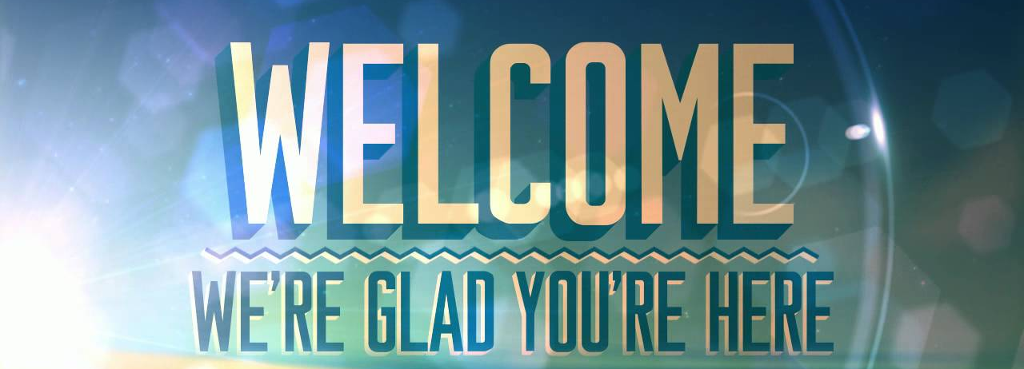
Name: ________________________________ Date: ____________________________

Phone Number: _________________________ Email: ___________________________

Home Address:
_____________________________________________________________________________
Street Apt City State Zip

What country are you from?

___________________________________________

What language do you speak at home?

___________________________________________

How long have you been in the United States? ________________________________________________
______ years ______ months ______ weeks

What is the best way to contact you? Phone, email or Facebook? ____________________________________

Who do you live with? Write 2 sentences about your family.

__________________________________________________________________________________________

__________________________________________________________________________________________

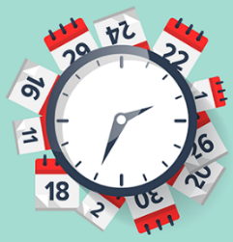
How long have you been learning English? ____________________________________
______ years ______ months ______ weeks

Check your answer

Did you study English in your home country? Yes ____ No _____
If yes, how did you learn it? (school, work, parents, yourself) __________________________________

Do you have a job? Yes ____ No _____
What is your job? _____________________

Check your answer

What do you want to practice?
_____ Grammar ______ Listening ______ Speaking
_____ Pronunciation ______ Writing ______ Vocabulary

Why do you want to improve your English? Write 2 to 3 sentences.
_______________________________________________________________________________________________________________________________________________________________________________________________________________________________________
We take photos and videos during class. Check your answer
1. Can a photo with you in it be on our private Facebook group? Yes ____ No_____
2. Can a photo with you be on an advertisement/flyer? Yes _____No_____
******************************************************************************************
Speaking Assessment (Completed by Teacher)
2- Excellent 1- done, needs some improvement 0- not done, needs instruction

Skill: | Circle One: | Comments
Greet (Introduce self) | 2 1 0
Active Listening (nod, eye contact, smile) | 2 1 0
Use correct rejoinders (“that’s great”, “oh no!”) | 2 1 0
SVC: “He/she is…” | 2 1 0
General pronunciation/intelligibility | 2 1 0

