Process: The diagram below shows how ocean thermal energy conversion (OTEC) works. Summarise the information by deciding on and exploring its main features, and make any relevant comparison.
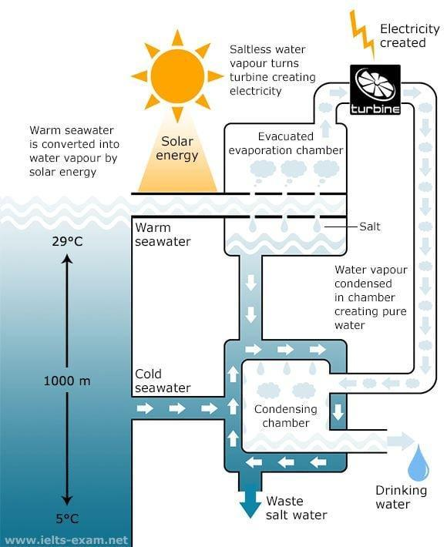
Hướng dẫn làm process:https://www.ieltstutor.me/blog/process
🡪 Given is the diagram illustrating differents steps to explain the process ocean thermal energy conversion operates.
Overall, it is clear that the system uses the difference between temperatures on the surface and undersea with 1000m distance to produce drinking water. The main elements of the system are an evacuated evaporation chamber, a turbine and a condensing chamber.
As can be seen in the process, solar energy heat the seawater. When the warm seawater flows to the chamber, it produces salt and then water divided into two lines and then turn to the under tunnel. The water vapour then comes to the condensing chamber.
At the same time, water vapour drives the turbine to generate electricity. The salt mixes with cold seawater cycles around the condensing chamber. Through this process, waste salt is brought back to the ocean, a new cycle restart again. The water which is produced and leaves the condensing chamber is drinkable.

IELTS TUTOR lưu ý:
- Dạng biểu đồ này thì đã rất quen thuộc với các bạn học sinh lớp IELTS ONLINE WRITING 1 KÈM 1 của IELTS TUTOR rồi nhé
  - Overall:
    - The process involves electricity production by utilizing sea water in different ways. >> IELTS TUTOR hướng dẫn Phân biệt CONTAIN / INCLUDE CONSIST/ INVOLVE
    - The sea water is used to generate electricity and drinking water through OTEC system.
  - Body 1:
    - Giới thiệu chung:
      - The sea water is divided according to its temperature which depends on its depth. >> IELTS TUTOR hướng dẫn Cách dùng động từ "involve" tiếng anh
      - Water on the surface of the sea is termed as warm sea water, and water 1000m below is called cold sea water having a temperature of 5 degree Celsius.
    - Viết về warm sea water:
      - The warm sea water is vaporized by energy from sun. These water vapors are utilized to run turbine and generate electricity.
      - The warm sea water is evaporated in an evaporation chamber which produces vapors to turn on turbine as well as salt as a waste. >> IELTS TUTOR hướng dẫn Các điểm Ngữ Pháp Tiếng Anh THPT Quốc Gia
  - Body 2:
    - Viết về cold sea water:
      - Cold sea water and the salt residue from evaporation chamber are used in condensation chamber.
      - The water vapors that were utilized for creating electricity in turbine are collected and condensed into drinking water in the condensing chamber. >> IELTS TUTOR hướng dẫn Cách dùng danh từ "Use" tiếng anh
      - The last step involves removal of the salty water from the OTEC system.

