- Em có câu hỏi gì muốn hỏi giáo viên về đề này không?không ạ

II. BẮT ĐẦU TÍNH THỜI GIAN LÀM BÀI ( 40 PHÚT CHO TASK 2 - 20 PHÚT CHO TASK 1 )

Đề bài:

Dàn bài ( 5-7 PHÚT )

- Dàn bài mà em lập cho đề này
- Intro
- Overview
- Body 1: the north
- Body 2: the south

Bài viết của em ( luôn nhớ max 300 words cho Task 2, max 160 words cho Task 1)
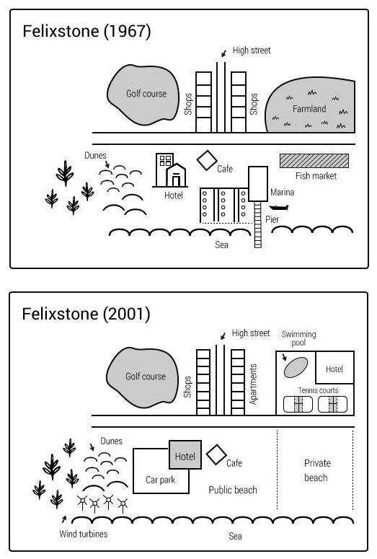
Hướng dẫn làm Map: https://www.ieltstutor.me/blog/map

178 words => cố gắng viết max 160 words thôi nhé

Given are the maps delineating changes in Felixstone in 1967 and 2001.

It can be observed from the diagrams that apart from the golf course, the café and the dunes with no alterations being witnessed, other places had undergone various conversions throughout the given period.

A closer look at the north of Felixstone reveals that there used to be large farmland in 1967. However, after nearly 4 decades, it was replaced by a complex with hotel, tennis courts and swimming pool. Moreover, in 1967, to the left of the farmland stood two shopping buildings separated by a high street, one of which had been converted into apartments by 2001.

Moving on to the south of Felixstone, only the café and the dunes stayed the same throughout the period. Private beaches and public one took the place of fish market, marina and pier. In proximity with the public beach located a hotel which had been renovated and a newly built car park. Last but not least, by 2001, new wind turbines adjacent to the car park had been constructed.

⇒ dạng map không viết như này nha chia ra mỗi biểu đồ 1 body
- Body 1: năm 1967
- Body 2: năm 2001 ⇒ chỗ này so sánh sự khác nhau

