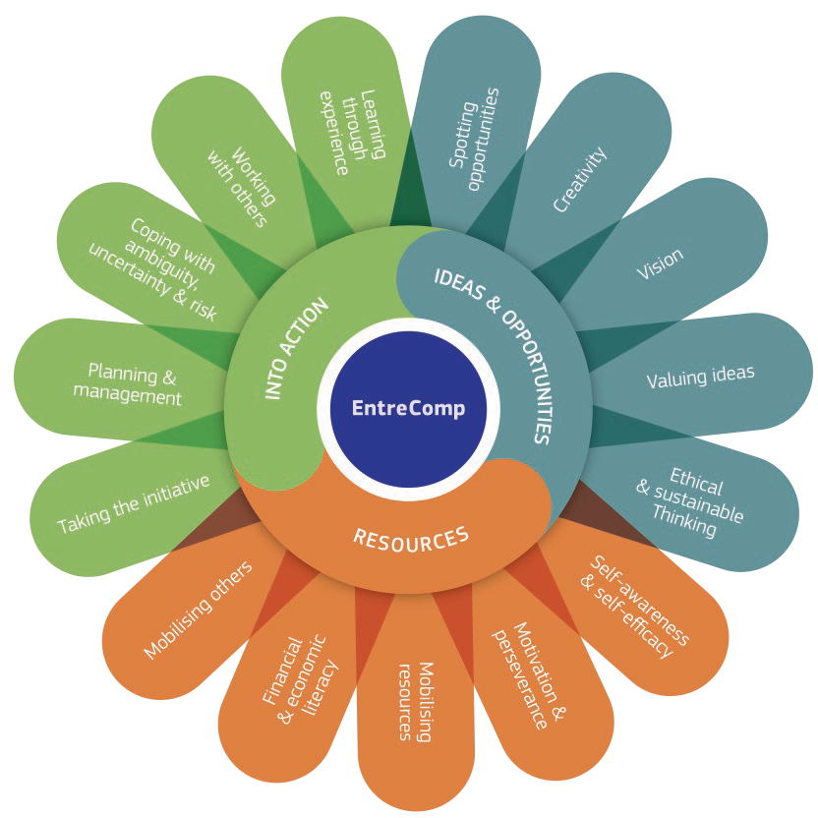

“Entrepreneurship as a competence applies to all spheres of life. It enables citizens to nurture their personal development, to actively contribute to social development, to enter the job market as employee or as self-employed, and to start-up or scale-up ventures which may have a cultural, social or commercial motive.”

“In the context of the EntreComp study, entrepreneurship is understood as a transversal key competence applicable by individuals and groups, including existing organisations, across all spheres of life. It is defined as follows:

Entrepreneurship is when you act upon opportunities and ideas and transform them into value for others.
The value that is created can be financial, cultural, or social (FFE-YE, 2012).

This definition focuses on value creation, no matter what type of value or context. It covers value creation in any domain and possible value chain. It refers to value creation in the private, public and third sectors and in any hybrid combination of the three. It thus embraces different types of entrepreneurship, including intrapreneurship (entrepreneurship and making things happen within organisations), social entrepreneurship, green entrepreneurship and digital entrepreneurship.”

Identify your own competence
Using S.T.A.R method to explain the Situation you were in, the Task you were undertaking, in a group or on your own, and the Actions or steps you took, to get the outcome or Result.

Use the table below to capture as many of the 15 competences as you can – but don’t force your answers, you might not have experience yet!

Advice: Be specific, clear/precise about your role and the result – and recognise changes and the journey you are on (improvements you still want to make).

Use: you can use this to prepare for interviews, in job applications or in reflective tasks when you are looking to evidence your competence and the next step!

Name: |  | Situation | Task | Action | Result
Ideas and opportunities, and challenges | Spotting opportunities | I was at / in | I was doing / making / organising etc | I noticed / saw/ discovered | Impact of action / outcome
Ideas and opportunities, and challenges | Creativity
Ideas and opportunities, and challenges | Vision
Ideas and opportunities, and challenges | Valuing ideas
Ideas and opportunities, and challenges | Ethical and sustainable thinking
Gathering Resources | Self-Awareness and self-efficacy
Gathering Resources | Motivation and perseverance
Gathering Resources | Mobilising Resources
Gathering Resources | Financial and economic Literacy
Gathering Resources | Mobilising others
Into Action | Taking the initiative
Into Action | Planning and management
Into Action | Coping with uncertainty / ambiguity / risk
Into Action | Working with others
Into Action | Learning through experience

Stage 2: Go deeper
You can now use this to help you apply for jobs or to help identify your strengths in a team, or where you want to continue to develop.

Either working alone, or by being interviewed about your STAR answers, capture your own personal plan below/

Name:
 |  | Key Strengths | Key Contribution to team | Areas for development  (less experience of) | What next? Where next? When?
Ideas and opportunities, and challenges | Spotting opportunities
Ideas and opportunities, and challenges | Creativity
Ideas and opportunities, and challenges | Vision
Ideas and opportunities, and challenges | Valuing ideas
Ideas and opportunities, and challenges | Ethical and sustainable thinking
Gathering Resources | Self-Awareness and self-efficacy
Gathering Resources | Motivation and perseverance
Gathering Resources | Mobilising Resources
Gathering Resources | Financial and Economic Literacy
Gathering Resources | Mobilising others
Into Action | Taking the initiative
Into Action | Planning and management
Into Action | Coping with uncertainty / ambiguity / risk
Into Action | Working with others
Into Action | Learning through experience

