SEEN Competences Explained
If you are new to enterprise and entrepreneurship education, the SEEN competences provide a helpful starting point for understanding what can be developed in students, by embedding enterprise education.

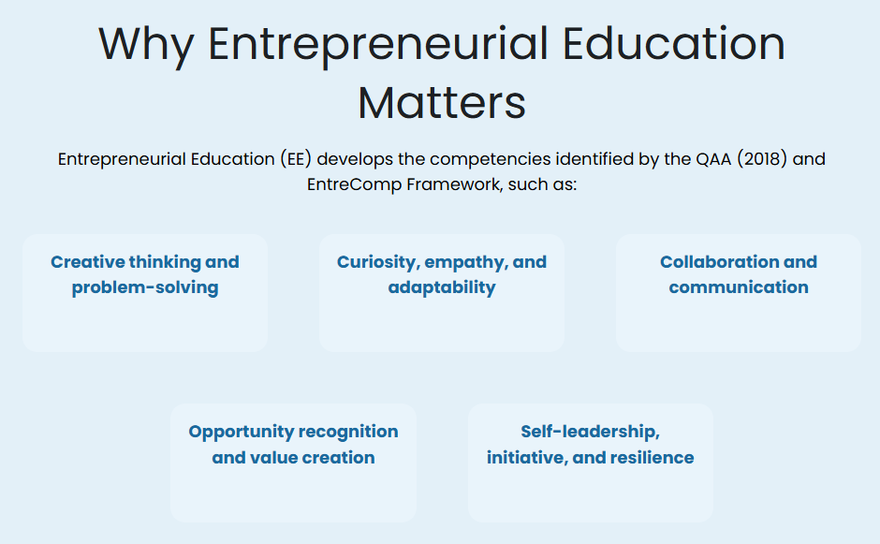

SEEN has identified “why entrepreneurial education matters” outlining 5 competencies. Rather than focusing the knowledge needed to support business start-up, these competences describe a broader mindset that will help students succeed.

The SEEN competences are:
- Creative thinking and problem-solving
- Curiosity, empathy and adaptability
- Collaboration and communication
- Opportunity and value creation
- Self-leadership, initiative and resilience

and are identified by SEEN as the key to supporting students to:
- Develop confidence and employability skills
- Apply their knowledge to real-world challenges
- Contribute to Scotland’s innovation and social well being

Rooted in the aspirations of the “Entrepreneurial Campus Blueprint” Report (Tuffee & Little 2023) helping institutions implement Theme IV (Curriculum), SEEN have recognised the potential of embedding enterprise education to skills and confidence to help students address real-world challenges.

These competences are deliberately depicted without a path or route, as enterprise skills and competences are interlinked, rather than linear. Just like the overlapping petals depicted in EntreComp (2018) there is no expectation to “start” at a particular point, or to work in a set order. This recognises that students are not “empty vessels” but engage in learning from a wide range of prior experience, whether gained from their work experience, personal background or hobbies. This may have provided opportunities to build these competences, or they may be providing new chances to address challenges or take up different roles.

The Five SEEN Competences (What they mean in practice)
SEEN highlights that developing these competences enables students to:
- Build confidence and employability skills: Students become more proactive, capable and ready to contribute in their future professional environments.
- Apply knowledge to real-world challenges: Learning becomes more meaningful when students can use what they know, creating value and impact
- Contribute to Scotland’s economy and social wellbeing
Graduates are better equipped to create positive change, whether in businesses, communities, or public services, contributing to every aspect of Scottish life.
Taking each SEEN competence in turn to explain what is meant, what is it not and what this means to you ‘in practice’ as an educator/teacher working to develop these in your students.
Creative thinking and problem-solving
This is the ability to explore ideas, think differently, and work through complex or ambiguous challenges to find workable solution It is about helping students move beyond an assumed “right answer” to explore ideas, test possibilities and solve real problems, where the route or solution is not yet apparent.
What this is not: This is not being ‘creative’ in an artistic sense or about rewarding student activity that demonstrates artistic flair.
In practice, this might mean using open-ended tasks, encouraging experimentation, or asking students to tackle messy, real-world challenge to go beyond the pre-defined (“textbook”) answer, correct method or approach. By avoiding pre-defined problems, for which you might already “know” the answer, open the group up to the possibility of a range of “right answers” (SEEN Lego Duck can help illustrate this) and welcome questioning and prompts that stretch thinking and open up experimentation, recognising it might end in “failure”. Assessment criteria should reward reflection and process, not outcome as success. The learning comes from evidence of the journey, not the output.

Curiosity, empathy and adaptability
This is about asking questions, understanding others’ perspectives, and adjusting thinking or behaviour in response to new information or changing situations.
What this is not: this requires more than surface-level engagement or working with the assumption that their perspective is always valid. It requires students to keep going, find workarounds and face uncertain or complex environments.
In practice it is about creating an environment in your classroom for students to ask questions, appreciate different perspectives, and adjust their thinking when situations change. This can be created by the authentic examples you chose to work with and alumni/externals you engage but is most visible by the role you take in class, the signals that you give and the learning culture that you create. This is about making space and rewarding the behaviour that builds confidence, welcoming and recognising all contributions. Try to model this level of curiosity through your own questioning as well as that of your students, highlighting assumptions or listening to stakeholder voices to showcase a range of perspectives.

Collaboration and communication
Working effectively with others, sharing ideas, active listening and contributing to collective goals are key to collaboration and communication. Group work, discussion, and peer feedback are effective ways to develop these skills and yet we rarely invite review past group experiences, plan for these shared challenges or review roles or personal practice.
What is it not: Enterprise learning is rarely done alone but there is limited consideration, support or reflection upon the challenge and possibilities created by working with others. There is a clear assumption in education that putting students into groups, is in itself sufficient for students to learn how to work effectively with others, share ideas clearly, and listen as well as contribute. This is clearly not the case.
In practice, this requires active engagement with the creation and operation of groups and teams. Setting expectations, agreeing protocols and creating permission for feedback and review can all support team goals, as can open discussion about previous experiences, difficulties and learning. Work with groups to position comment and feedback as a way to listen actively with the potential to act in order to improve rather than as criticisms or highlighting weakness and recognise the shared responsibility in group work.
Opportunity and value creation
Recognising opportunities and taking action to create value (whether that is economic, social or cultural) is at the heart of enterprise education. It is
What is it not: Whilst it is not the precursor to all business starts, but it is vital to appreciate that “value” is not just about making money and maximising profit, exploiting others or resources - it includes impact, improvement, and contribution.
In practice, this requires being explicit about value to move beyond application into evaluation, asking “who benefits” or identifying the impact. Using real-world authentic contexts helps bring this to life and active consideration of stakeholder can be illuminating.
Self-leadership, initiative and resilience
Students are encouraged to take ownership of their learning, act on ideas, and persist through challenges and setbacks, when things don’t go to plan. This includes building confidence, managing their own learning and goal setting, through reflection and self-awareness.
What it is not: it is not about expecting success first time, without effort or guidance. This recognises the entrepreneurial way of prototyping, testing, trialling and expecting feedback which guides and informs the next decision. It is bot about avoiding risk, but about finding a way through calculated risk in decision making.
In practice, this is forward looking and action orientated, asking what has been learned and what can be done next time? This helps to normalise challenge and development and provides encouragement through pathways to success.

Shift in your role to deliver SEEN Competences

These competences are about asking students to know “about” the subject but to behave entrepreneurially in their subject context and this requires you to shift your role and teaching.

SEEN competences | Key Shift: From | As a | To shift to
Creative thinking and problem-solving | Delivering solutions | Facilitator | Enabling open exploration; identifying uncertainty
Curiosity, empathy and adaptability | Giving instruction and direction | Coach | developing awareness and reflection
Collaboration and communication | Managing group roles | Facilitator | Opening to diversity (of approach, being and thinking) as a way of enabling effective collaboration
Opportunity and value creation | Outlining concepts and frameworks | Facilitator | Ensuring effective application and meaningful impact
Self-leadership, initiative and resilience | Direction & instruction | Coach | Independent and resilient approach to learning

What does this mean to me?

In simple terms, this is less about what you teach and more about how you design learning experiences, that is how you teach. You are not just delivering content to transfer knowledge. You are helping students become people who can spot opportunities, work with others, and solve problems to create value in the world around them. To deliver this, you are changing your role from “the teacher” to a curator of knowledge, a facilitator and a coach, who is: Creating opportunities for students to do, reflect and apply; supporting them to think, act and engage and helping them develop the confidence to make things happen. This shift in the teaching role aligns strongly with experiential or “learning by doing” approaches where students actively engage in tasks that build these competences over time. Take a look at the SEEN Guides on Experiential Learning to get started!

References:
McCallum, E., Weicht, R., McMullan, L. and Price, A., (2018) EntreComp into Action - Get inspired, make it happen: A user guide to the European Entrepreneurship Competence Framework, Bacigalupo, M. and O`Keeffe, W. editor(s), EUR 29105 EN, Publications Office of the European Union, Luxembourg, 2018, ISBN 978-92-79-79360-8, doi:10.2760/574864, JRC109128

Quality Assurance Agency (QAA) (2018) 2nd Edition “Enterprise and entrepreneurship education”. Guidance for UK higher education providers, The Quality Assurance Agency for Higher Education: London https://www.qaa.ac.uk/docs/qaas/enhancement-and-development/enterprise-and-entrpreneurship-education-2018.pdf?sfvrsn=15f1f981_8

Tuffee, R., & Little, J. (2023). The entrepreneurial campus: The higher education sector as a driving force for the entrepreneurial ecosystem [Strategy/plan]. Scottish Government.
https://www.gov.scot/publications/entrepreneurial-campus-higher-education-sector-driving-force-entrepreneurial-ecosystem/

