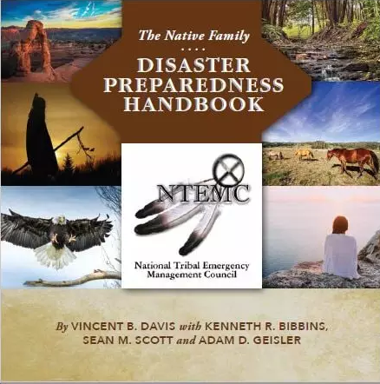
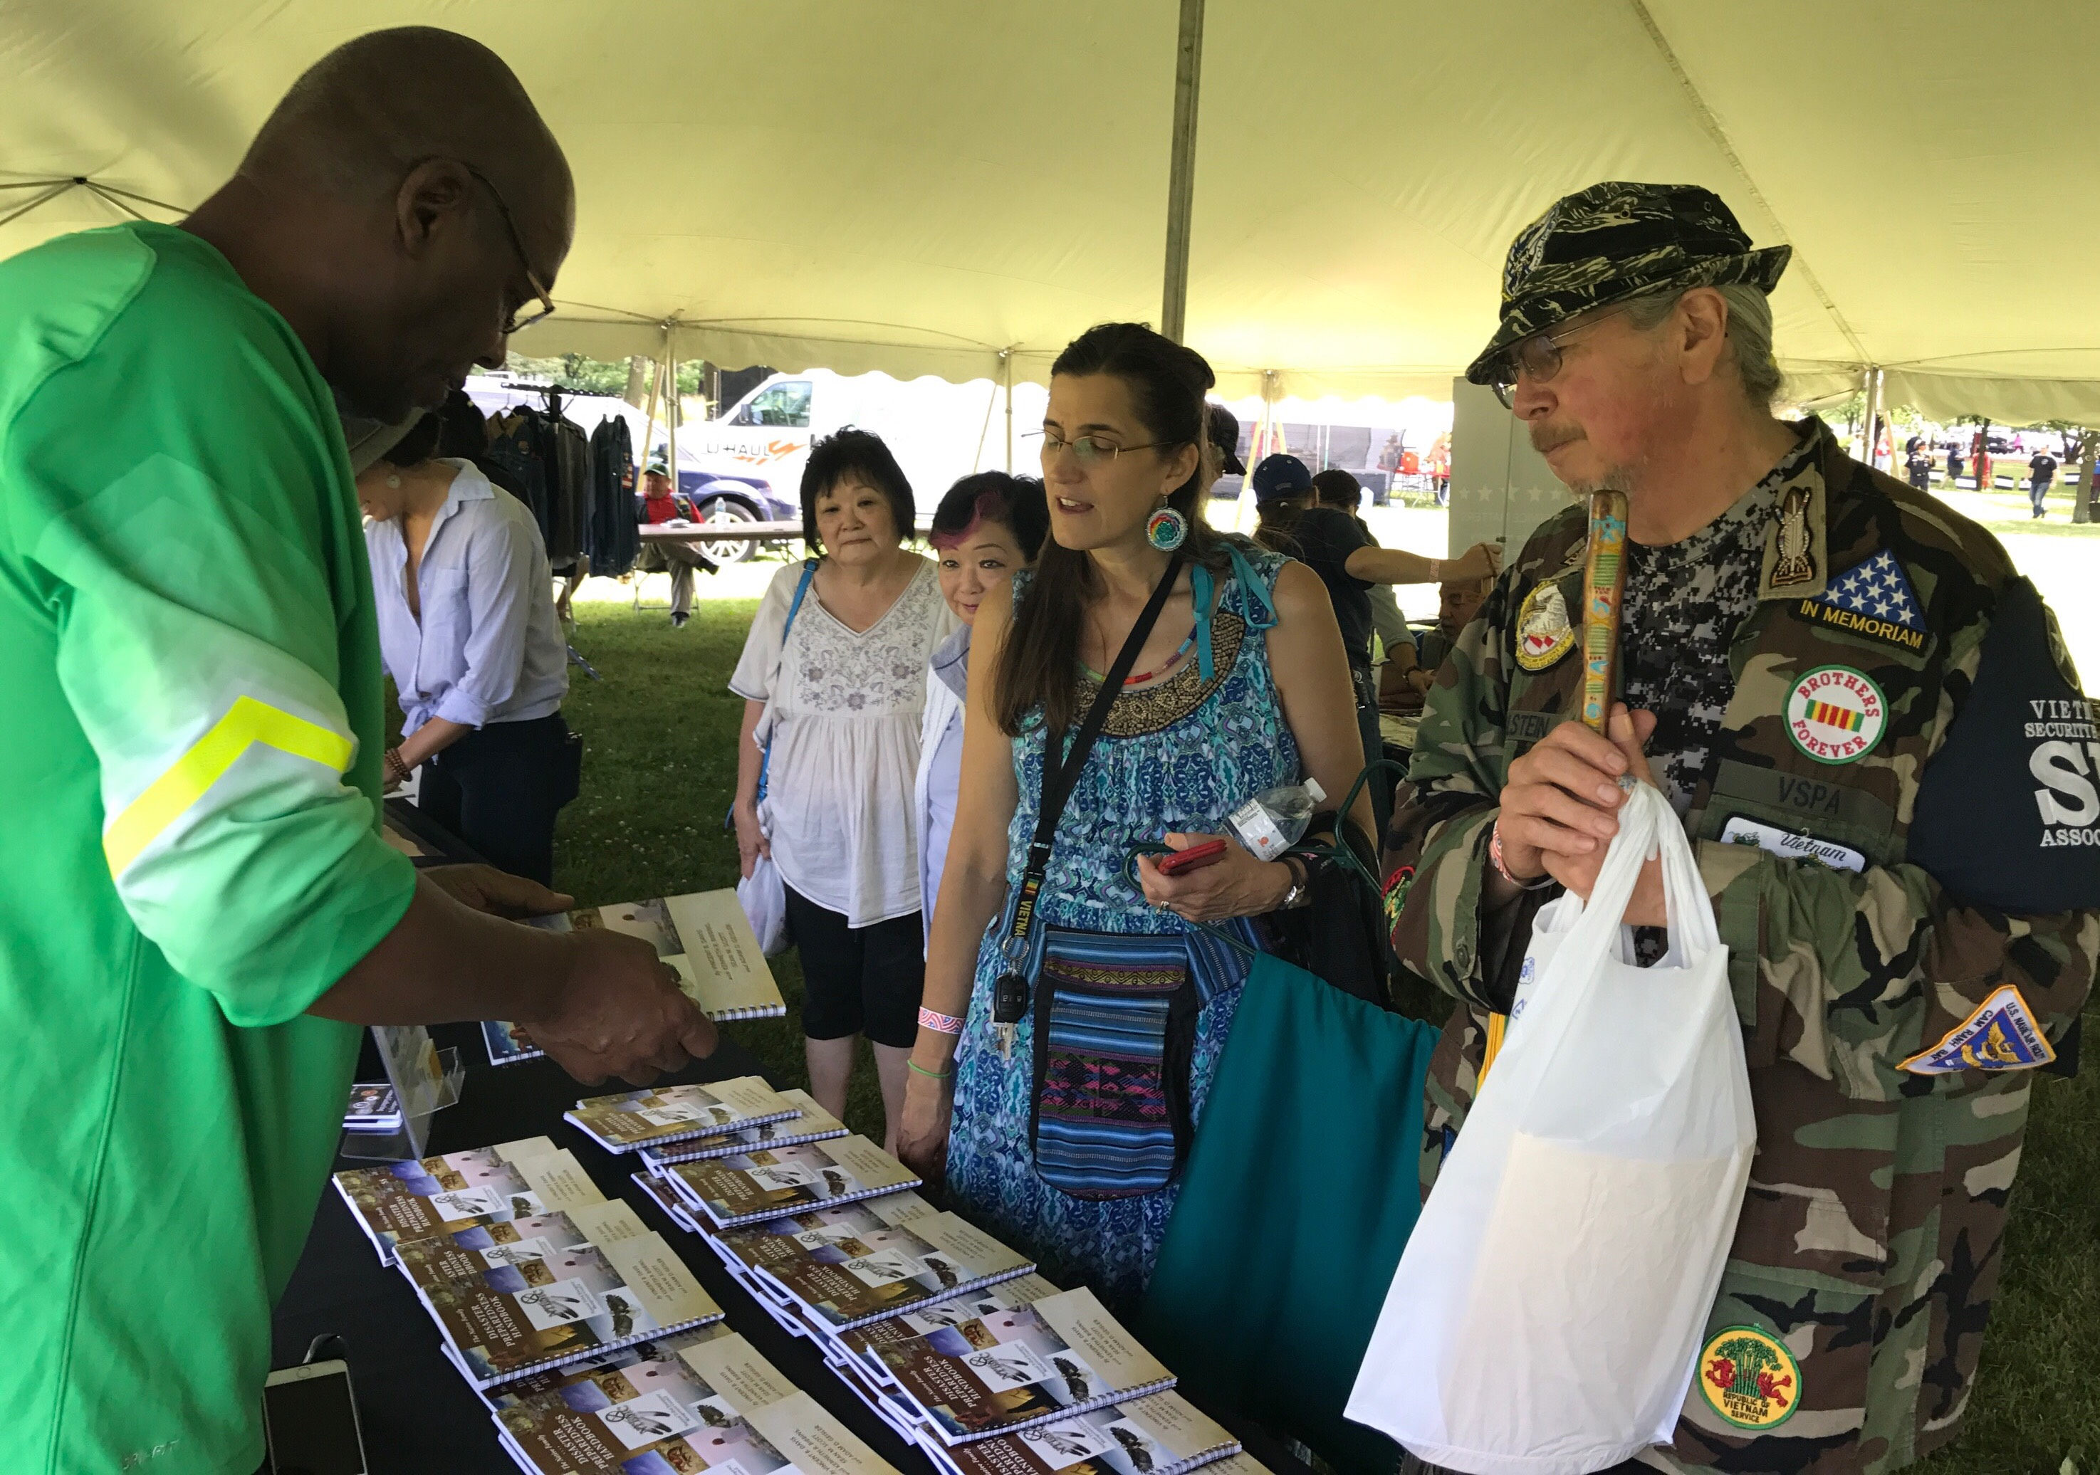
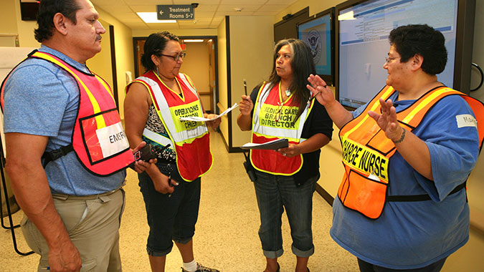

The Native Family Disaster Preparedness Handbook

Overview

Preparedness Matters Disaster Network

Overview

In recent years there have been more than 1,000 Federal disasters declared in the U.S., with hundreds of smaller but equally devastating incidents occurring daily. The 2017 disaster season saw a record number of wildfires, floods, hurricanes, tornadoes, and other catastrophes across the nation.
With the growing occurrence of natural and human-caused disasters, Native American and Alaska Native families are increasingly at-risk. Tribal resident’s vulnerability to fatalities, injuries, destruction of property and sacred sites, and contamination of water, soil and other resources is greater than ever before.
For Native American and Alaska Natives, there is an urgent need to prepare for disasters and emergencies. Preparing these communities is even more challenging because of limited access important information, much of which is available on the internet. Despite the plethora of information, less than ten percent of reservation inhabitants have access to the internet. To address this gap, Preparedness Matters collaborated with native organizations to develop a handbook.
Without taking minimal preparedness steps, Tribal residents will continue to suffer severe outcomes in disasters. Vulnerable populations such as the elderly, disabled, and children are even more susceptible to injuries, health crises, and fatalities.
The Native Family Disaster Preparedness Handbook was developed to help bridge the disaster preparedness gap by providing timely, culturally relevant information about risks, and practical steps Native families can take, to save lives and protect property, before, during, and after disasters.
The 66-page full color handbook was developed in collaboration with Native Public Media, National Tribal Emergency Management Council, and other partner organizations committed to improving disaster outcomes for Tribal communities. It was designed for use as a standalone family preparedness manual, or as a supplement existing preparedness training tools and materials to help Native families prepare.
Potential Handbook Users:
Individuals & Families
Tribal Emergency Managers
Tribal Community Emergency Response Teams (C.E.R.T)
Educational Institutions
Public Health Providers
Disaster Relief Organizations
Housing Authorities
As a practical tool, the Native Family Disaster Handbook is a primer of culturally relevant preparedness knowledge and tips to ensure Tribal communities are ready to care for themselves and their neighbors when catastrophe strikes.
Benefits of the Handbook:
- Explains how the disaster process works for Tribal residents
- Highlights key Tribal partners and resources and services offered
- Spiral bound to allow for easy printing of templates
- Customizable to add tribal logos and local contact info
- Contains simple all-hazards tips for what to do before, during and after a disaster
- Co-authored and endorsed by Native subject-matter-experts
About the Authors
Principal Author Vince Davis is the founder of Preparedness Matters Disaster Consulting, and a nationally recognized disaster expert. He previously authored Lost and Turned Out – A Guide to Preparing Underserved Communities (Amazon 2012) and the Emergency Communications Guidebook for Broadcasters Serving Indian Country (Native Public Media 2016) Mr. Davis is a Certified Emergency Manager with more than 30-years’ experience which includes FEMA, American Red Cross, Walgreen Co. and Sony, and Amazon. Mr. Davis is currently Director of Disaster Services at Feeding America. Co-Authors Sean Scott, (The Red Guide to Disaster Recovery) Ken Bibbins (Prep World LLC), and Adam Geisler (LaJolla Band of Indians) also made major contributions to the publication.
Our Mission and Goal
Preparedness Matters’ mission is to improve disaster literacy and foster safe outcomes for underserved communities. We believe preparedness is the key to fostering resilient communities, reducing trauma and suffering, and saving lives. Our goal is to provide the Native Handbook to all Tribal communities nationwide, as a ready resource for educating, informing, and preparing families and communities.
Through sponsorships and participation in Tribal conferences and events, Preparedness Matters has provided more than 10,000 copies of the Native Handbook to tribal leaders, emergency managers, and native stakeholders.
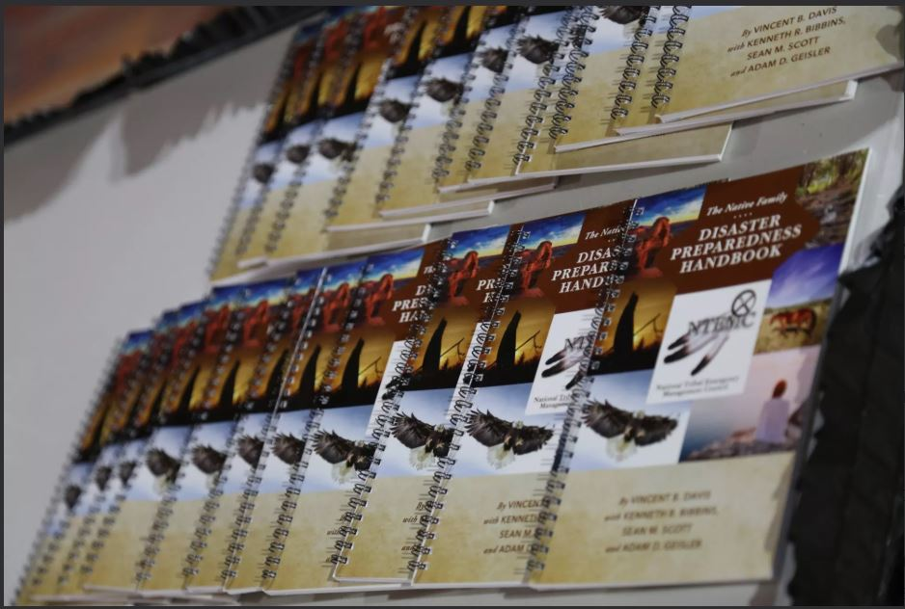

For more information contact: Vincent Davis at 760-916-4328. Or visit our websites at www.thenativefamilydisasterhandbook.com
www.preparednessmatters.net

