\\\
Pastor: Brad Cox
Worship Leader: Jeff Haney
Special Music: Wawasee Lakeside Choir
Piano: Deana Sceniak

Happenings: Wednesday evenings, Adult Bible Study 6-7
Youth Group Wednesday evening 5-6
Elder Council Meeting on Monday, May 4th at 6 pm

Pray For: Niles Family
Francis Denton
Bill Musser
Mikki Hernandez
Our Country

Scripture Reading: Hebrews 10:19-25
19 Therefore, brothers and sisters, since we have confidence to enter the Most Holy Place by the blood of Jesus, 20 by a new and living way opened for us through the curtain, that is, his body, 21 and since we have a great priest over the house of God, 22 let us draw near to God with a sincere heart and with the full assurance that faith brings, having our hearts sprinkled to cleanse us from a guilty conscience and having our bodies washed with pure water. 23 Let us hold unswervingly to the hope we profess, for he who promised is faithful. 24 And let us consider how we may spur one another on toward love and good deeds, 25 not giving up meeting together, as some are in the habit of doing, but encouraging one another—and all the more as you see the Day approaching.
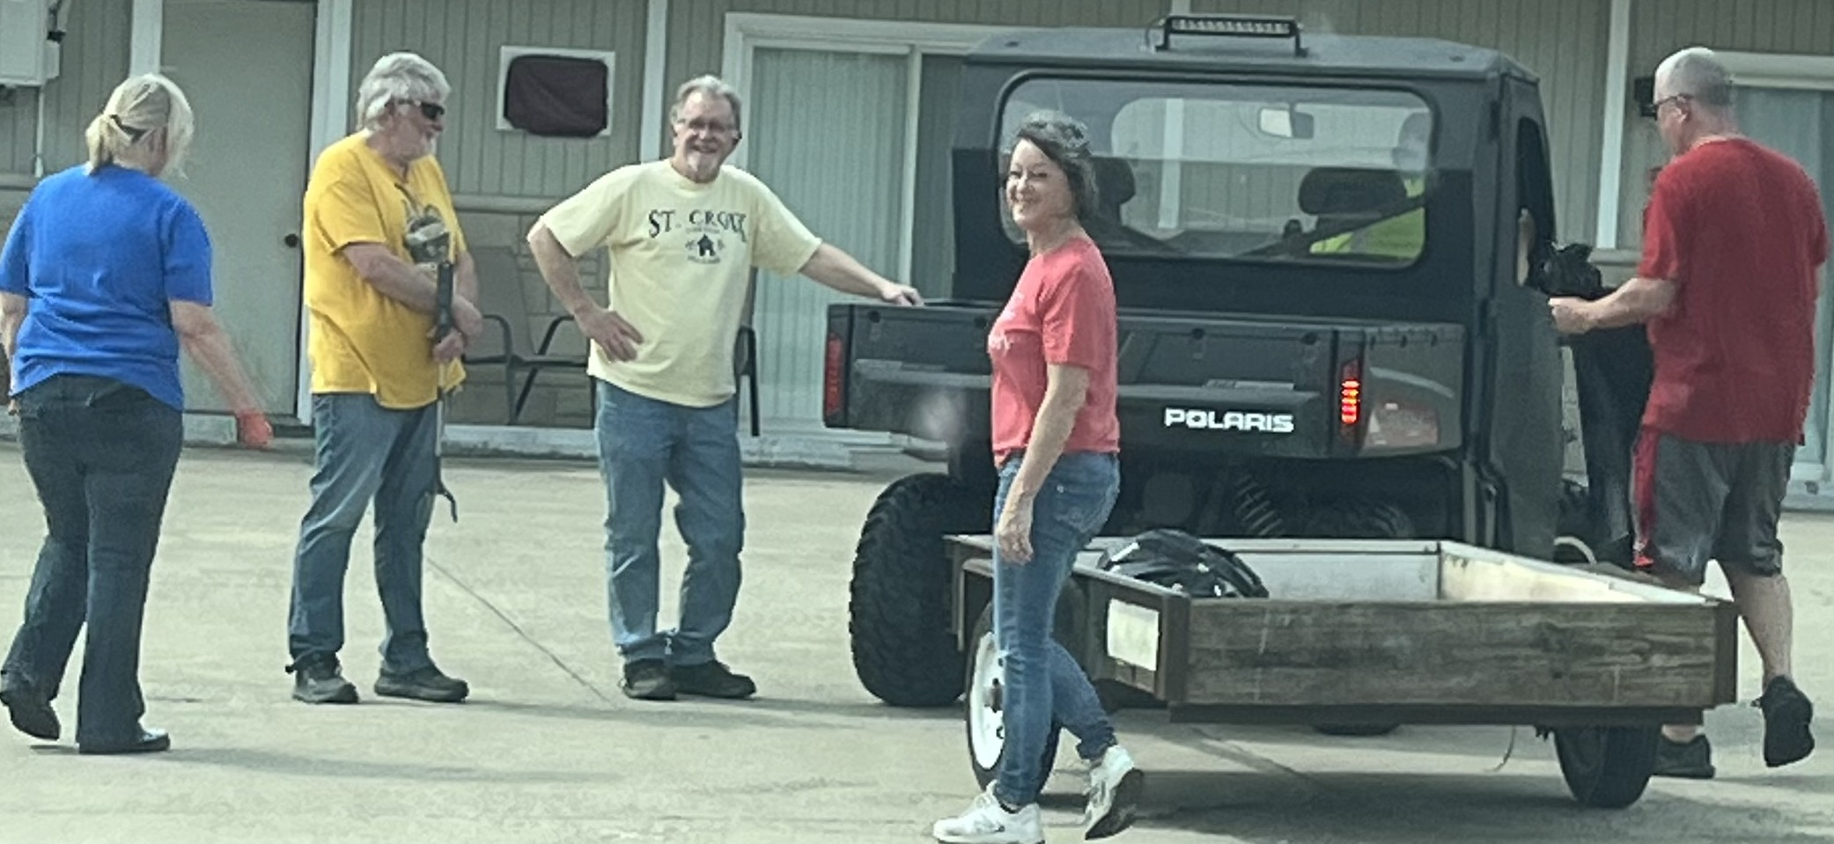
Roadside Clean up at its finest!

ORDER OF WORSHIP – 10 A.M.
May 3, 2026
Prelude Music

Call to Worship: Wawasee Lakeside Choir

Hymn: #43 All Hail the Power of Jesus Name
# 597 Take My Life and Let It Be Consecrated

Welcome and Announcements
If you are visiting here today, please fill out a visitor card and drop it into the offering plate.

Offering

Doxology

Affirmation of Faith
I believe that Jesus is the Christ, the Son of the Living God
And that He is the Savior of the world.

Prayer Time
(Children dismissed for Children’s Church)

Special Music: Wawasee Lakeside Choir

Scripture: Hebrews 10:19-25

Sermon: “A Call for Unity”

The Lord’s Prayer

Blessing

Postlude Music

Nursery: Open for children 4 and under during Worship
Coffee Time: In the Fellowship Room after the service, join us!
Sunday school: Sunday school
Church website: wawaseelakesidechapel.org


Fish Fry – October 15
Do you have your tickets?
See --Linda Stuckman



