From Scale to Trust：
How AI and Networks Reshape Modern Economy and Human Connections

By

Zirui Fan

Scholar of Tomorrow Economics Paper Competition

25 August 2026

Abstract
This essay will explore how much the contemporary economies are influenced by networks instead of markets and evaluate whether human relationships can become economically significant as artificial intelligence becomes widespread. The study shows that although networks have reshaped the modern economy to a significant extent, market factors such as the price mechanism continue to play an important role in some specific contexts. In addition, there exists a complementary relationship between human connections and AI. Therefore, the advent of the AI era has not diminished the economic value of human connections. Instead, it has highlighted their economic significance as screening and assurance mechanisms. Finally, this essay suggests that individuals, businesses and policy makers should take effective actions to fully integrate the advantages of networks and AI technologies and build a more resilient economy.

I. Introduction
Over the past two decades, online platforms have emerged as vital intermediaries for resource allocation in the digital economy, with businesses and industries relying heavily on network effects to drive value expansion. The term network effect illustrates that an Internet user’s satisfaction of joining one platform will depend on the number of users on the other side of this platform (Beck). More recently, artificial intelligence (AI) is further altering the ways in which information is generated, verified and transmitted. This essay argues that, although the market continues to play a role in price determination and resource allocation, networks have fundamentally reshaped the modern economy to a significant extent. In a world increasingly influenced by AI, human connections will become more important, because their economic role has shifted from transmitting information to serving as the cornerstone for establishing trust and facilitating complex collaboration.

II. Market and Networks on Modern Economy
The modern economy is largely shaped by networks. In the one-sided market model, consumers and firms engage in direct transactions determined by market prices. In contrast, the platform economy is defined as a two-sided market, where two groups of agents realize interactions through an intermediary. In addition, the value of a platform to any given user depends on the size of its user base, because more buyers attract more sellers and vice versa in a self-reinforcing cycle. Therefore, network effects have become the dominant motive in industries where the interdependence between different sides and where platform’s marginal costs of adding participants are low can generate strong market scales. The emergence of digital markets has further led to a dramatic increase in business scalability and networks (Soares and Nieto-Mengotti). According to Figure 1, business e-commerce sales across 45 economies reached $28 trillion in 2024, with the aggregate sales index growing from 100 in 2016 to 214 by 2024. This expansion confirms that networks contribute to a large share of modern economic activities.
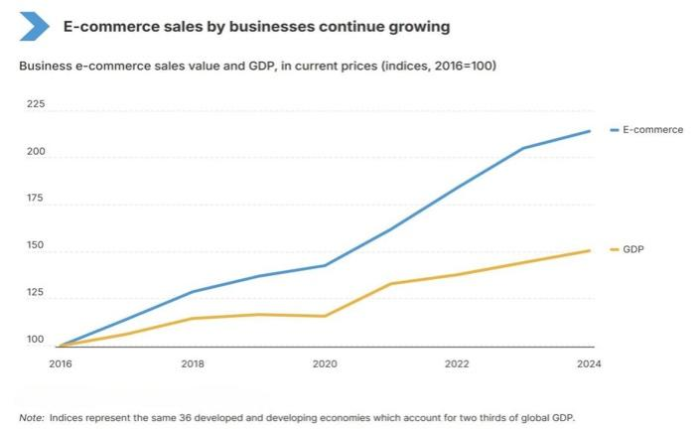
Figure 1: E-commerce sales by businesses continue growing (UNCTAD)
(Source: unctadstat.unctad.org/insights/theme/260)
Nevertheless, the multi-homing behavior of platform users means that the modern economy remains subject to certain market forces. Multi-homing refers to the situation where economic agents choose to join two or more similar platforms simultaneously. Under a multi-homing model, agents can compare the costs of accessing different platforms while keeping enjoying network effects from large platforms. Consequently, to attract more users, platforms will employ competitive tactics, like subsidies and lowering commissions or subscription fees. This shows that in the cases where users are able to multi-home, pricing mechanisms are a very important determinant of their ultimate decision, as well as the attractiveness of network effects (Alekseev).
In conclusion, networks have radically transformed the logic of operation of the contemporary economy, although it has not entirely supplanted the traditional market forces. Thus, networks and markets are layered. Networks are best suited to matching and scaling where standardization is key and markets to exchange where differentiation and complexity reigns supreme.

III. The Importance of Human Connections in the Age of AI
III.1 The Complementary Relationship Between AI and Human Connections
There is increasing evidence that AI and human skills are complements. In economics, two factors of production are complements if an increase in the use of one increases the demand for the other. Fan et al. present firm-level data from China demonstrating that AI investment boosts total factor productivity mainly by improving product competitiveness and the human capital structure. This suggests that the productivity gains from AI rely on complementarity with human skills rather than being standalone. According to a growth theory model, Gomes also highlights that continuous growth in productive efficiency relies on the synergy between AI growth and human capital accumulation. Moreover, the difference between substituting humans in routine tasks and augmenting human capabilities in complex situations where human discretion is essential suggests that AI's effect on human connections depends on the nature of the task (Braathen and Findsrud). In tasks requiring judgment, empathy or discretion, such as healthcare, law and education, AI does not replace humans but enhances them. For instance, in telemedicine, AI can analyse patient information, but doctor-patient trust affects compliance and treatment outcomes. As a result, AI enhances individual abilities, and these abilities make human connections more trustworthy and meaningful. Thus, human relationships become more significant not in spite of AI, but partly due to AI enhancing the human judgment component of trust-based relationships.
III.2 How Do Human Connections Become More Important
The economic importance of human connection is becoming increasingly significant in settings that depend on trust and a high level of judgement with regard to the progressive increase of prevalence of AI generated information. In an experiment in Germany, people were less likely to believe news sources when they knew it was AI-generated, especially when it came to politics (Nanz et al.). This experimental finding suggests that human authorship has more credibility than AI authorship in news production. Based on the data shown in Figure 2, while 76% of respondents trust businesses in the technology sector, only 50% express comparable trust in artificial intelligence itself. This gap reinforces the finding that people place greater trust in human institutions than in the technology they produce. This presents the possibility that when users cannot directly assess the reliability of AI-generated outputs, they might turn to human intermediaries due to the credibility advantage of human sources over AI sources among humans’ current credibility criteria. Therefore, as a mechanism for screening and assurance, human connections have acquired significant economic importance.
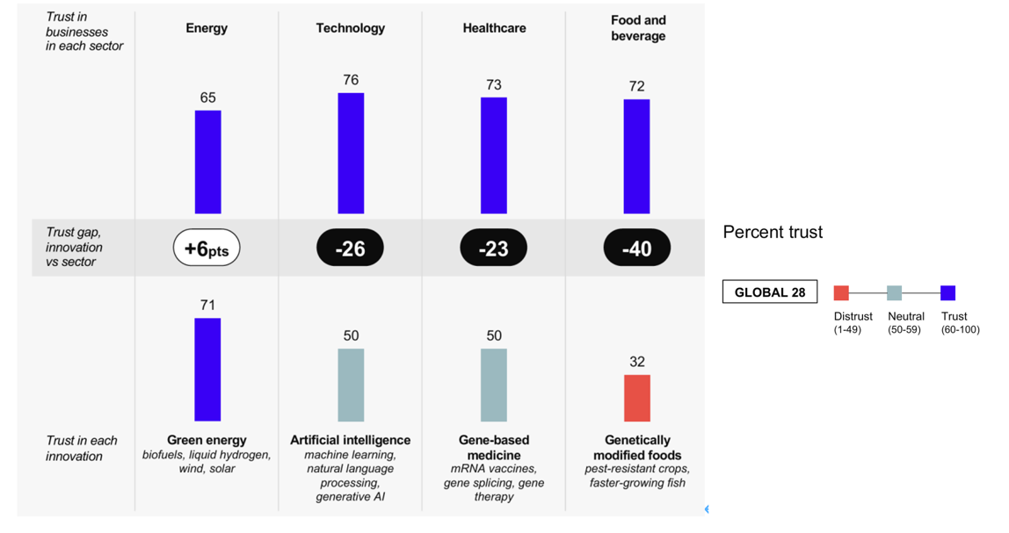
Figure 2: Trust in Industry Sectors
(Sourcewww.edelman.com/trust/2024/trust-barometer)
It is undeniable that in some data-intensive industries, the economic value of human effort may diminish. The accumulation of AI capital can reduce the income of unskilled workers or landowners depending on factor intensities, and that digital exclusion can exacerbate inequality when certain groups cannot access high-tech industries (Hazari and Mohan). Therefore, the AI era will not lead to the elimination of human connections, but a reconfiguration of their functions, including building mutual trust, managing unstructured conflicts and engaging in long-term collaboration.

IV. Evaluation and Solutions
In the AI era, multidimensional solutions are required to realise the economic value of network effects and human relationships in the modern economy. First, individuals must take control of their online reputation, participate in trusted communities and reduce their reliance on unverified AI-generated information. Secondly, companies should build trust infrastructure by introducing systems for auditing human vs AI-generated content and community governance. Companies generate economic value from AI by enabling business model themes like novelty, complementarity and lock-in through positioning data network effects within their business model architecture (Costa-Climent). But this value creation needs to be founded on trustworthy audit and governance systems, otherwise the loss of user trust would undermine the lock-in effects that the business model themes are supposed to guarantee. The workflows should also be designed by firms in a manner that can facilitate collaboration between human and AI, incorporating the efficiency of AI automation in routine tasks and the nuance of human judgment in exceptions and strategic decisions.
Thirdly, regulators and authorities need to set clear guidelines on issues like AI content identification, data privacy and algorithmic transparency. These would reduce the information verification costs to users and enhance accountability of digital interactions, at least in the short term. Additionally, policies are to promote digital literacy initiatives that educate users about how to recognize AI-generated contents. Figure 3 shows that although 46 countries have attained Tier 1 status, there are still many countries that are constructing the institutional trust infrastructure required to make these policies effective. This demonstrates the need for users or the overall society, viably through the assistance of external tools or one's own abilities, to develop judgment capability to distinguish between AI-generated and human-written content to some degree since it represents the infrastructure that offers the foundation of bigger network economies. Consequently, this can result in a stronger economy and increased trust in AI systems by people in the long-term due to such policies.
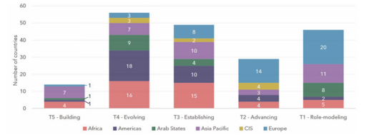
Figure 3: Tier performance, by region (ITU)
(Source: www.itu.int/en/ITU-D/Cybersecurity/Pages/global-cybersecurity-index.aspx)
V. Conclusion
To conclude, despite the fact that markets remain to be crucial in pricing and resource allocation in various specific situations, networks have already transformed the contemporary economy in a significant manner. In addition, human relations have become the foundation of establishing trust between people and long-term cooperation in trust-sensitive and judgment-intensive economic processes, whereas their importance is likely to decrease in highly standardized and data-intensive processes where AI technologies are slowly replacing routine information exchange. Ultimately, different economic actors can attain a more resilient modern economy by capitalizing on the benefits of networks and human connections.

References
Alekseev, Afanasii M. The Evolution of Platform Competition Models: Achievements and Challenges. 2025, econpapers.repec.org/article/snrmdrcmp/v_3a19_3ay_3a2025_3ai_3a5_3ap_3a124-137.htm. Accessed 15 Aug. 2026.
Beck, Roman. "Network effect theory." The Network (ed) Economy: The Nature, Adoption and Diffusion of Communication Standards (2006): 41-78.
Braathen, Petter, and Rolf Findsrud. “A Typology of Human–AI Value Cocreation.” Journal of Creating Value, vol. 11, no. 2, Nov. 2025, pp. 238–52. https://doi.org/10.1177/23949643251389315. Accessed 15 Aug. 2026.
Costa-Climent, Ricardo. “On How Firms Can Use Artificial Intelligence for Economic Value Creation : A Business Model Approach.” DIVA, 2024, urn.kb.se/resolve?urn=urn:nbn:se:uu:diva-540703. Accessed 15 Aug. 2026.
Edelman. 2024 Edelman Trust Barometer. Edelman, 2024, www.edelman.com/trust/2024/trust-barometer. Accessed 15 Aug. 2026.
Fan, Chen, et al. “Artificial Intelligence and Enterprise Total Factor Productivity: A Human Capital Requirement Perspective.” International Review of Economics & Finance, vol. 104, Sept. 2025, p. 104661. https://doi.org/10.1016/j.iref.2025.104661. Accessed 15 Aug. 2026.
Gomes, Orlando. “The Human Capital — Artificial Intelligence Symbiosis and Economic Growth.” De Economist, vol. 173, no. 2, May 2025, pp. 331–65. https://doi.org/10.1007/s10645-025-09452-y. Accessed 15 Aug. 2026.
Growiec, Jakub, et al. “Workers’ Incentives and the Optimal Taxation of AI.” Economics Letters, vol. 266, May 2026, p. 113062. https://doi.org/10.1016/j.econlet.2026.113062. Accessed 15 Aug. 2026.
Hazari, Bharat, and Vijay Mohan. “Exclusion and the Growth of AI Technology: A Trade-theoretic Analysis.” Frontiers in Human Dynamics, vol. 6, May 2024, https://doi.org/10.3389/fhumd.2024.1203664. Accessed 15 Aug. 2026.
ITU. Global Cybersecurity Index 2024. International Telecommunication Union, 2024, www.itu.int/en/ITU-D/Cybersecurity/Pages/global-cybersecurity-index.aspx. Accessed 15 Aug. 2026.
Li, Qin, et al. “Coordinated Incentives in AI-generated Misinformation Governance.” Humanities and Social Sciences Communications, Aug. 2026, https://doi.org/10.1057/s41599-026-08630-w. Accessed 15 Aug. 2026.
Nanz, Andreas, et al. “AI In the Newsroom: Does the Public Trust Automated Journalism and Will They Pay for It?” Journalism Studies, vol. 26, no. 14, Aug. 2025, pp. 1745–64. https://doi.org/10.1080/1461670x.2025.2547301. Accessed 15 Aug. 2026.
Soares, Isabel, and Manuel Nieto-Mengotti. “Network Effects on Platform Markets. Revisiting the Theoretical Literature.” Scientific Annals of Economics and Business, vol. 71, no. 4, Dec. 2024, pp. 605–23. https://doi.org/10.47743/saeb-2024-0029. Accessed 15 Aug. 2026.
UNCTAD. E-commerce sales by businesses continue growing. UNCTADstat, 2026, unctadstat.unctad.org/insights/theme/260. Accessed 15 Aug. 2026.

