开场白海报

9L韧带缩短提升术

9L Ligament Shortening Lift

Mechanism of Action

使用特质V型的双向医疗器械套针后面跟着光滑的PLLA缝合线（聚左旋童颜缝合线）通过针眼将面部的主要韧带层缩短缝合固定。缩短后的面部就回到你年轻时候的位置和状态。产生的新胶原会比你以前已经松弛的韧带更加结实致密。

This procedure requires no surgical incision. A specially engineered V-shaped bidirectional cannula is utilized to place a smooth PLLA (poly-L-lactic acid) suture through a minimal needle entry point, allowing precise shortening and fixation of the major facial retaining ligaments. By restoring the support and tension of these ligamentous structures, the descended facial soft tissues are repositioned toward their youthful anatomical location, resulting in a natural lifting and rejuvenating effect.

前3年由缝合线固定力量作用。后3-5年缝合线逐渐吸收后由PLLA产生的纤维胶原维持效果。产生的新胶原会比你以前已经松弛的韧带更加结实致密，适合面部皮肤衰老不是特别严重的群体。

Downtime: 3–5 days
Longevity: Approximately 5-10 years

原理视频
决定面部衰老很重要的因素是韧带
The facial retaining ligaments are one of the most important factors influencing facial aging.

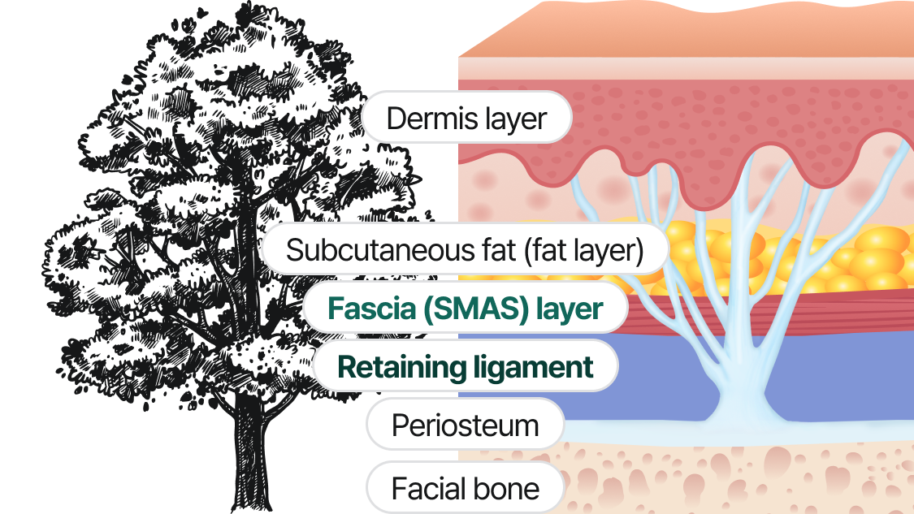

面部支撑韧带是从骨膜层发出垂直穿过面部各个层次最终到达真皮层，
Facial retaining ligaments originate from the periosteal layer, extending vertically through the various anatomical layers of the face and ultimately inserting into the dermis.

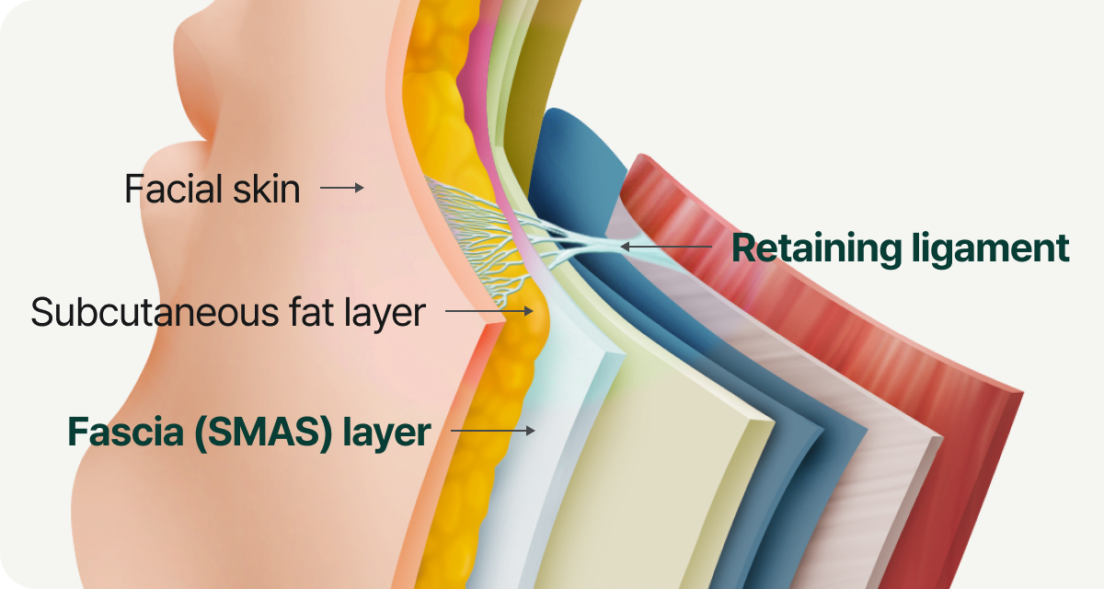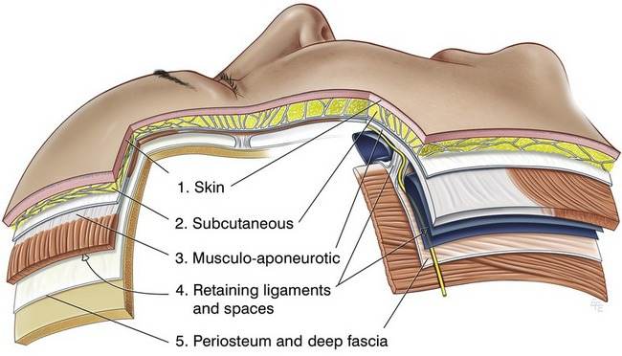

而这些维系韧带和SMAS筋膜变松变长就造成了衰老
Aging occurs when these retaining ligaments and the SMAS (Superficial Musculoaponeurotic System) become elongated and lax, resulting in soft tissue descent and loss of facial support.

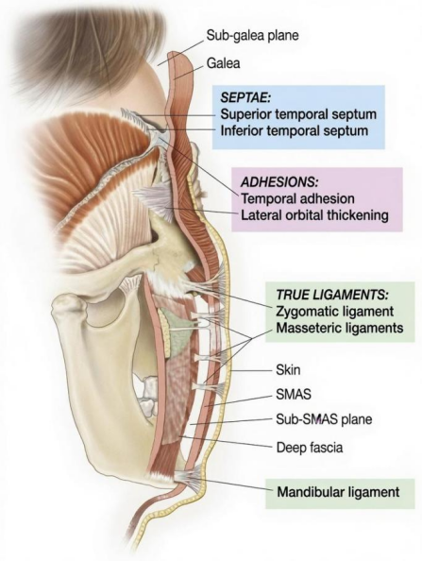

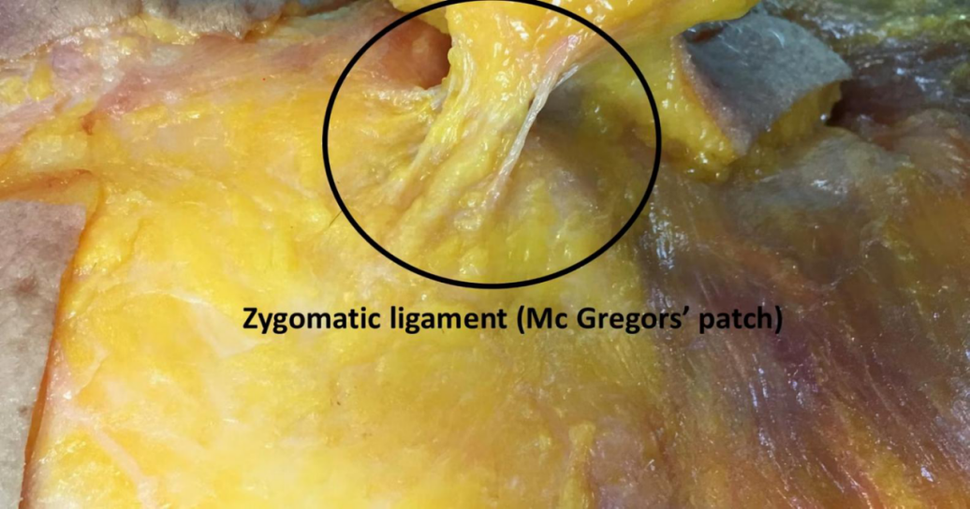

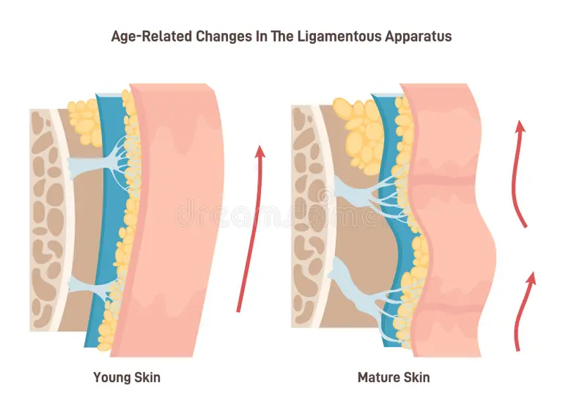
转场视频
分层
https://www.xiaohongshu.com/search_result/6a0ff9e50000000038034225?xsec_token=ABZFj2DZdgaaAMJzP-mwe6VVGpXgxG0kS4flCxVf8jZhY=&xsec_source=

AI模特

而决定我们面部衰老相关的韧带一共有9个，分别是
There are nine key retaining ligaments that play a critical role in facial aging, including:

1.泪槽韧带 Temporal Fusion Line
2颧皮韧带 Orbital Retaining Ligament
3下颌韧带 Tear Trough Ligament

4颧弓韧带 Zygomatic Cutaneous Ligament
5耳前韧带 Zygomatic Arch Ligament

6咬肌皮韧带 Masseteric Cutaneous Ligament
7耳后韧带 Mandibular Ligament

8颞融合缝 Preauricular Ligament
9眶韧带 Postauricular Ligament

My proprietary 9L Ligament Shortening Lift is performed without any surgical incisions.
而我独创的的9L韧带缩短提升术是不需要任何切口的情况下，

https://www.xiaohongshu.com/search_result/659376f4000000001d037fcf?xsec_token=ABeJd_bvjEF31sFAe7yEgVUXJb8amrFBCHZsBnv_kQCRg=&xsec_source=

使用V型的双向医疗器械套针后面跟着光滑的PLLA缝合线（聚左旋童颜缝合线）
A specialized V-shaped bidirectional medical cannula is utilized in conjunction with a smooth PLLA (poly-L-lactic acid) suture.

素材今天补

通过针眼将面部的主要韧带层缩短缝合固定。
Through needle entry points, the major facial retaining ligament layers are shortened, sutured, and secured into a more youthful position.

张院视频素材
韧带缩短后的面部就回到你年轻时候的位置和状态，维持5-10年，
Following ligament shortening and fixation, the facial soft tissues are repositioned to their younger anatomical location and contour, with results lasting approximately 5–10 years.

筋膜缩短素材+
变年轻动画特效
https://www.xiaohongshu.com/search_result/6a0ed3260000000006037423?xsec_token=ABeZNtfs_8GJVgb8Z4-L2Im-y0kWRdStGeWQX8RtEyzsI=&xsec_source=

前5年由缝合线固定力量作用。之后缝合线逐渐吸收后由PLLA产生的纤维胶原维持效果。产生的新胶原会比你以前已经松弛的韧带更加结实致密，
During the first five years, the lifting effect is primarily maintained by the mechanical support provided by the PLLA sutures.As the sutures are gradually absorbed over time, the long-term result is sustained by newly formed collagen and fibrous tissue induced by PLLA.The neocollagen generated through this process is denser and structurally stronger than the previously lax and elongated retaining ligaments.

PLLA动画素材
https://www.xiaohongshu.com/search_result/66693c750000000006007a43?xsec_token=ABorZsU4RPS2sLr0Xcn_vAtQtkKt42Oy55jsp1G9nsd8U=&xsec_source=

适合面部皮肤衰老不是特别严重的群体。
This procedure is particularly suitable for patients with mild to moderate facial aging and without severe skin laxity.

模特对比图

