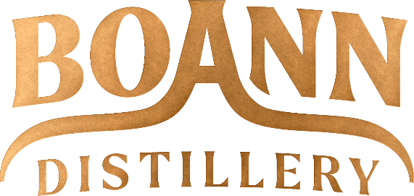

Dear Chamber Member.

We have set out the brochure in an easy-to-read format which we think will make your ordering easier by following these steps:

- Accumulate your order in the boxes beside each product in the Brochure which you wish to order.

- When you have made up your order, please e-mail it by scanned copy of brochure or directly by e-mail to :
Paddy Cooney,
Boann Distillery Limited, Lagavooren, Platin Road, Drogheda, Co. Meath,
Ireland
e-mail: paddy.cooney@boanndistillery.ie
Mob: +353 86 026 6090

Specify the company name and address for the invoice.

Please attach a delivery address, with contact name and telephone number.

- Boann will send you an Invoice for the Order, Vat and Delivery Charge by return.

- Transfer the funds to following Bank Account:
Boann Distillery Limited.
Bank of Ireland, Laurence Street, Drogheda, Co. Louth, Ireland.
IBAN: IE 25 BOFI 9033 2247 8260 96
BIC: BOFIIE2D

- On receipt of the funds Boann will ship the goods within 2 working days or goods can be collected directly from the Boann Distillery by prior arrangement.

Thank you for taking the time to read this e-mail and reviewing the Christmas Gifting Brochure.

We look forward to hearing from you.
Best regards,

Patrick J Cooney

