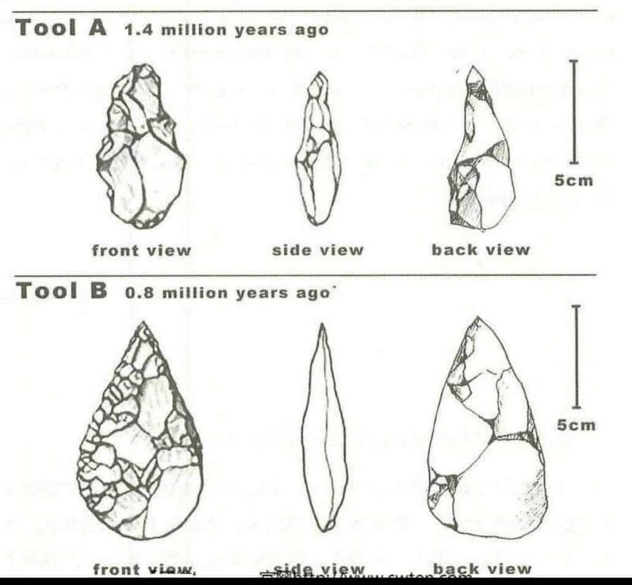

Đọc kĩ cách viết dạng describe object https://www.ieltstutor.me/blog/cach-viet-dang-mo-ta-object-ielts-writing-task-1

Given is the graph delineating the difference between tools utilized by ancient human beings 1.4 million years and 0.8 million years ago.

It can be observed from the picture that throughout the period, the tool had become sharper and more sophisticated, enabling the workers to perform tasks more efficiently.

It is clear that 1.4 million years ago, the tool was simple and resembled a natural stone. The front view demonstrates the unidentifiable shape of the implement. Moreover, a glance at the side view reveals that it was blunt and its length was approximately 8 cm.

Moving on to the Tool B, the front view of it bore a similarity to a droplet. In addition, the edge of the implement was sharper compared to the older one. Last but not least, little noticeable difference is witnessed when it comes to the back view of both tools, with the newer one being slightly larger.

