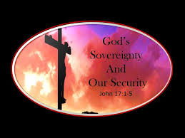\\\
Happenings: Christmas Eve service 6:30-7pm. Bring friends and family and celebrate the birth of Jesus!

Pray For: Sally Henderson
Chuck Rush
Mary Walker (Death)

Scripture Reading: Luke 2:8-20
8And there were shepherds living out in the fields nearby, keeping watch over their flocks at night. 9 An angel of the Lord appeared to them, and the glory of the Lord shone around them, and they were terrified. 10 But the angel said to them, “Do not be afraid. I bring you good news that will cause great joy for all the people. 11 Today in the town of David a Savior has been born to you; he is the Messiah, the Lord. 12 This will be a sign to you: You will find a baby wrapped in cloths and lying in a manger.”13 Suddenly a great company of the heavenly host appeared with the angel, praising God and saying,14 “Glory to God in the highest heaven, and on earth peace to those on whom his favor rests.”
15 When the angels had left them and gone into heaven, the shepherds said to one another, “Let’s go to Bethlehem and see this thing that has happened, which the Lord has told us about.”
16 So they hurried off and found Mary and Joseph, and the baby, who was lying in the manger. 17 When they had seen him, they spread the word concerning what had been told them about this child, 18 and all who heard it were amazed at what the shepherds said to them. 19 But Mary treasured up all these things and pondered them in her heart. 20 The shepherds returned, glorifying and praising God for all the things they had heard and seen, which were just as they had been told.
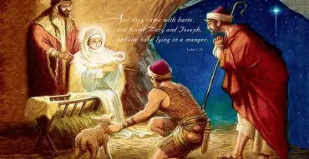

Pastor: Brad Cox
Worship Leader: Jeff Haney
Special Music: Charles Cotton,
Cindy Chadwell, Chris Gortney.
Piano: Deana Sceniak

ORDER OF WORSHIP – 10 A.M.
December 21, 2025

Prelude Music: Charles Cotton

Call to Worship: Psalm 80:19 Restore us, Lord God Almighty;
make your face shine on us, that we may be saved.
Prayer
Hymn: #251 It Came Upon a Midnight Clear

Welcome and Announcements
If you are visiting here today, please fill out a visitor card and drop it into the offering plate.
Thank you to Alyssa Custer for the youth group Christmas evening of games and fellowship!

Special Music: Cindy Chadwell

Offering

Doxology

Affirmation of Faith
I believe that Jesus is the Christ, the Son of the Living God
And that He is the Savior of the world.

Prayer Time
(Children dismissed for Children’s Church)

Special Music: Chris Gortney

Scripture: Luke 2:8-20

Sermon: “Sharing Christmas”

Special Music: Cindy Chadwell

The Lord’s Prayer

Blessing

Postlude Music: Charles Cotton

Nursery: Open for children 4 and under during Worship
Coffee Time: In the Fellowship Room after the service, join us!
Sunday school: Sunday school
Church website: wawaseelakesidechapel.org


Fish Fry – October 15
Do you have your tickets?
See --Linda Stuckman



