https://todoist.com/app/upcoming/task/5319941279

Describe a tall building in your city you like or dislike
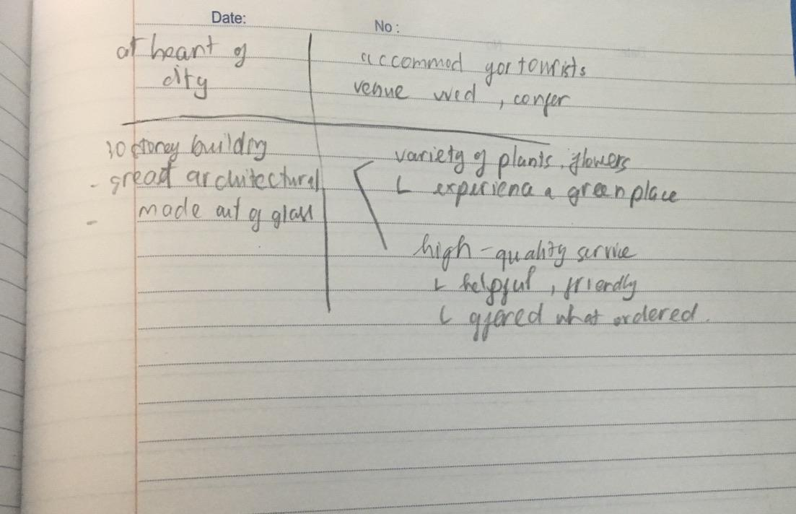

You should say
Where it is?

- Well, I want to talk about a high-rise building that I have an appreciation for in my hometown.

If my memory serves me right, it is located right at the heart of my city and can be easily accessed from all directions.

What it is used for?
- The building is a common accommodation for tourists visiting the city and it also serves as a venue for weddings and conferences

What it looks like?
- Basically, it is a 30-storey building with a great architectural design. In fact, the first thing that caught my attention is the fact that the outer of the entire building is made out of glass.

And explain why you like or dislike it?
- The reason why it triggers my interest is that it has a variety of plants and flowers around it. I went there once and was amazed by the number of flora in the back of the building. To be honest, that was the first time I experienced a green place in the city center. On top of that, the building also has high-quality service as the staffs were helpful, friendly, and I was offered what I ordered within a few seconds.

bố cục tốt rồi nhé có thể tham khảo thêm cần bám sát vào cue card để trả lời:
- where it is what it is used for
  - I’m going to talk about a building called..... which is located in the center of .... close to where I used to work. In fact, it's the tallest building in the city, with about 50 floors.
- what it looks like
  - It looks more like a ‘corn’. Therefore, given its distinctive design, this building really stands out from all the buildings in town. My first impression of the interior of the building was that it was really clean and spacious with so many fully furnished office units and rooms for meetings. >> IELTS TUTOR hướng dẫn Từ vựng topic Housing & Architecture IELTS
- And explain why you like or dislike it
  - 2 reasons
    - Main idea 1: It has become a famous landmark in the city.
      - Supporting idea: it's just a huge glass tower, and you can see it as you approach my city, and it's an easy place to meet people because it's so distinctive and easy to find.
    - Main idea 2: The building has spectacular views of the city with the best vantage point in my city
      - Supporting idea: there are no walls, only huge windows, so you can look out over the city in any direction. I'd recommend anyone who visits... to go there and experience the view.

