Welsh Triathlon Association Membership – Step by Step Instructions
In order to be a part of Swansea TriSharks you will need to affiliate with the Welsh Triathlon Association.

Membership and payment needs to be done online.

Why become a member?
- Being a member of the Welsh Triathlon Association will allow you to train and compete with Swansea TriSharks
- Public Liability Insurance whilst training and racing
- Worldwide Personal Accident Insurance
- Free Accident Legal Service
- No day license fees
- TriNews magazine
- British Triathlon Annual Handbook
- Eligible to apply for GB Age Group Teams
- Eligibility to compete for GE British and Welsh Triathlon
- Automatic entry into Welsh Grand Prix Series

To do this, please follow the following steps
- Visit the following Website - http://www.welshtriathlon.org/membership
- Click the Membership Tab, then click Join us
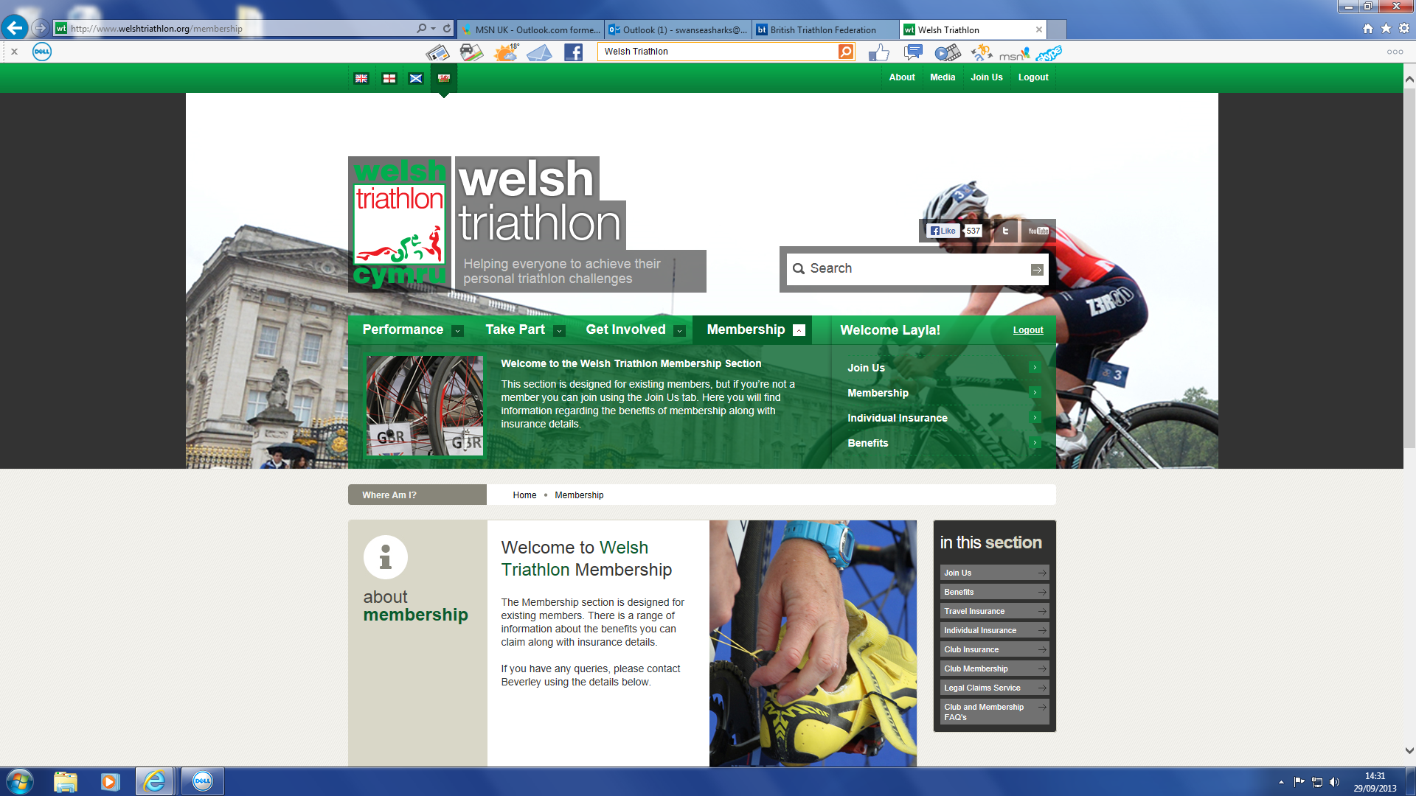
2.
Click ‘Membership’ then ‘Join us’
1.
www.welshtriathlon.org

- Select your Date of Birth
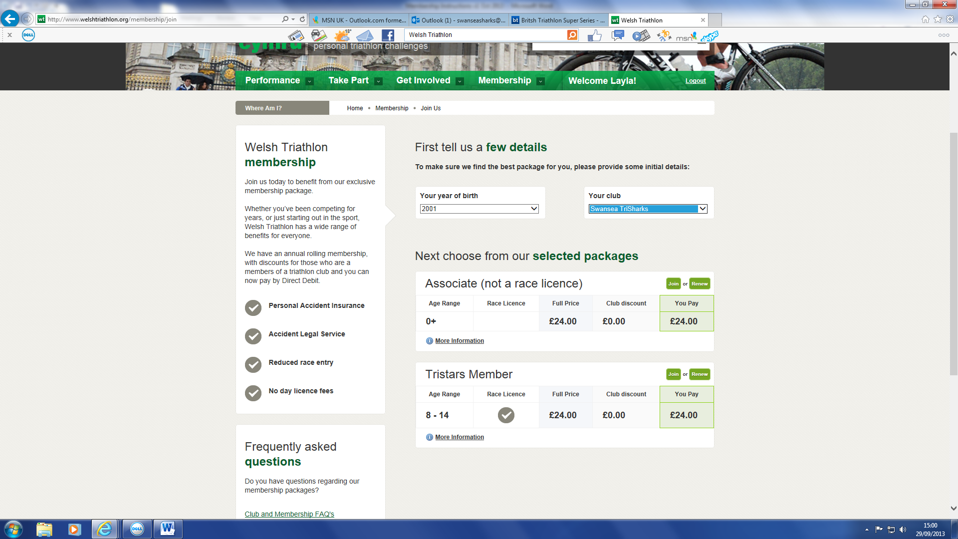
5.
Select the option most relevant and click ‘join’
4.
Select your Club
3.
Select you DoB
- Select your Club – Swansea TriSharks
- A couple of options will appear, depending on your age. Always select the one which has ‘Race Licence’ ticked e.g. TriStar; Junior Member; Individual Member, unless you are just a committee member, where you will need to select ‘Associate’. Then click ‘Join’.
- This will take you to the ‘Registration’ page. Please fill out steps 1-6. Make a note of your password from Step 1. Step 5 asks if you would like to renew via Direct Debit, if you choose ‘Yes’ you will receive a further £2 discount.
- Once the transaction is complete make a note of your Membership No.
- To log on to your membership account, please use your membership No. and your password from Step 2.
- Email me on Swanseasharks@hotmail.co.uk to inform me of your registration so I can update Swansea TriSharks Membership System.
Any problems please phone me on 077888 54832.

