The maps show the change of Pentland from 1980 to 2007. Summarize the information by selecting and reporting the main features, and make comparisons where relevant.
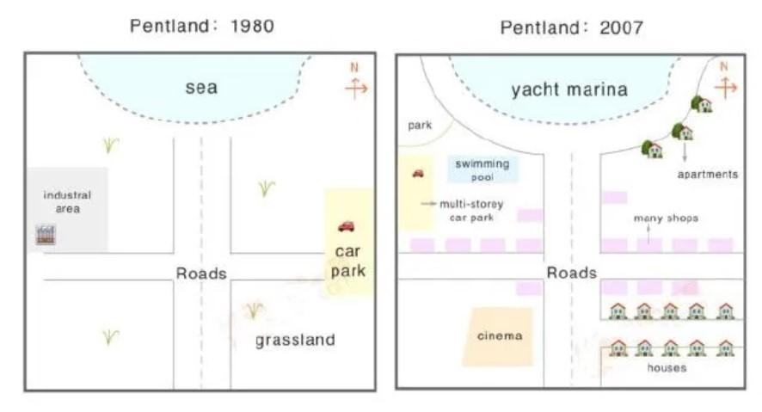
Tham khảo cách triển khai bài nhé: https://www.ieltstutor.me/blog/map
The maps illustrates modifications to the town of Petland between 1980 and 2007.
Overall, it is readily apparent that there was a lot of residental and commercial development over the period including the construction of yacht marina, shops, houses and recreational facilities.
In 1980, Petland consisted mainly of grasslands to the south, two main intersecting roads, an eastern car park, an industrial area in the west and the sea to the north. In 2007, all have been replaced or relocated. The coast was converted into yatch marina with the addition of road, while a park has been built opposite to the seaside apartments. ⇒ Bố cục xem lại nha thường body 1 viết về map 1, ở đây map 1 không đến nỗi thiếu để mình chỉ viết 1 đoạn ngắn củn như vậy nha
In 2007, the roads have been lined with shops and the car park have been moved from the eastern to the western end of the town with the buidling of additional floors. In the northwest, industrial had been demolished, whereas there are the addition of a new swimming pool. In the south, grasslands made way for a cinema to the west and there are many residental houses have been built on either side of a new eastward avenue.
=> Chia thì chú ý vào nhé. Bài này chỉ nguyên lỗi sai thì thôi cũng đã đủ làm điểm mình mất đi rất nhiều rồi

lưu ý đọc kĩ về bố cục nhé
- Overall: Pentland was a more residential area after roughly a quarter-century in 2007 while it was an industrial site in 1980
- Phân thành 2 đoạn thân bài:
  - Body 1: map 1 mô tả từ bao quát đến chi tiết, từ bên phải qua bên trái
    - Grassland was on the southeast corner, whereas car parking was on the east side >> IELTS TUTOR hướng dẫn Phân biệt However/ Whereas
    - There were perpendicular roads, which divided the region to four parts
    - On the north side was a half-cup shape sea.
    - The only major establishments in Pentland were industries, which were located towards the west.
  - Body 2: map 2: cũng theo đúng bố cục như đã mô tả ở body 1 để đồng nhất:
    - Houses area took the place of grassland whereas, opposite the road developed cinema
    - Alongside the road, many shops opened—apparently built on the northeast side. >> IELTS TUTOR hướng dẫn Cách dùng alongside tiếng anh
    - The sea was later known as yacht marina and surrounded new road developed in the northwest corner new park build.
    - Car parking shifted below to park, which was multi-storey. Next to it, a swimming pool was created.

