WORKSHOPS BY MICHAEL BEEDENBENDER
WEDNESDAY, AUGUST 12, 2026 REGISTRATION FORM
FOLK ART CENTER – BLUE RIDGE PARKWAY
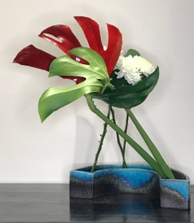
WORKSHOP #1 - 10:30 AM – 12:30 PM
“LEAVES AND ONE FLOWER”
COST - $50
Lunch 12:30 until 1:30

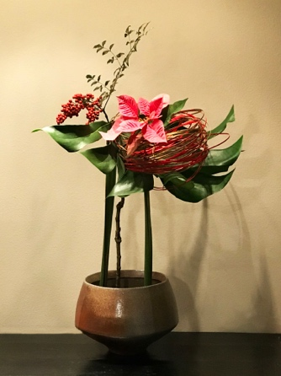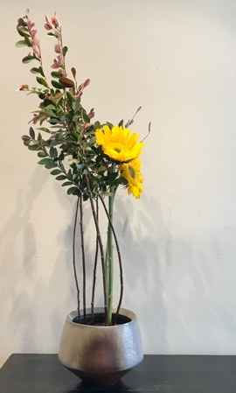
WORKSHOP #2 – 1:30 – 3:30 PM
“SHOWING LINES AT BASE”
COST - $50

OPEN TO ALL IKEBANA INTERNATIONAL MEMBERS
OPEN TO ALL SOGETSU MEMBERS that are not I.I. members AFTER JULY 9, 2023

LUNCH CHOOSE ONE: COST $20
______Turkey croissant w/lettuce, tomato, cheese, mayo, chips, cookie, water
______Veggie croissant w/hummus lettuce, tomato, cucumber, cheese, chips, cookie, water

NAME OF ATTENDEE____________________________________________________
EMAIL:______________________________ PHONE:__________________________
WORKSHOP #1 $_____________
WORKSHOP #2 $_____________
LUNCH $_____________
TOTAL AMOUNT ENCLOSED $_______________________
Make check payable to: Ikebana International AVL Chapter 74
Mail to: Joyce Gayles, 24-A Trillium Ct., Asheville, NC 28805
CHECKS MUST BE RECEIVED BY July 27TH DEADLINE

