Asheville Chapter #74 Annual Luncheon & Demonstration
August 11, 2026 Registration

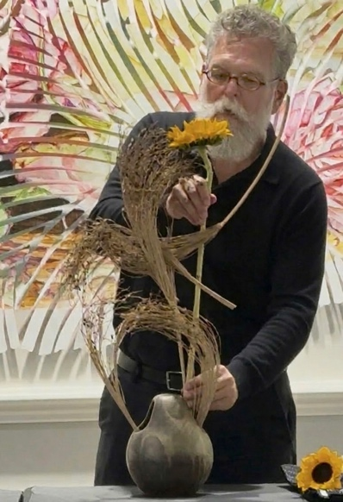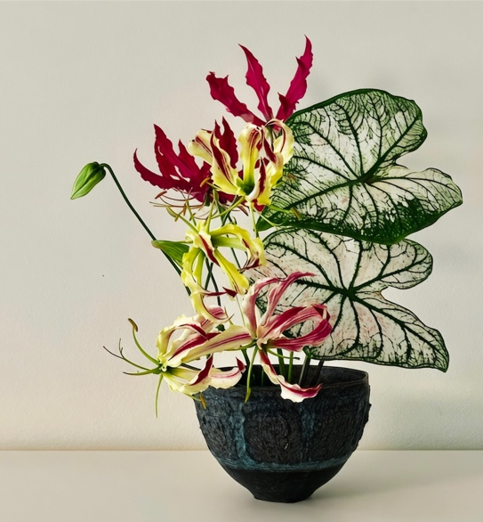

"Celebration of Sogetsu’s Past 100 Years"
Michael Beedenbender – Riji of Sogetsu School of Ikebana

DEMONSTRATION, LUNCHEON AND GINZA
Country Club of Asheville
170 Windsor Road, Asheville, NC 28804

9:30 AM– Ginza/Silent Auction of Japanese and Ikebana Items
10:30 AM – Demonstration by Michael Beedenbender
12:30 – Lunch is served 1:30 Live Auction
COST: $60 PER PERSON
MEMBERS AND GUESTS ARE WELCOME

Name of Attendee_______________________________________________________________
Email:______________________________________ Phone:____________________________
Lunch Choice (Choose One)
______Salmon with Lime Hollandaise Sauce
______Honey Pecan Chicken
______Vegetarian Risotto
______Vegan Tofu Stir Fry
Make check payable to: Ikebana International AVL Chapter 74
Mail to: Joyce Gayles, 24-A Trillium Ct., Asheville, NC 28805
CHECKS MUST BE RECEIVED BY July 27TH DEADLINE

