IELTS WRITING ANSWER SHEET

- Dàn bài mà em lập cho đề này

Bài viết của em ( luôn nhớ max 300 words cho Task 2, max 160 words cho Task 1)

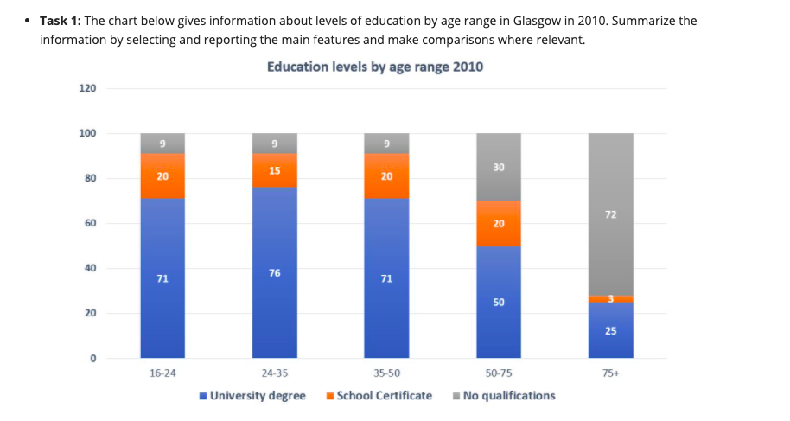

LẦN 2

Given is the chart illustrating levels of education by age range in Glasgow in 2010.
Overall, the majority of individuals with university degrees was younger, whereas the figure for no qualifications was the highest in older groups.
It can be seen that the proportions of people aged 24-35 with university degrees was the highest, by 76%, then the proportions of residents aged 16-24 and 35-50 were just the same as 71%. Additionally, the percentages of residents with no qualifications by aged 16-50 were equal with 9%.
The data indicates that those who had academic degrees by citizens aged 50-25 was double as much as those of people aged over 75, 50% and 25% respectively. Besides, it was quite the reverse that the figure for individuals aged over 75 was eight times higher than the percentages of three younger groups, by 72% and 9%. Although the figure for residents aged 16-75 with school certificates accounted for almost nearly the same as 15% and 20%, the proportion of the elderly aged over 75 was the lowest, by 3%.
→ Chia lại nhóm số liệu, không có miêu tả như bài được, mình gộp hết như vậy rồi sao người đọc hiểu số nào là của nhóm nào được

