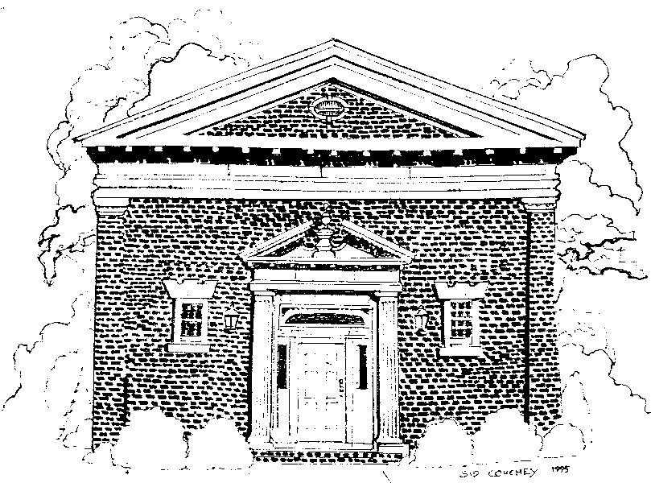

**PAINE MEMORIAL FREE LIBRARY 2025-2026 STORY HOUR REGISTRATION FORM**

**FOR CHILDREN AGES 3-5**

**September 12th _ June 12th Friday Mornings: 10:00 am -11:00 am**

**The Story Hour Program Follows the Willsboro Central School District Calendar**

**Child’s Name** ___________________________________________ **DOB** ______________________________________

**Parent’s/Guardian’s Name(s)** _____________________________________________________________________

**Address** _____________________________________________________________________________________________

**Telephone # (day)** ___________________________________ **(evening)** __________________________________

**Email Address** ______________________________________________________________________________________

**Emergency Contact Name** ___________________________________ **Tel.** _________________________________

**Please provide any information about your child that you would like to share or believe we should be aware of. For example, learning style, behavior, likes, dislikes, fears, health issues, allergies.**

____________________________________________________________________________________________________________________________________________________________________________________________________________________________________

**What type of books/topics interest your child?** __________________________________________________________________________________________________________________

**What type of interactive games/songs/music/imaginary play/crafts does your child like?**

_________________________________________________________________________________________________________________

**Are there any skills that you feel are a high priority for your child to work on? (ex: taking turns, playing with others, fine motor skills, attention, listening, etc.)**

________________________________________________________________________________________________________________