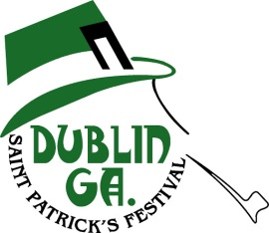
53rd Annual St. Patrick’s Festival
2018 Sponsor Levels

Gold Festival Sponsor $5,000.00
10 Order of Shillelagh or Order of Blarney Stone Memberships
Two VIP Reserved Tables for Dueling Pianos
Five (5) 2016 Souvenir Pins
Radio & Newspaper Recognition
Recognition on Festival Banner at all official events
Brochure Listing
Two Complimentary Invitations to Awards Banquet
One Parade Entries
Vendor Booth Space at Arts and Crafts

Silver Festival Sponsor $3,000.00
8 Order of Shillelagh or Order of Blarney Stone Memberships
One VIP Reserved Table for Dueling Pianos
Four (4) 2016 Souvenir Pins
Radio & Newspaper Recognition
Recognition on Festival Banner at all official events
Brochure Listing
Two Complimentary Invitations to Awards Banquet
One Parade Entry

Bronze Festival Sponsor $2,000.00
6 Order of Shillelagh or Order of Blarney Stone Memberships
One VIP Reserved Table for Dueling Pianos
Three (3) 2016 Souvenir Pins
Radio & Newspaper Recognition
Recognition on Festival Banner at all official events
Brochure Listing
One Complimentary Invitation to Awards Banquet

Emerald Festival Sponsor $1,000.00
4 Order of Shillelagh or Order of Blarney Stone Memberships
Two (2) 2016 Souvenir Pins
Radio & Newspaper Recognition
Recognition on Festival Banner at all official events
Brochure Listing
One Complimentary Invitation to Awards Banquet

Irish Festival Sponsor $500.00
2 Order of Shillelagh or Order of Blarney Stone Memberships
One (1) 2016 Souvenir Pins
Radio & Newspaper Recognition
Recognition on Festival Banner at all official events
Brochure Listing

