Describe a (jigsaw, crossword, etc) puzzle you have played
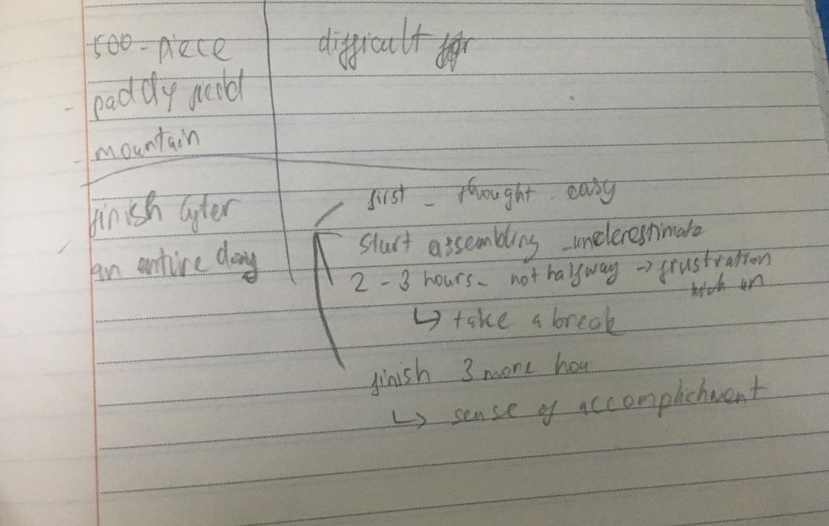
You should say
What it is like?
- Well, I want to talk about a jigsaw puzzle that I was gifted in my 10th birthday.

Basically, it is a 500-piece puzzle with a picture of a beautiful landscape with paddy fields and a big mountain

How easy or difficult it is?
- If my memory serves me right, it was really hard for me
How long it takes you to solve it?
- as I remember finishing it after an entire day
And how you feel about it?
- At first, I thought it looked rather easy, but when I actually started assembling all the pieces, I knew I underestimated how difficult and challenging the puzzle was. After spending 2 or 3 hours on it, my frustration began to kick in since I wasn't halfway done, so I decided to take a break for a few minutes to calm myself down and came back to it later. Then, I was able to concentrate better, I finally managed to finish it after 3 more hours. At that time, as I showed it to my family, I felt a great sense of accomplishment as if I was standing on the top of the world.

All in all, that is a puzzle piece that I had a chance to play.
bám sát vào cue card để trả lời nhé:
- what it is like
  - It is a big square, and it is divided evenly into 81 square boxes, so each side of the square has 9 boxes. Some of those boxes have a random number from 1 to 9 in each of them while some others are blank.
- how easy or difficult it is
  - When I first looked at it, I thought it was easy and straightforward, and I could do it right away, but I was totally wrong when it was a lot harder than I expected
- how long it takes you to solve
  - It is one of my favourite pastimes (hoặc I make Sudoku a part of my daily schedule), and it takes me around 2-3 days to finish it >> IELTS TUTOR hướng dẫn Cách dùng danh từ "end" tiếng anh
- And how you feel about it
  - Useful for 2 reasons
    - Main idea 1: It can promote one’s intellectual development
    - Main idea 2: It require our full attention, help us wrest ourselves away from screens, devices, even the television, which seems like a nearly impossible task these days.

