Namaste,
This is my first time in Rajasthan and I can’t wait to explore the cityscapes, food and history alongside you.
What’s happening?
This is the tentative schedule we have planned
Time | Thu 7 | Fri 8 | Sat 9 | Sun 10
7:30 AM | Arrive, rest and relax | Meditation
8:00 AM |  | Yoga till 9:30
9:00 AM
10:00 AM |  | Breakfast
11:00 AM |  | Workshop: Patanjali’s secret of Yoga | Shop at Jaipurs Bazaar | Explore Pushkar Fair
12:00 PM
1:00 PM | Lunch
2:00 PM | Rest
3:00 PM | Ice breakers and Intro | Discover Jaipur's palaces | Drive and Reach Pushkar
4:00 PM | Jantar Mantar |  |  | Leave to Ajmer Airport
5:00 PM
6:00 PM | Yin Yoga
7:00 PM | Dinner
8:00 PM | Yoga Nidra/ meditation
9:00 PM | Journal writing/ reflection and lights off | Movie Night | Moonlight stroll

Home sweet home:
Over our four days, we will be visiting three different cities. Our first stop is in Jaipur and we will be staying in the posh residential area of the city, from where all the famous sites are just a stones throw away
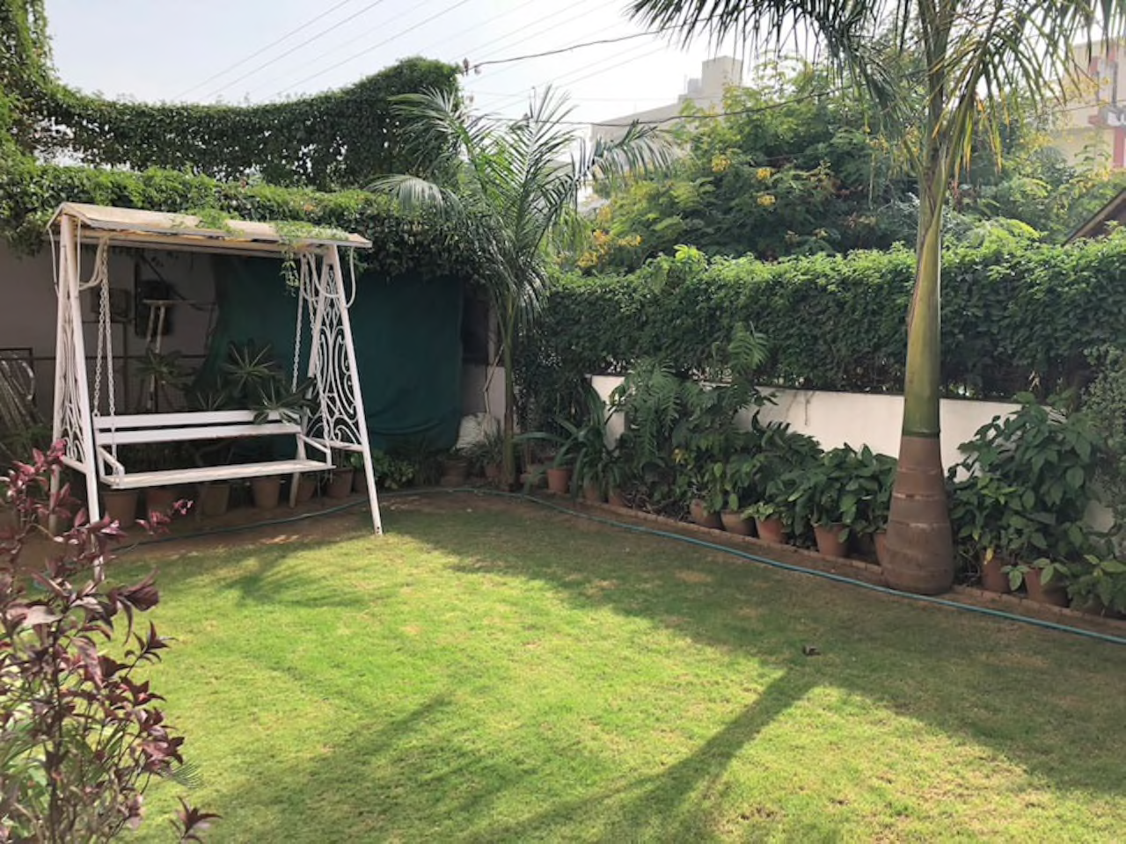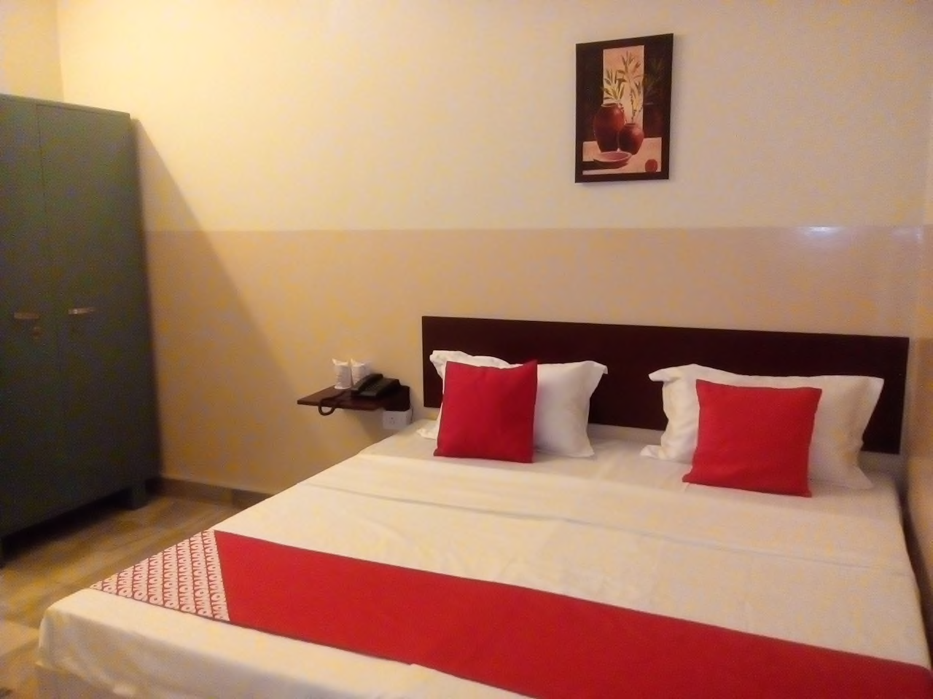

We stay in this simple and beautiful home for two nights, exploring Amber palace, the famous Jantar mantar and of course shopping in Jaipur
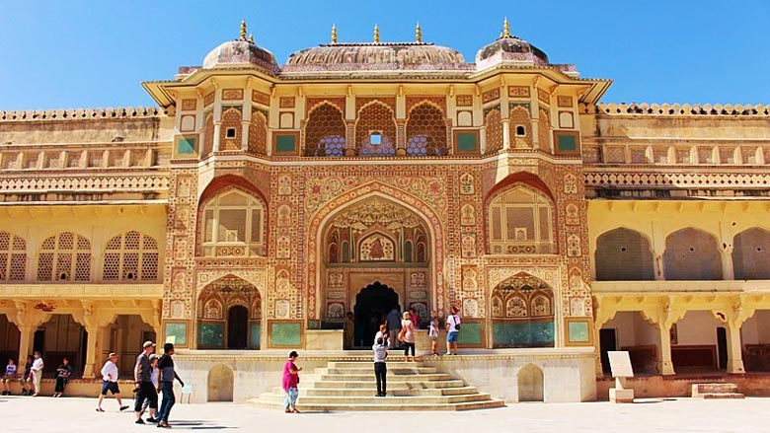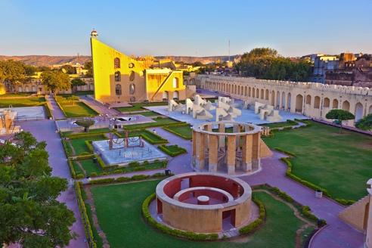

From here, we will take a taxi and drive down to Pushkar – Stop along the way in Ajmer – really famous for its sufi temple and whilring dervishes
The driver will drop us off in the dusty and yet culturally rich town of Pushkar – home to the largest camel fair in the world
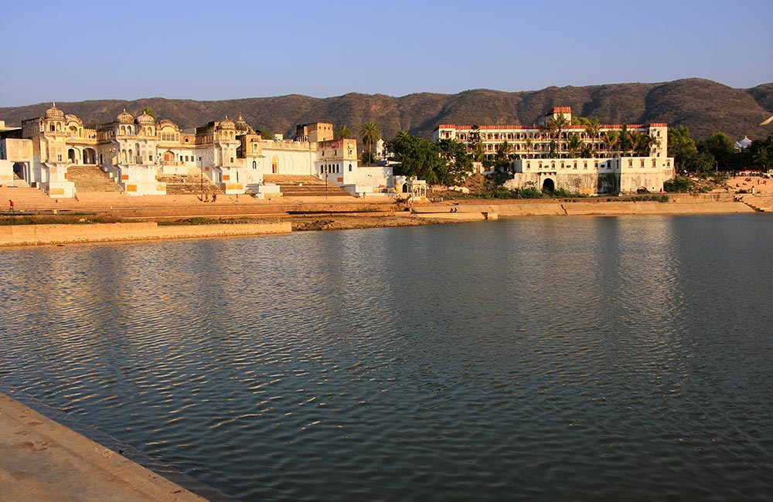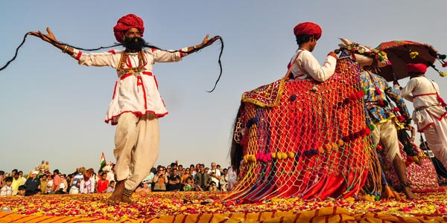

We spend the night in an outdoor adventure ranch
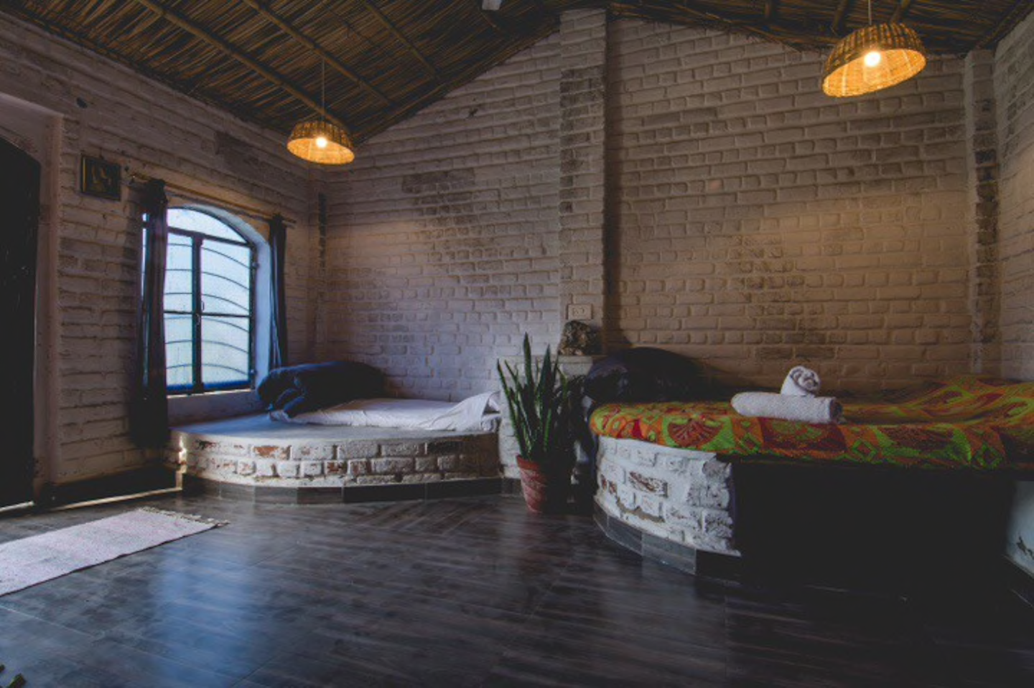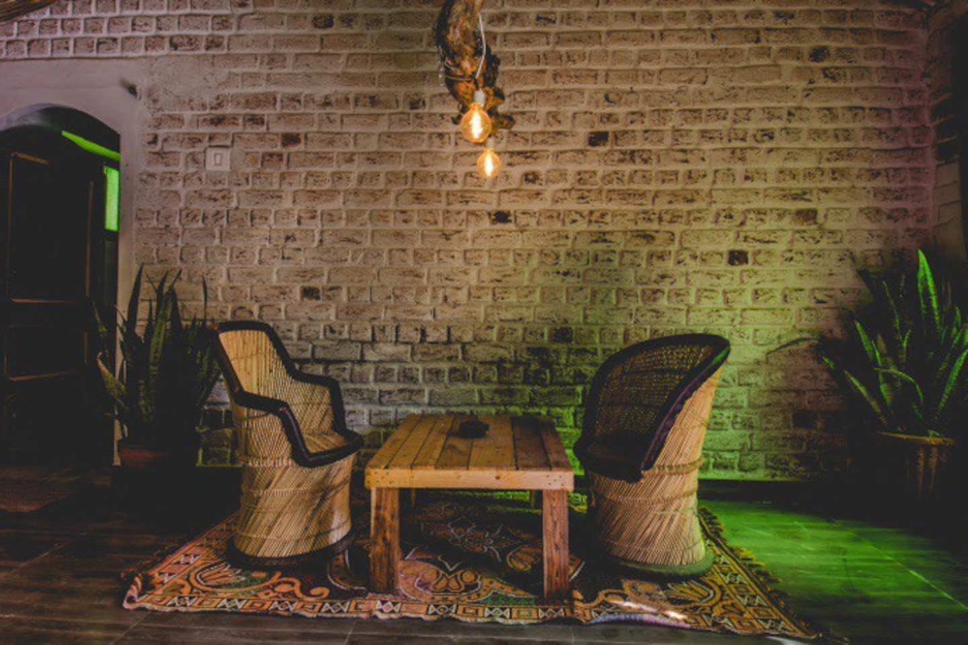
On our last day we explore pushkar fair with it’s world’s longest moustache + camel decorating competition and make our way back home <3
Things to bring:
- Yoga Mat
- Clothes (yoga and things you can wear out)
- Shoes
- Sunglasses
- Scarf
- Toiletries
- Money for shopping
- Camera to take lots of pictues
- A sense of adventure
To get to Jaipur and back we recommend:
a. To get to Jaipur SG 321 that departs Chennai at 4:35 am and reaches Jaipur at 6:50 am
b. To return please take flight SG 2769 Departing from Ajmer airport on the 10th at 4:40 pm
Please check all the options on www.makemytrip.com or http://www.cleartrip.com/

I am looking forward to practicing with you!!

Rohini Manohar,
Yogini, Chennai Yoga Studio

