Describe an item on which you spent more than expected
You should say:
What it is
How much you spent on it
Why you bought it
And explain why you think you spent more than expected
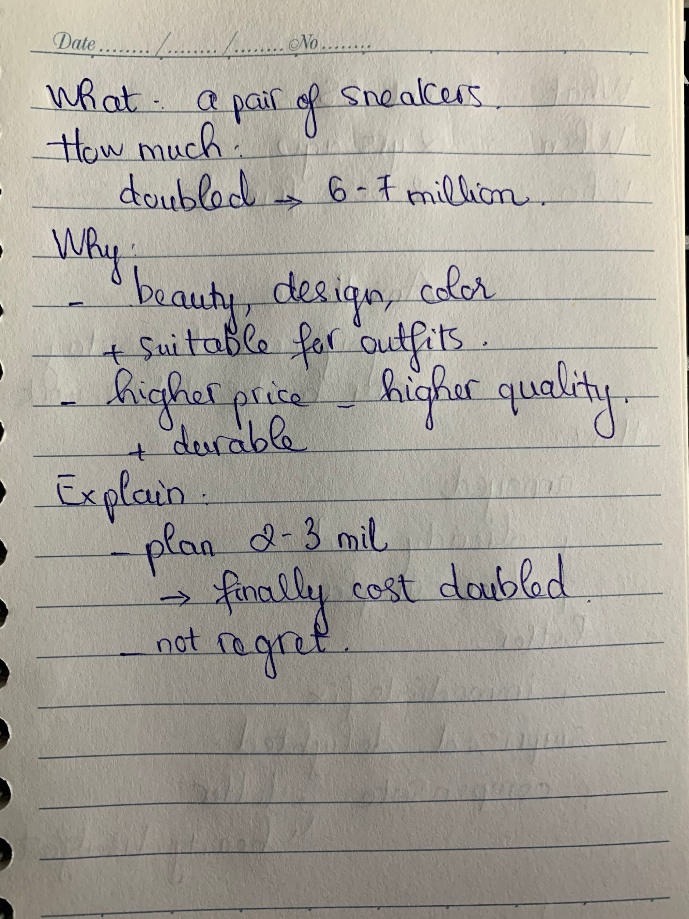
What it is
I would like to talk about a thing that I spent more than I expected, and this is the first and the last time I do that with my budget. At that time, to prepare for a trip to Da Lat with my friends, I plan to purchase a pair of sneakers which may cost about 2-3 million VND.
How much you spent on it
When I went to the shopping center to find a pair of sneakers, I saw such an amazing sneakers that I loved at first sight. Actually, when I tried it on, I thought that I would buy it right away, but unfortunately, its price was doubled. It cost 6-7 million VND which is over my budget. However, finally I decided to buy it.
Why you bought it
So, I will tell you the reason. The first one is I super love it because of its beauty, its color and its design, and everything matched perfectly. Moreover, I thought that the sneakers were very suitable for my daily outfits, so after the trip I could use them in daily life. The second reason is I just believed that the higher the price, the higher the quality. What I mean is that although the sneakers had an unaffordable price, I suppose that it would be very durable, so I thought it was worth it.
And explain why you think you spent more than expected
As I just mentioned before, I planned to buy a pair of sneakers which cost 2-3 million VND, but finally I got the higher price one which cost doubled. However, I did not regret buying that sneakers although I have to pay too much for it, but adversely I felt so delighted to own such an attractive sneakers.
=> Câu cuối này cần trả lời lại nhé. Template như sau: From my perspective, there are two explanations why I believe I spent more than expected. Firstly,... Secondly,...Tham khảo: https://www.ieltsdanang.vn/blog/ielts-speaking-cach-tra-loi-cau-hoi-why-cuoi-cung
lưu ý:
- Intro
  - Today, I’m going to tell you about a time I spent a lot of money on buying a mobile phone.
- What it is?
  - I considered various models, but ultimately, I decided to buy the Apple iPhone.
- How much did you spend on it?
  - The phone was much costlier than I expected when it was priced at ....
- Why you bought it?
  - I think I made the purchase because of the brand name and because of friend’s reviews.
  - In fact, previously, I had a Samsung phone, but all my friends told me that Apple is way above Samsung in quality >> IELTS TUTOR hướng dẫn Cách dùng "quality" tiếng anh
- And explain why you think you spent more than expected.
  - Main idea 1: I bought the mobile phone not because of need but because of impulse (the price was way higher than the other models in the market)
    - Supporting idea 1:
      - I know I am not a heavy mobile phone user when I mainly use the mobile phone to call and to check WhatsApp messages >>I could have that done all that I wanted with a much cheaper version
  - Main idea 2: I had to postpone the decision of buying a new laptop, which I urgently need because of this decision
    - Supporting idea 1:
      - My old one is about 6 years old, and sometimes it takes nearly half an hour to start up.
      - A new laptop would have made my life much more comfortable than the iPhone did

