**Magic Dragon Preschool**

13/5/21 • magicdragonpreschool@hotmail.co.uk • 07971 421 834

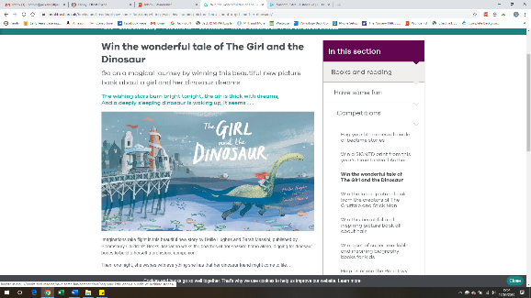

**Learning Journals** will be coming home this week

They show what your child has been doing at preschool and how their learning is progressing. **Please enjoy sharing them at home and then return them when you have finished or by Tuesday May 25th at the latest.** Thank you.

Phonics

The blue group children will be leaning the ‘l’ and ‘h’ sounds next week.

To help your child with their learning, try making a long line of things from around the house that start with ‘l’. You could do the same with things that start with ‘h’ but make it into the shape of a lower case ‘h’.

**Please remember to use lower case letters with your children at home if you are writing with them – thank you.**

**Inclusion and Portage visit.**

We are lucky to have a visit from our Inclusion and Portage specialist this Tuesday to monitor and review our provision and children’s progress. She is a wealth of information and support to us, so please do speak to your child’s key person if you would like any help or have any concerns about your child.

**Dates for your diary:**

**Committee meeting for all parents – Wednesday 26th May**

**Speech and language telephone drop-ins every Thursday 9:45-12:15 tel: 0300 124 5832**

Please return Learning journals by Tuesday 25th May.

Hello Everyone,

The children were showing real levels of engagement and enjoyment during our minibeast week. There was bug hunting, drainpipe water play, sweeping, shaving foam puddles and obstacle course fun. Inside the children enjoyed loose parts play with the tubes and boxes, spider's web challenge, making minibeasts using small loose parts, bug exploring in the small hall, musical shapes, dressing up, sharing minibeast books, clay modelling junk modelling, stepping stones course and building homes for minibeasts.

Next week we will be looking closely at some wriggling creatures that have joined us at preschool. We will be watching them grow and enjoying the story of The Hungry Caterpillar. There will be painting, building, climbing, mark making, role play, printing, puzzles and lots more.

**To help your child at home this week, enjoy playing a game as a family such as an Orchard Toy game which involves turn taking. Waiting your turn is a tricky skill to master.**

As you are aware, our preschool needs a chair, secretary and child protection officer for September. Please consider one of these roles if your child is staying on at preschool. It is a great way to get involved with preschool life and learn about what goes on at preschool.

This week there are over 45 photos that we would love to share with you…

<https://www.instagram.com/magicdragonpreschoolbristol/>

<https://www.facebook.com/magicdragonpreschool>

Have a lovely weekend everyone.

From Niki and the Magic Dragon team

**Things to try to remember next week:**

* Please return any outstanding technology sheets that have been sent home.
* Take a peek in the lost property drawer in the registration trolley as there are a few things accumulating.

 

Makaton sign of the week =

More **We encourage the**

**children to** **say ‘More please’**

**at snack time.**

**Snack next week:**

Brioche and spreads, satsumas and breadsticks cheese and crackers and cereal.