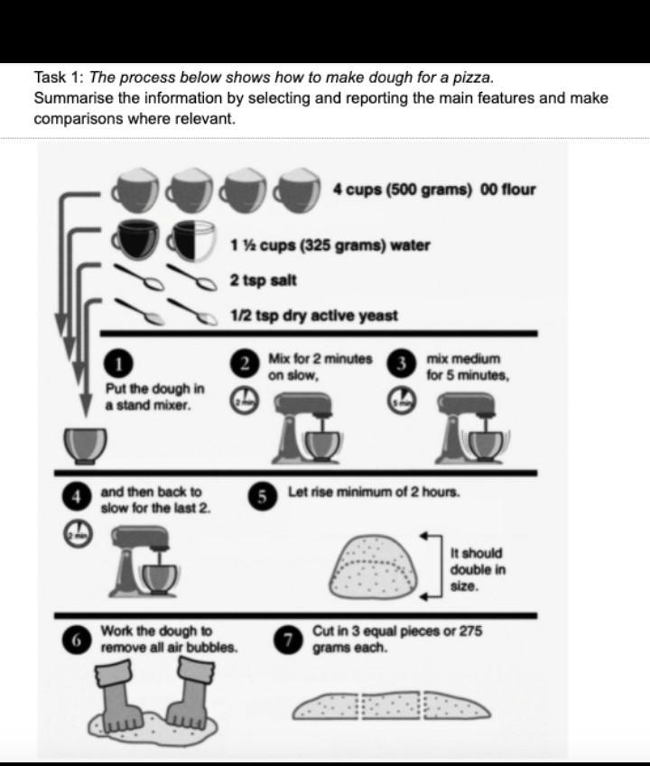

Given is the diagram illustrating the steps in the process of pizza dough

Overall, there are seven stages in how dough for a pizza is made, beginning with the combination of ingredients and ending with the production of pizza dough.

First of all, they put the powder mixture for a pizza in stand mixer, after the following ingredients are prepared: four cups of 500 grams of flour, a cup and a half or 325 grams of water, two teaspoons of salt, and a half teaspoon dry active yeast.

Secondly, the mixture is blent for two minutes at low speed. After that, the powder is mixed for five minutes at medium speed and then the dough is back to slow speed again at least two minutes. At the fifth stage, the powder is rose for minimum of two hours and it should be in double size. In the last two stages, the dough for a pizza is removed all air bubbles by the worker and then they are cut in three equal pieces with 275 grams in each.

**⇒ Về nội dung bố cục mình chia ổn nhé, sau khi mình triển khai và sửa các lỗi trên bài thì lần tới sẽ đề xuất các cách viết câu và paraphrase cho bài mình đa dạng từ vựng và cấu trúc hơn**

[IELTS TUTOR](https://www.ieltstutor.me/blog/sua-de-thi-ielts-writing-22-8-2020) lưu ý:

* Overall:
  + There are various steps in the process, which start with putting all the ingredients into the mixer and conclude with cutting the dough into smaller portions.
* Body 1:
  + The process commences with combating 4 cups of 00 flours, which is approximately 500 grams, with around 325 grams of water, along with 2 teaspoons of salt and finally a half teaspoon of dry active yeast into a stand mixer.
  + Mix them for 2 minutes on a slow level.
* Body 2:
  + The level is increased to medium and continues to mix for 5 minutes more and back to slow for the last 2 minutes before resting and letting the dough double in size for a minimum of 2 hours.
  + The dough is taken out and is being worked to remove all air bubbles.
  + The dough is cut into 3 even shares with 275 grams each.