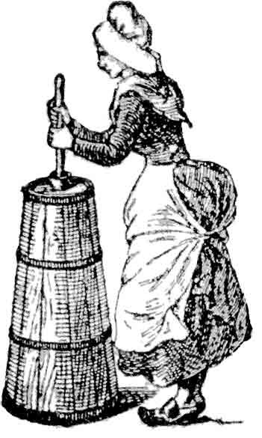**Delaware County   
Vintage Base Ball Association   
&  
Livestock Foundation   
proudly present the 5th Annual  
CELEBRATING 200 YEARS OF BASEBALL IN THE CATSKILLS**

**Cowtown Scramble**

**EST.**

**2021**

**“EARN**

**THE**

**CHURN”**

**October 4-5, 2025**

**Creamery Park  
1390 County Route 6  
Bovina Center, N.Y.  
  
livestockfoundation.org/delcovintagebaseball.org/creamerypark.com**

**FESTIVAL MAP**

**To Hwy 28  
Andes/Delhi**

**Pavillion  
Food/Restrooms**

**Porta-Jon**

**Parking**

**Creamery Field   
#1**

**To Russell’s General Store (.7mi) and Putt Putt Van Winkle (3.3 mi)**

**MacPhersonField   
#2**

**Calico Field   
#3**

**Parking**

|  |  |
| --- | --- |
| **FOOD ALL DAY!** | **POST-GAME BASH!** |
|  |  |

Butter & Churn 1 clipart, cliparts of Butter & Churn 1 free download ...Butter & Churn 1 clipart, cliparts of Butter & Churn 1 free download ... **DelCo VBBA congratulates the previous winners of the *Cream of the Crop Award*:  
Atlantic B.B.C. (’23) and Bovina Dairymen (’24)**

|  |  |  |  |  |  |
| --- | --- | --- | --- | --- | --- |
| **GAME SCHEDULE  (all matches played by 1864 rules unless otherwise noted) SATURDAY** | | | | | |
|  | **10AM** | **11:45AM** | | **1:15PM** | **3PM** |
| **Creamery Field**  **1** | Bovina  Dairymen v  Tri-Mountain Base Ball Club | Atlantic  Base Ball Club v.  Tri-Mountain Base Ball Club | | Atlantic  Base Ball Club  v.  Mountain  Athletic Club | * 1895 Match *   Mountain  Athletic Club  v Westfield  Wheelmen (MA) |
| **Mac**  **Pherson Field**  **2** | Hamden Nine  v  Mutual  Base Ball Club | Westfield  Wheelmen  v.  Hamden Nine | | Bovina  Dairymen v  Rising Sun  Base Ball Club | Rising Sun Base Ball Club  v. Brickmaker Base Ball Club |
| **Calico Field**  **3** |  | Mutual  Base Ball  Club of N.Y. v. Kingston Guards | | Brickmaker  Base Ball Club  v.  Providence Grays | Providence  Grays  v.  Kingston  Guards |
|  | | | | | | |
| **SUNDAY** | | | | | |
|  | **8:30AM** | | **10:15AM** | **12PM** | **1:45PM** |
| **Creamery**  **Field 1** | Providence  Grays v.  Rising Sun  B.B.C. | | Providence  Grays v. Hamden  Nine | Brickmaker  B.B.C.  v.  Westfield  Wheelmen | Westfield  Wheelmen v. Bovina  Dairymen |
| **Mac**  **Pherson Field 2** | Mutual  B.B.C. v Brickmaker  B.B.C. | | Atlantic B.B.C.  v. Rising Sun B.B.C. | Mountain  Athletic  Club  v Mutual  B.B.C. |  |
| **Calico Field 3** | Hamden  Nine v.  Tri-Mountain B.B.C. | | Tri-Mountain B.B.C.  v.  Mountain Athletic Club | Bovina  Dairymen v. Atlantic  B.B.C. |  |

**PARTICIPATING CLUBS**

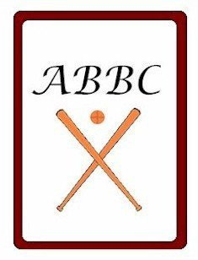Delegates at the first convention of the National Association of Base Ball Clubs in 1857, the Mutuals were re-established in 1999 at Old Bethpage Village Restoration in Bethpage, NY. The club takes their historical accuracy seriously and are leaders in the vintage baseball community. www.nymutuals.com

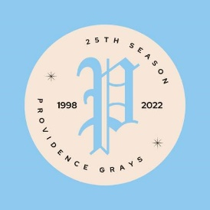Among the most well-traveled clubs in the circuit, now in   
their 29th season, the **Atlantic Base Ball Club** honors the original team founded in 1855 in Brooklyn during the early days of the “New York Game.” Most adept at swatting the sphere, they haven’t had a losing record since 2001. www.brooklynatlantics.org  
  
A throw-back tribute to the 1884 (first-ever)   
“World Championship,” the **Providence Grays** have been a staple on the vintage baseball circuit for over 25 years. The club are fine ambassadors of the first year of the overhand pitch and have an illustrious history about which many books have been written. www.providencegrays.com

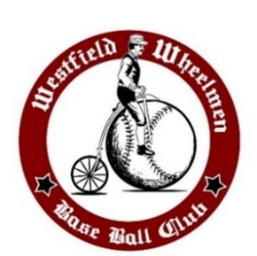  
The **Westfield Wheelmen Base Ball Club** are a revival of the original factory team formed for workers at Pope Manufacturing, makers of Columbia Bicycles in Westfield, MA during the late 19th century. They are hard-nosed competitors, playing the game the right way since 2006. www.facebook.com/westieldwheelmen

**Fleischmanns Mountain Athletic Club** harkens back to 1895 when Charles Fleischmann used his yeast-making fortune to build a private atheltic grounds in the sleepy Catskill village for his sons to play alongside future and former big leaguers where the M.A.C. still holds court and has since 2007. www.macvintagebaseball.org  
Our perennial hosts for the Scramble, the **Bovina Dairymen** epitomize the Delaware County spirit…home-grown in 2008 from the tightly-knit farming community where ballplayers have gathered on hard scrabble fields for at least two centuries. www.bovinadairymen.org

Originally founded in 1866 in the days following the Civil War, the **Rising Sun Base Ball Club** was the first organized team in Maryland and continued in various iterations until 1956. In 2012, the Club was revived in Rising Sun and hosts two festivals of their own each Spring and Fall at Dove Valley Winery. www.risingsunbbc.com

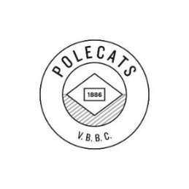The **Polecat Vintage Base Ball Club** featuring the **Hamden Nine** draws its inspiration from a local nine for many years in the Town of Hamden where an ad appeared looking to challenge others to a game of “BASS-BALL” all the way back in 1825. FB@DelhiVBBC

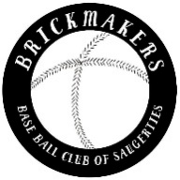  
Named for the “Washingston Guards” 121st regiment of Hudson Valley men sent to guard the capitol during the Civil War, they’ve burst onto the 19th century scene with gusto and are looking to grow the sport with style and theatrics. www.kingstongruards.com  
  
Carrying on a tradition of their famous townsman, Frank Pidgeon - pitcher on the Eckfords of Brooklyn 1855-1862,the **Brickmaker Base Ball Club of Saugerties** have expanded the Hudson Valley 19th century base ball scene with a unique look and swagger. www.saugertiesvbbc.org  
 **Tri-Mountain Base Ball Club** is new to the circuit after having combined players from other New England states under the auspices of the Dirigo Base Ball Club of Maine. As other teams have disbanded, the Tri-Mounts recruited the finest talent and are off-and-running to make their name in the 19th century base ball circuit.

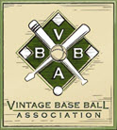**UMPIRES ARE PROVIDED BY EACH CLUB**  
  
Many of the participating Clubs are members of the **Vintage Base Ball Association** (www.vbba.org) and/or the **National Association of Historic Base Ball Clubs**   
 (www.nahbbc.com)

**1864 Rules (distinctly different from current rules)**

**Gloves:** None

**Bat:** Bat length/weight has no limits.

**Ball:** The ball was slightly larger and handmade with one piece of leather. It was stitched in a way that resembled an orange peel and the center was made of a number of small round objects.

**Uniforms:** Players wore long pants and a long sleeve buttoned shirt with a square logoed "shield" across the chest.

**Umpire:** Umps didn’t say much unless prompted by a captain to settle a dispute or close play. Umpires made the final call on balls, strikes, foul balls and balks.

**Pitching/Field Geometry:** Balls were “pitched (underhand) not thrown (overhand)” from a line 45 feet from home plate. Pitcher can move freely along the line six feet (from center) in either direction to present the ball to the batter from different angles.

**Balls/Strikes:** Batters were issued a warning if they delayed the game or tried to wear out the pitcher by not swinging, after which the umpire issued strikes. If the pitcher fails to deliver a fair pitch to the batter, or throw "pitchouts" to prevent runner getting to another base, the umpire could issue a ball. After three balls, the batter could take first base and all base runners advance regardless of a force. After three strikes (swing and miss or called strikes), the batter is out. There was no “strike zone”… a hittable pitch was considered a strike.

**Home plate:** Round andbetween 9 and 13" in diameter and made of wood, iron, or marble.

**Outs:** If the batter hits the ball (fair or foul), they can be put out if that ball is caught either on the fly or on the first bound. A batted ball that lands in fair territory is a fair ball (regardless of whether it crosses first or third base).

**1895 Rules**

* A batted ball is only counted as a strike against the batter if the ball is tipped and held onto by the catcher (i.e. "foul tip") or the ball is hit into foul territory while attempting to bunt (i.e. "foul strike").
* The pitcher is only permitted one step in delivering the ball to the plate.
* On a balk, the base runners advance one base and the batter advances to first base.

**Other facts of significance in 1895 base ball**

* Size of the pitcher's plate increased to 24" long x 6" wide (current size).
* Maximum bat barrel diameter increased to 2 and 3/4" (current size) and couldn’t be anymore than 42” long (current length).
* The last year that "base ball"appeared in print more frequently as two words.
* Home base was usually round or square, not five-sided and didn't become so until 1900/1901.

**Terms Commonly Used in 1860’s** **Base Ball**

**Ace** **or Tally** = run  
  
**Ballist** = slang term for a ball player  
  
**Bounder, Grounder, Ground Ball =** Terms for a bounding ball from the bat which strikes the ground within the lines of the in-field; A **bound out** is when the ball is caught on the hop for an out.  
 **Daisy Cutter** = a grounder that does not bounce

**Hands Down, Hands Out or Hands Lost** = out

**Hurrah =** A well-documented American cheer of the 19th century was three “Hip, Hip, Hurrahs”

**Match** = game

**Muff =** Muffed balls are treated as errors of fielding. (Interestingly, Muff is still in the scoring section of MLB’s official rules).

**Muffin** = Less experienced player  
**Not out** = “safe”

**Striker or Batsman** = batter  
 **Spectators** = the term “Fans” is an anachronism from much later in baseball’s history. In the 1880’s rabid/raucous fans were sometimes called “Cranks.”

**Uniforms and equipment of vintage base ball seen this weekend are furnished (in part) by the following vendors:**

**Bulldog Bat Company –** bulldogbatsonline.com **Hanford Base Ball Company** – hanfordbaseballcompany.com  
**K&P Weaver LLC** – baseballamericaspastime.com  
**Stockbridge Sewing Works** – stockbridgesewingworks.com

**Vintage Base Ball Factory** – vbbf.com

From the *Delhi Gazette* July 12, 1825

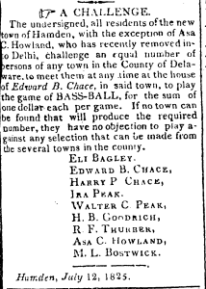

The Delaware County Vintage Base Ball Association would like to thank all our fans and the Clubs for attending our festival. And a special tip of the cap to our supporters at the   
Livestock Foundation and the MARK Project.   
Stay in touch at www.delcovintagebaseball.org.