2016 Bottom Barrier Monitoring Report

Prepared Pursuant to
California Regional Water Quality Control Board Lahontan Region Board Order No. R6T-2014-0059

FINAL DRAFT
January 30, 2016

2016 Bottom Barrier Monitoring Report

Prepared for the Tahoe Keys Property Owners Association

Submitted by: Kirk J. Wooldridge, General Manager

Signature: _________________________________________________

Prepared by Sierra Ecosystem Associates
South Lake Tahoe, CA

Tahoe Keys 2016 Bottom Barrier Monitoring Report
Table of Contents
A. Waste Discharge Requirements 1
B. Proposed Corrective Action from 2015 Season 1
I. Heavier Barrier Material 1
II. Larger Barriers 1
III. Heavier Weighting Material 1
IV. Use of installation Companies 1
V. Updating Form 19 1
C. 2016 Implementation Plan 1
D. Summary of Findings 2
E. Summary of Bottom Barrier PErformance 3
I. Installation of Barriers 3
II. Harvesting near Bottom Barriers 3
III. Fragments from Harvesting 3
IV. Siltation on top of the Bottom Barriers 3
V. Identification and Marking 3
F. Montoring Data 4
G. 2017 Implementation and Recommendations 4
H. List of Preparers 5

Table of Figures
Figure 1. Location of 2016 Bottom Barriers 2

Attachments
Attachment A – Homeowner Program Evaluation Statements
Attachment B – Bottom Barriers Identification Sign

Waste Discharge Requirements

The Tahoe Keys 2016 Bottom Barrier Monitoring Report is being submitted in compliance with the Waste Discharge Requirements as adopted by the Lahontan Regional Water Quality Control Board Order No. R6T-2014-0059 on July 17th, 2014. Report format follows the outline described in Monitoring and Reporting Program No. 2014-0059 Section D, Bottom Barrier Monitoring Report.

Proposed Corrective Measures from 2015 Season
In an effort to correct the problems observed during the 2015 program, the TKPOA proposed the following actions for the 2016 season: heavier barrier material, larger barriers, more and/or heavier weighting material, use of professional installation companies, and an update to the TKPOA’s Form 19 (application for Bottom Barrier Program).

Heavier Barrier Material
The bottom barriers that were used for the 2015 program were thin, difficult to place, and prone to billowing. The TKPOA proposes searching for sources of and using thicker barriers. This will aid with installation of the barriers and help ensure that, once in place, the barriers will not move.

Larger Barriers
The barriers used for the 2015 program were 10ft x 10ft and two barriers were used by each homeowner. This limited the treatment area. The TKPOA proposes searching for and using larger sized barriers. Treating a larger area with the bottom barriers may lead to greater success in preventing aquatic weed growth and may promote collaboration between homeowners who would like to treat several dock areas at one time.

Heavier Weighting Material
The light rebar provided with the barriers was not effective at weighing down the barriers in an area of high boat traffic. This made installation of the barriers difficult and led to removal of the barriers after only a short time. The TKPOA proposes using a thicker rebar to weigh down the barriers and investigating the use of heavy chain across the barrier that is secured to the frame.

Use of Installation Companies
Many of the properties in the Tahoe Keys are second homes or managed as rental properties. The labor intensive process of installing the barriers may act as a deterrent to these homeowners. The TKPOA will investigate companies that have experience with installing bottom barriers and supply a list of qualified companies to the homeowners in an effort to encourage participation in the bottom barrier program.

Updating Form 19
The TKPOA application for the bottom barrier program, Form 19, includes requirements of the program and guidelines for installation. The TKPOA proposes updating the form to clarify installation procedures and expand the area where the barriers can be installed.

2016 Implementation Plan
Along with the proposed corrective measures to the bottom barrier program, TKPOA received an increased number of bottom barriers from the Tahoe Resource Conservation District (TRCD) to equip eighteen (18) homeowners with barriers. The intent was to use more barriers at different location among the waterways to see the different result due to location.

Summary of Findings

In 2016, the Tahoe Keys Property Owners Association (TKPOA) conducted another season of its bottom barrier program for homeowners. Barriers were supplied by the Tahoe Resource Conservation District (TRCD) free of charge for eighteen homeowners at the locations shown on Figure 1. As part of the process, the homeowners were required to fill out an application and permit for use of the barriers. Barriers were installed by the homeowners in June 2016 and removed no later than October 2016. The barriers were monitored throughout the season by the Water Quality (WQ) and ACD Staffs.

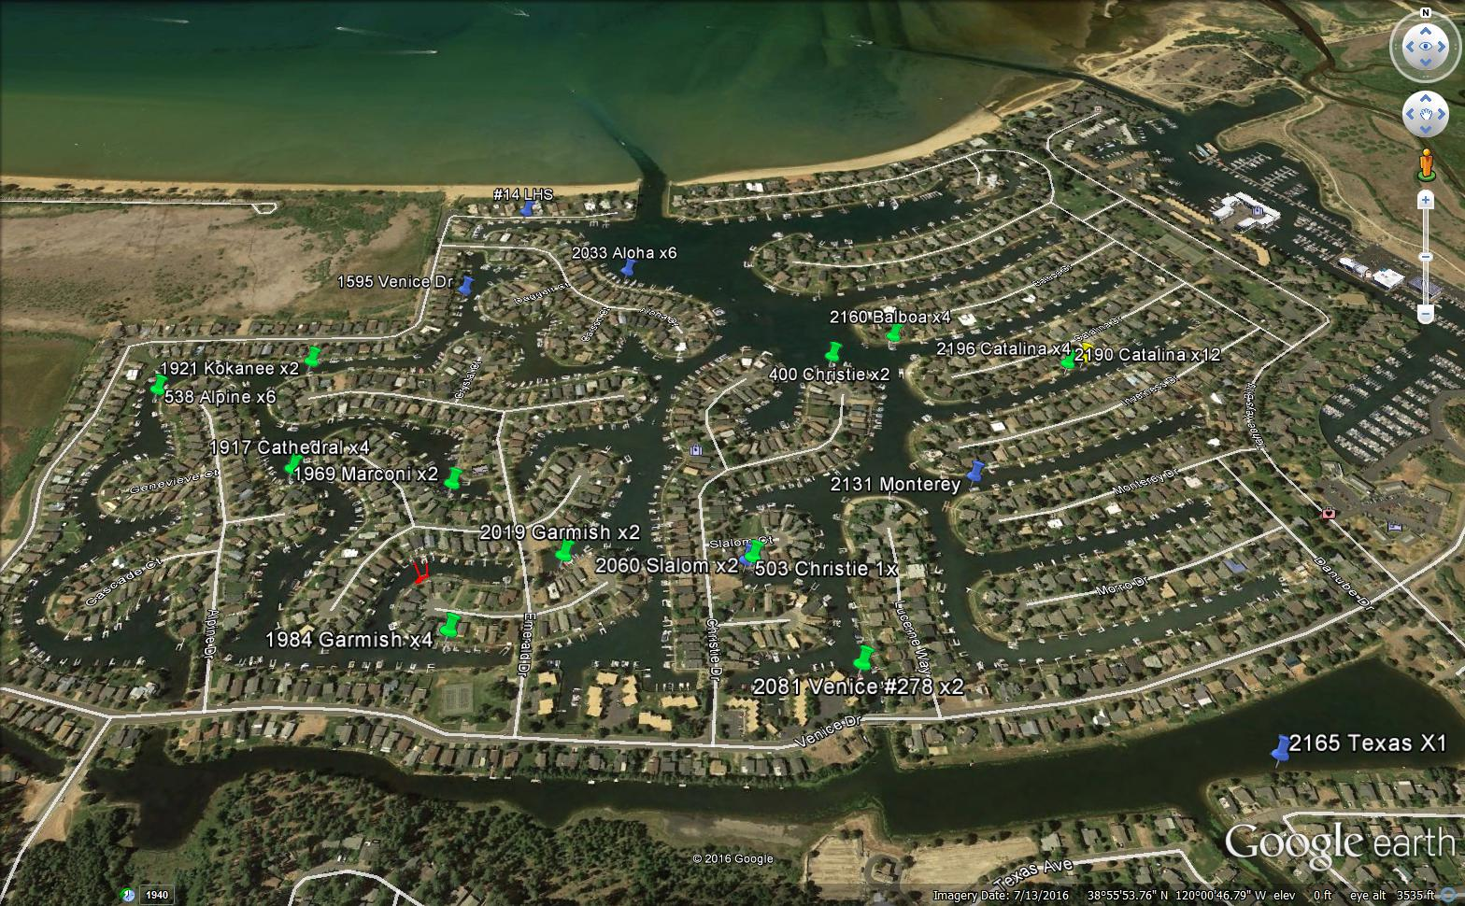
Figure 1. Location of 2016 Bottom Barriers
After all the bottom barriers were removed the treated areas were inspected by the homeowner for plant growth. The barriers were effective in preventing the growth of aquatic weeds directly underneath them but it was noted that plants were growing near the edges of the barriers and on top of the barriers in the sediment that had accumulated there. It was also noted that, while the bottom barriers were effective, they only covered between 100 and 300 square feet (depending on the amount and size that each property received)and the rest of the cove was densely infested with aquatic plants.

Each homeowner that participated in the program was given an end of the season report that consisted of these questions
- Name / address / phone number
- Density of plants during installation
- Date installed / duration of installation / date removed
- Effectiveness of the installation of barriers for the season
  - Are any live weeds observed after removal?
  - Was there any accumulation of dead/ decaying plant material observed?
  - Were any odors of decaying plant material detected during the deployment?
  - Was the water clouded (turbid) upon removal?
  - Were and how was the barrier cleaned upon removal and where is it stored?
  - Were the barriers cost effective to the homeowner?
- Were there any incidents reported during the deployment, such as: Loose barriers, watercraft or swimmer entanglements, chemical spills, etc?
- Additional comments or concerns
See Appendix A for each of the homeowner’s End of the Season Report. Note that six homeowners did not fill out the required paperwork. ACD contacted and requested this information.

Summary of Bottom Barrier Performance

Several obstacles hindered the success of the 2016 Bottom Barrier Program. Issues included difficulties with installing the barriers, inability to harvest aquatic weeds near the barriers requiring cooperation with nearby homeowners, fragments from harvesting operations, and siltation on top of the barriers.

Installation of Bottom Barriers
Homeowners were responsible for the installation of barriers. Some installed it themselves while others outsourced it to diving companies. The level of effectiveness that the barriers had over the season was largely depended on how they were initially installed.

Harvesting Near Bottom Barriers
Harvesting is the primary aquatic plant control method used in the Tahoe Keys. Large harvesters travel around the lagoons and cut the plants to a height that allows boat access. Areas around the bottom barriers could not be harvested due to the risk of dislodging or damaging the barriers. Due to this, aquatic plant growth around the barriers was substantial and unchecked which can limit boat access. Docks belonging to other homeowners that were next to the bottom barriers could not be serviced which meant that cooperation with the adjacent homeowners was needed

Fragments from Harvesting
While harvesting near the bottom barriers was prohibited, there was still harvesting taking place in the same cove where barriers were installed. The harvesting created fragments that settled on top of the barriers and began to root in the sediment which had accumulated on the surface of the barriers.

Siltation on Top of Bottom Barriers
Over the four-month period that the barriers were in place, a layer of silt accumulated on top of them. This silt most likely came from boat traffic disturbing the layer of fine sediment on the bottom of the lagoons. The layer of silt allowed new aquatic weeds to root and grow on top of the barriers. The added weight of the silt and plant growth on the top of the barriers made removal more difficult. Removal of the barriers also disturbed the lagoon bottom and created a high level of turbidity in the local vicinity, which took several hours to clear.

Identification and Markings
There were two visual markers that the homeowners were required to display to identify the Bottom Barrier area. There were two (2) laminated sheets of white paper signs that that were posted on opposite ends of the docks to identify that there were bottom barriers in the vicinity. To identify the exact location of the outline a yellow buoys were placed at the edges. Most of the signs were taped to the dock, which allowed a many of them to be blown away due to wind. At the end of the season a majority of docks and slips did not have signs that remained. Also, many of the buoys were improperly weighted down and had the same results of the signs.

Monitoring Data
The barriers were monitored throughout the season by the Water Quality (WQ) and ACD Staffs.
However, the homeowners were responsible for documenting their experience with the bottom barrier program. Attachment A includes documentation from the two participants in the 2015 program.

2017 Implementation and Recommendations
The TKPOA will offer the same Bottom Barrier Program for the homeowners to participate in. The homeowners will be required to fill out the permit / application through the Architectural Control Department and will be responsible for the installation, removal, cleaning, monitoring and documentation of the barriers. Upon completion of the installation, the Water Quality Department will be responsible for monitoring, ensuring the upkeep of the barriers by the homeowners and the end of season reporting for the program.

List of Preparers

The following individual prepared the text presented in this report.
Name Education Role
Gregory J Hoover A.A Natural Science Primary Author
TKPOA A.A Liberal Arts: Math and Science
Lake Tahoe Community College

Attachment A

Homeowner Program Evaluation Statements

Attachment B

Bottom Barriers Identification Sign

