2015 Bottom Barrier Monitoring Report

Prepared Pursuant to
California Regional Water Quality Control Board Lahontan Region Board Order No. R6T-2014-0059

FINAL DRAFT
January 30, 2016

2015 Bottom Barrier Monitoring Report

Prepared for the Tahoe Keys Property Owners Association

Submitted by: Kirk J. Wooldridge, General Manager

Signature: _________________________________________________

Prepared by Sierra Ecosystem Associates
South Lake Tahoe, CA

Tahoe Keys 2015 Bottom Barrier Monitoring Report
Table of Contents
A. Waste Discharge Requirements 1
B. Summary of Findings 1
C. Summary of Installations and Bottom Barrier Performance 2
I. Installation of Barriers 2
II. Harvesting Near Bottom Barriers 3
III. Fragments from Harvesting 3
IV. Siltation on Top of Barriers 3
D. Proposed Corrective Measures for 2016 4
I. Heavier Barrier Material 4
II. Larger Barriers 5
III. Heavier Weighting Material 5
IV. Use of Installation Companies 5
V. Updating Form 19 5
E. 2016 Implementation Plan 5
F. Monitoring Data 5
G. List of Preparers 6

Table of Figures
Figure 1. Location of 2015 and Proposed 2016 Bottom Barriers 1
Figure 2. Installation of Bottom Barrier 2
Figure 3. Aquatic Plants on Bottom Barrier 3
Figure 4. Removal of Bottom Barrier 4
Figure 5. Turbidity Caused by Removal of Bottom Barrier 4

Attachments
Attachment A – Homeowner Program Evaluation Statements

Waste Discharge Requirements

The Tahoe Keys 2015 Bottom Barrier Monitoring Report is being submitted in compliance with the Waste Discharge Requirements as adopted by the Lahontan Regional Water Quality Control Board Order No. R6T-2014-0059 on July 17th, 2014. Report format follows the outline described in Monitoring and Reporting Program No. 2014-0059 Section D, Bottom Barrier Monitoring Report.

Summary of Findings

In 2015, the Tahoe Keys Property Owners Association (TKPOA) began its bottom barrier program for homeowners. Barriers were supplied by the Tahoe Resource Conservation District (TRCD) free of charge for two homeowners at the locations shown on Figure 1. As part of the process, the homeowners were required to fill out an application and permit for use of the barriers. Barriers were installed by the homeowners in June 2015 and removed in September 2015.

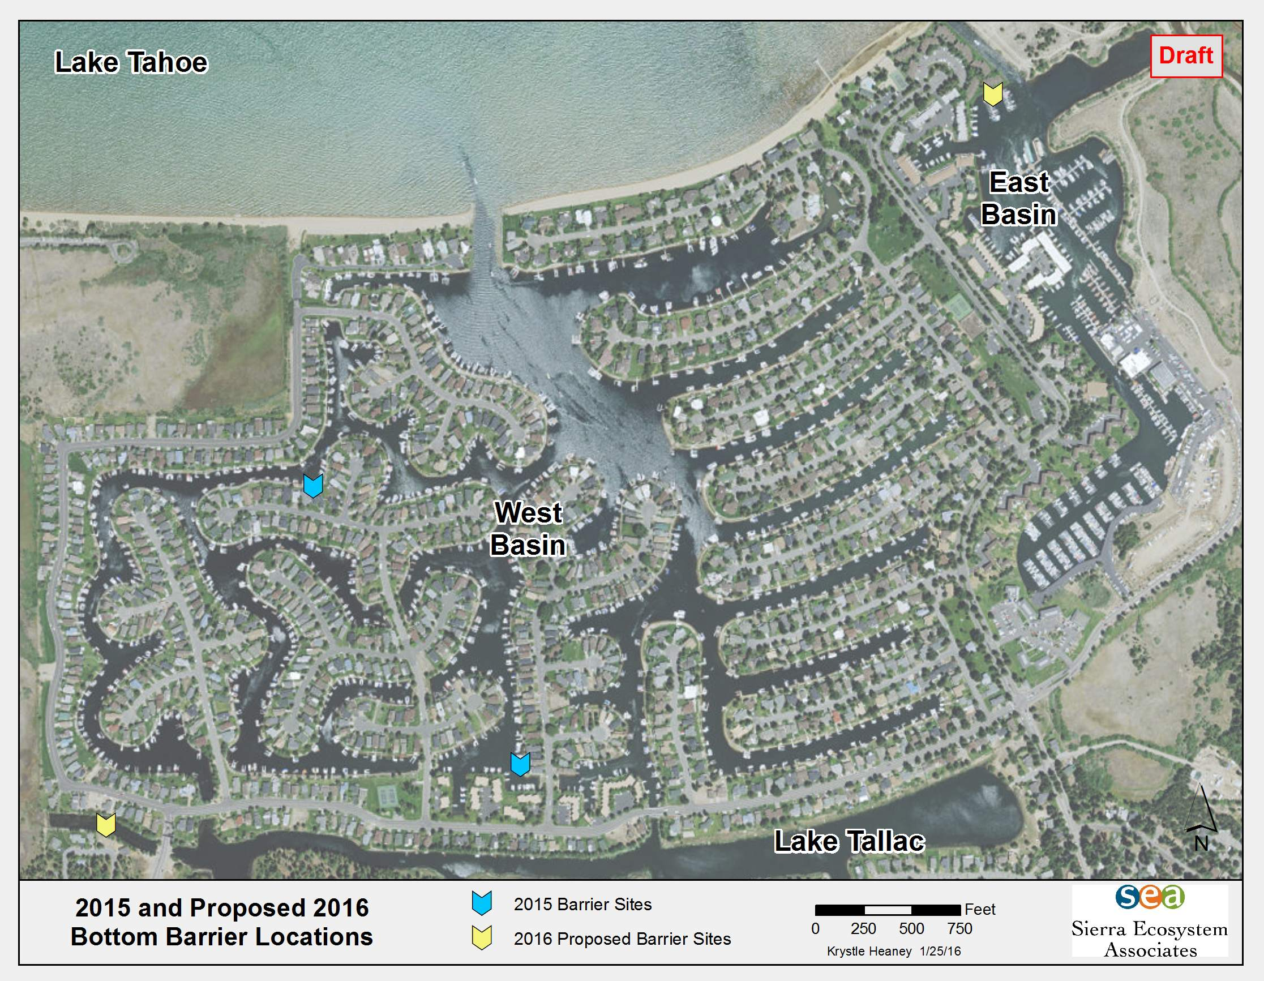
Figure 1. Location of 2015 and Proposed 2016 Bottom Barriers

Logistical difficulties were encountered by the homeowners for both installation and removal of the barriers. The barriers were thin and damaged in some sections, requiring that extra care be taken during installation to prevent further damage. The thin material was prone to billowing and the supplied rebar was insufficient to weigh down the material. One homeowner was unable to get the barriers to lie flat and removed the barriers shortly after installation. The other homeowner had difficulty removing the barriers in September due to a layer of sediment that had accumulated on top of the barriers.

After all the bottom barriers were removed the treated areas were inspected by the homeowner for plant growth. The barriers were effective in preventing the growth of aquatic weeds directly underneath them but it was noted that plants were growing near the edges of the barriers and on top of the barriers in the sediment that had accumulated there. It was also noted that, while the bottom barriers were effective, they only covered 200 square feet and the rest of the cove was densely infested with aquatic plants.

Summary of Installations and Bottom Barrier Performance

Several obstacles hindered the success of the 2015 Bottom Barrier Program. Issues included difficulties with installing the barriers, inability to harvest aquatic weeds near the barriers requiring cooperation with nearby homeowners, fragments from harvesting operations, and siltation on top of the barriers.

Installation of Barriers
Homeowners were responsible for the installation of barriers. Low water levels due to the ongoing drought, enabled them to wade out or use a kayak to stretch out the barriers (Figure 2). In a normal water year, the water levels would be much higher and this method would most likely not be feasible. One homeowner was able to successfully install the barriers and weigh them down with the included rebar. The second homeowner, who lives where there is high boat traffic, was unsuccessful with installation due to billowing. The light rebar included in the kit was not able to adequately weigh down the barrier. After 24 hours, the homeowners decided that the risk of the barriers billowing further and drifting into the channel was too great and subsequently removed the barriers.

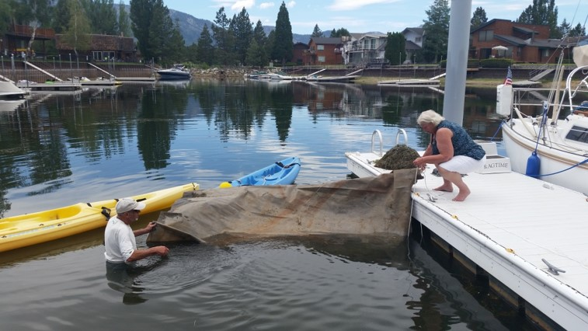
Figure 2. Installation of Bottom Barrier

Harvesting Near Bottom Barriers
Harvesting is the primary aquatic plant control method used in the Tahoe Keys. Large harvesters travel around the lagoons and cut the plants to a height that allows boat access. Areas around the bottom barriers could not be harvested due to the risk of dislodging or damaging the barriers. Due to this, aquatic plant growth around the barriers was substantial and unchecked which can limit boat access.

Docks belonging to other homeowners that were next to the bottom barriers could not be serviced which meant that cooperation with the adjacent homeowners was needed. For the 2015 installation, the adjacent homeowners were not going to be using their dock and were therefore not concerned with boat access. However, in a normal water year most homeowners make frequent use of their docks, which could present a problem for those homeowners wanting to install bottom barriers.

Fragments from Harvesting
While harvesting near the bottom barriers was prohibited, there was still harvesting taking place in the same cove where barriers were installed. The harvesting created fragments that settled on top of the barriers and began to root in the sediment which had accumulated on the surface of the barriers.

Siltation on Top of Barriers
Over the four-month period that the barriers were in place, a layer of silt accumulated on top of them. This silt most likely came from boat traffic disturbing the layer of fine sediment on the bottom of the lagoons. The layer of silt allowed new aquatic weeds to root and grow on top of the barriers as can be seen in Figure 3.

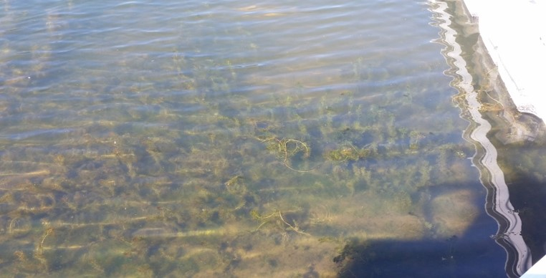
Figure 3. Aquatic Plants on Bottom Barrier
The added weight of the silt and plant growth on the top of the barriers made removal more difficult. Had 2015 been a normal water year, deep water would have further hampered removal of the barriers possibly requiring assistance from a dive team and boat crew. Since it was a low water year, a portion of the lagoon bottom was exposed in front of the bulk head creating a beach onto which the homeowners were able to drag the barriers for cleaning and drying (Figure 4). Removal of the barriers also disturbed the lagoon bottom and created a high level of turbidity in the local vicinity, which took several hours to clear (Figure 5).

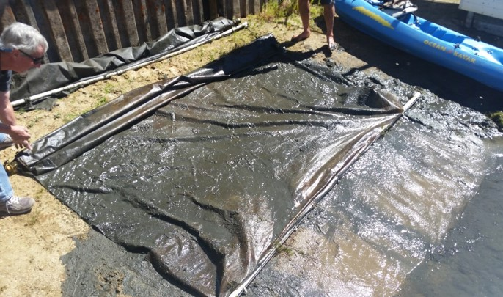
Figure 4. Removal of Bottom Barrier

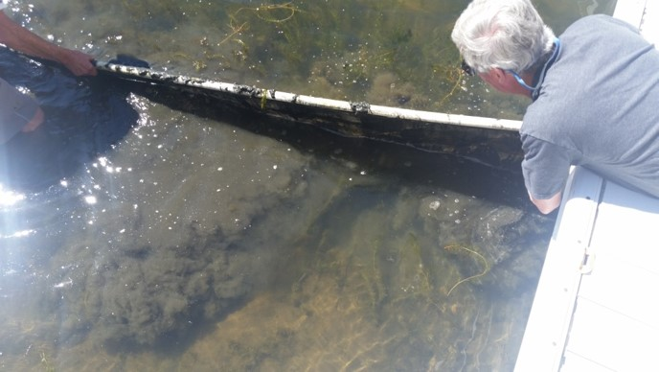
Figure 5. Turbidity Caused by Removal of Bottom Barrier

Proposed Corrective Measures for 2016
The 2015 Bottom Barrier Program was the first time TKPOA has provided a program for homeowners to install bottom barriers. The program included only two participants and limited success was observed in controlling the weeds. In an effort to correct the problems observed during the 2015 program, the TKPOA is proposing the following actions: heavier barrier material, larger barriers, more and/or heavier weighting material, use of professional installation companies, and an update to the TKPOA’s Form 19 (application for Bottom Barrier Program).

Heavier Barrier Material
The bottom barriers that were used for the 2015 program were thin, difficult to place, and prone to billowing. The TKPOA proposes searching for sources of and using thicker barriers. This will aid with installation of the barriers and help ensure that, once in place, the barriers will not move.

Larger Barriers
The barriers used for the 2015 program were 10ft x 10ft and two barriers were used by each homeowner. This limited the treatment area. The TKPOA proposes searching for and using larger sized barriers. Treating a larger area with the bottom barriers may lead to greater success in preventing aquatic weed growth and may promote collaboration between homeowners who would like to treat several dock areas at one time.

Heavier Weighting Material
The light rebar provided with the barriers was not effective at weighing down the barriers in an area of high boat traffic. This made installation of the barriers difficult and led to removal of the barriers after only a short time. The TKPOA proposes using a thicker rebar to weigh down the barriers and investigating the use of heavy chain across the barrier that is secured to the frame.

Use of Installation Companies
Many of the properties in the Tahoe Keys are second homes or managed as rental properties. The labor intensive process of installing the barriers may act as a deterrent to these homeowners. The TKPOA will investigate companies that have experience with installing bottom barriers and supply a list of qualified companies to the homeowners in an effort to encourage participation in the bottom barrier program.

Updating Form 19
The TKPOA application for the bottom barrier program, Form 19, includes requirements of the program and guidelines for installation. The TKPOA proposes updating the form to clarify installation procedures and expand the area where the barriers can be installed.

2016 Implementation Plan
Along with the proposed corrective measures to the bottom barrier program for homeowners, the TKPOA will be testing the effectiveness of larger scale installations. There are two sites currently under consideration for testing (Figure 1). One site is Lake Tallac to the west of 15th Street, which is roughly three quarters of an acre. This site is connected to the rest of Lake Tallac by concrete conduit underneath the 15th Street crossing. The second site is located by the East Channel on the Tahoe Marina Shores’ property along the shoreline. For the second site, a 1,300 ft² area would be covered with bottom barriers in a strip along the shore that is 10 ft. wide and 130 ft. long.

By testing the effectiveness of bottom barriers in these possible locations, the TKPOA would gather data on the practicality and efficacy of larger installations within the Keys. Large scale installations have been implemented in other areas around the lake, but nowhere with an infestation similar in severity to the Keys.

Monitoring Data
Homeowners were responsible for documenting their experience with the bottom barrier program. Attachment A includes documentation from the two participants in the 2015 program.

List of Preparers

The following individuals prepared the text presented in this report.
Name Education Role
Rick A. Lind M.A. Geography (Water Resources) Principal-in-Charge
SEA U.C. Davis

Krystle Heaney B.A. Geography (Physical) Primary Author/
SEA CSU Sacramento GIS Mapping

Kris Kiehne B.S. Biology Technical Editor
SEA Washington University

Rachael Schaefer A.A. in Progress Document Preparation
SEA Lake Tahoe Community College

Attachment A

Homeowner Program Evaluation Statements

