Describe an argument two of your friends had. 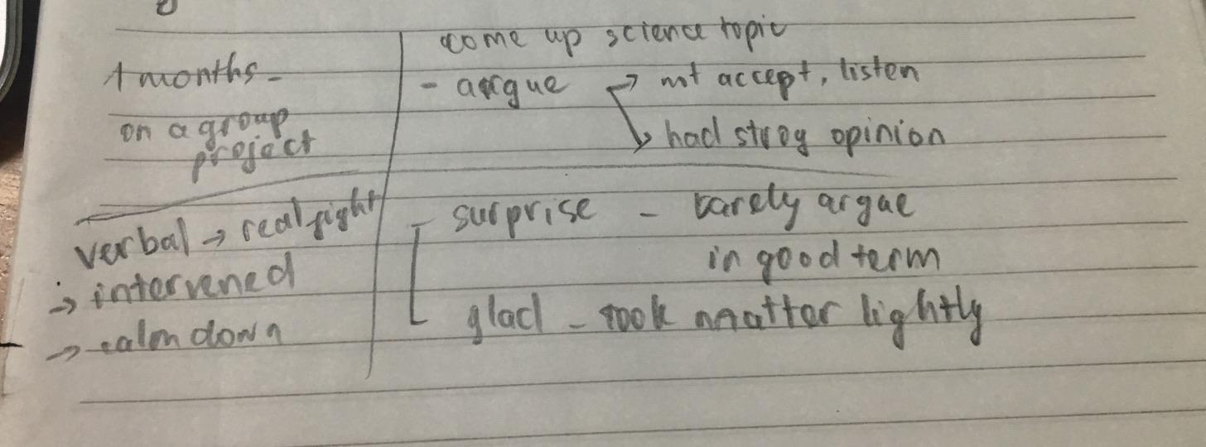
You should say
When it happened?
- Well, I want to talk about a time my friends got into a heated argument. As far as I remember, it was about a month ago when we worked on a group project.
What it was about?
- At that time, we had to come up with a science topic of our choice and finish it in a week. However, two of my friends started to argue with each other instead of discussing and assigning the work equally. This is because they were not willing to listen and accept other's ideas on the topic, and both had a strong opinion about the assignment we were given. Soon, the verbal fight turned into a real fight, and at this point I had to intervened.

How it was solved?
- the end, I told them that they had to end this nonsense fight or else we would never have anything done in time, and they began to calm down and take other's opinions into consideration. Finally, we were able to agree on the topic
How you felt about it?

- At first, it really came as a surprise for me since they rarely argue about anything and seem to be in a good term. Despite that, I'm glad that they took the matter lightly and left the argument behind. Moreover, after every argument, it feels like we have a better understanding of each other, which helps to bond our relationship.

All in all, that is the argument between my friends

lưu ý bám sát vào cue card để trả lời nhé:
- Intro + What they argued about:
  - Today, I wanna talk about one such incident when my friends got into a heated argument that took place when we were discussing whether a lockdown should be imposed when VN faced the new coronavirus wave
- Why they argued with each other
  - A believed that a stringent lockdown was the only solution to bring down the cases.
  - B believed that lockdowns don’t help when lockdowns lead to huge loss to the economy
  - As the argument continued, both of their voices went up. There was a lot of talking back, a lot of ranting and raving but no real “listening”
- What happened at the end
  - I & my husband warned them to stopped making arguments. They need to calm down, but at this point, they were so engrossed that they didn’t listen
- How you felt about it
  - 2 lessons drawn /learned from this experience:
    - Main idea 1: That day I learned the importance of emotional control (the ability to tame your anger and not let it cloud your judgement)
    - Main idea 2: Being able to put yourself together and letting things slide are crucial skills in today’s hectic world

