Đề bài

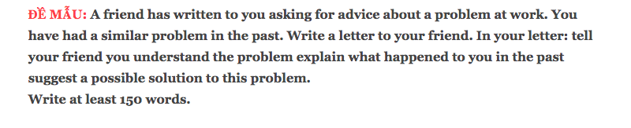

Dàn bài lần 1
_ the purpose of the letter and express the sympathy
_what happened in the past: a busy day on the weekend; a lot of customers and sick animals; worked alone
_solution: make a call to manager; prioritise serious patients; convince other customers; stay focus on operation

Bài viết lần 1

Cách làm dạng viết thư: https://www.ieltstutor.me/blog/letter
Dear Mai,
I am writing in respond your letter requesting advice about managing the pet clinic on weekend. Honestly, I totally understand how overwhelming you feel in the situation.
In fact, it was always crowded on every weekend; however, there was only me undertaking the clinic at the moment, while more and more customers with their pets were coming over. I guess that you would be as panicked as me, still here is the steps you should make.
Firstly, making a call to the manager is needed to inform the situation and ask for supporting. Meanwhile, it would be better off prioritising treating the severe sick pets, also convince other customers to wait. It is more important that you stay mindful on what you could do the best because, everything is likely to be more chaotic if you try to be a multitasker in the condition.
I hope my sharings would come in handy for your work.
Best regards,
Duy Nguyen

You should spend about 20 minutes on this task. Write about the following topic

A friend has written to you asking for advice about a problem at work. You have had a similar problem in the past.

Write a letter to your friend. In your letter:

tell your friend you understand the problemadvertising

explain what happened to you in the past

suggest a possible solution to this problem.

Write at least 150 words.

Model Answer:

Dear Tim,

I`m very delighted to hear from you and glad to know that you`ve already commenced building your career as an actuarial analyst with a prestigious insurance company. In your letter, you mentioned some issues about transitioning from student life to work life. I`d like to share with you my experience and advice.

Actually, it's a conundrum that most graduates have to meet and tackle. I totally understand your confusions since I also had a tough period at the beginning of my career. You know, there won't be textbooks and lecture notes anymore, and you have to learn everything by yourself.

Fortunately, my line manager was quite supportive and arranged a mentor to give lots of useful guidance. I got heaps of questions and made many errors when I ran the quantitative models. However, my mentor was always able to point out the crux of the matter. I really appreciated her help.

So, my suggestion is those regular communications with your manager and do not hesitate to ask for help from your colleagues. Usually, one word from an experienced actuary can a stitch in time saves nine.

Let me know if you have further concerns and keep me posted about your career progress.

Best Wishes,

David

Total Words: 207

