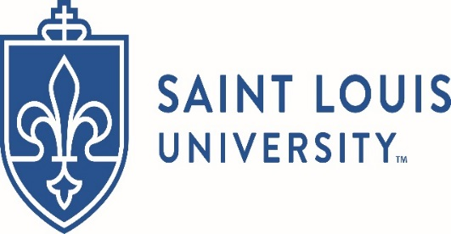

2018 Student Research Conference Schedule

June 7-10

School Information Packet

Saint Louis University and St. Louis College of Pharmacy

Saint Louis University(SLU) and St. Louis College of Pharmacy(STLCOP) is proud to host the 2018 NCSSS Student Research Conference. Join us on the STLCOP campus in St. Louis, MO, with special excursions planned to show you St. Louis.
EDIT
Saint Louis University

St. Louis, MO
Founded in 1818, Saint Louis University is one of the nation’s oldest and most prestigious Catholic universities. SLU, which also has a campus in Madrid, Spain, is recognized for world-class academics, life-changing research, compassionate health care, and a strong commitment to faith and service.

St. Louis College of Pharmacy

St. Louis, MO
Founded in 1864, St. Louis College of Pharmacy is the third-oldest and 10th-largest college of pharmacy in America. For more than 150 years, the College has been preparing students for expert practice and leadership in pharmacy and health professions careers.

Locations

St Louis, Missouri will serve as the backdrop for this year's NCSSS Student Research Conference, visible from our home-base of St. Louis College of Pharmacy (STLCOP). Dinner and events in the city of St. Louis will be planned for Friday and Saturday evenings. Lodging will be at STLCOP.

St. Louis College of Pharmacy

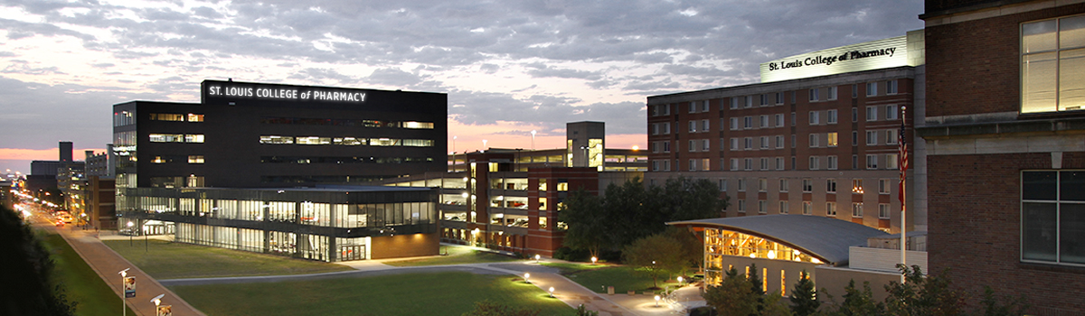

Saint Louis University

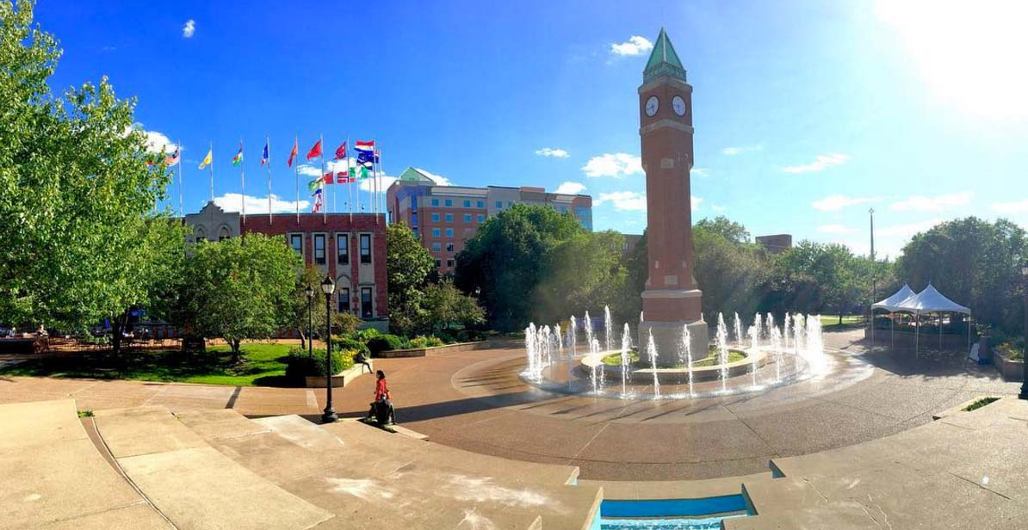

Tentative Conference Schedule

Check this webpage for updates throughout the spring

Thursday, June 7

A warm welcome from STLCOP and SLU
12-4 PM Arrival and Shuttles from St. Louis Lambert International Airport
6:00 PM Dinner at STLCOP
7:30 PM Welcome Activity
8:00 PM Chaperone Meeting
10:00 PM Floor Meeting

Friday, June 8

Campus Tour STLCOP and tour of St. Louis
8:00 AM Breakfast
9:00 AM Set up Poster Presentations
9:15 AM Welcome Presentation
10-12 PM Poster Presentations
12-1 PM Lunch
1-3:00 PM Tours and Lab Visits
3:00 PM Evening Prep Time
5:00 PM Evening Dinner and Depart STLCOP for Event
10:00 PM Return to STLCOP

Saturday, June 9

SLU Campus tours, program finale
7-8:00 AM Breakfast
8-11 AM Campus Tours at SLU
11:30 AM Lunch-Catered
12:30 PM Depart for activity
1-4:00 PM Activity-TBD
4:00 PM Return to STLCOP
5:00 PM Evening Dinner and Depart STLCOP for Event
10:00 PM Return to STLCOP

Sunday, June 10

Return home
All Morning Shuttles to Airport
7-8:00 AM Breakfast
12:00 PM Check Out of Residence Hall

Registration

Conference cost: Each school is responsible for the registration fee of $200 per participant. Schools are responsible for securing their own transportation to and from the conference for their students and chaperones. All meals, accommodations, activities, and daily transportation to and from conference events is included in the registration fee. The registration fee can be paid via school check made out to:

"Pre-College Activities Fund" and sent to

NCSSS Student Research Conference

Attn: William Perkins

1 North Grand Ave. Du Bourg Hall Rm 156

St. Louis, MO 63103.

Research: Each student will have the chance to present their research in a poster project competition at St Louis College of Pharmacy on Friday. An abstract will be requested in advance via the Student Research Conference Symposium Guidelines form, downloadable below.

Travel: If traveling by air, fly into St. Louis Lambert International Airport (STL).

Housing Arrangements: All students and chaperones will be housed in residence halls at St. Louis College of Pharmacy. Students will be housed two per room with shared bathrooms on each floor. Chaperones will be housed in the residence halls as well. Students will be housed on same-sex wings for safety and security.

If you have questions regarding the conference, please contact info@ncsssstudentcon.org

Downloadable School Information Packet

Student Research Conference Symposium Guidelines

Sample Abstract/Research Symposium Participation Form #1

Sample Abstract/Research Symposium Participation Form #2

Refund Policy: refunds for the school registration fee can be obtained via written request to info@ncsssstudentcon.org

Before May 4: 100% refund

May 4-June 1: 50% refund

After June 1: No refund

Conference Timelines:

May 4: Deadline for School Conference Registration and fee of $200 per participant due to St. Louis University

May 18: All forms due to St. Louis University (will be emailed to all registered schools in April)

June 7-10: 2018 NCSSS Student Research Conference

