Engineering a Solution in the School Ecosystem

A Next Generation Science Standards (NGSS) curriculum for 5th graders

© Super Science Squad

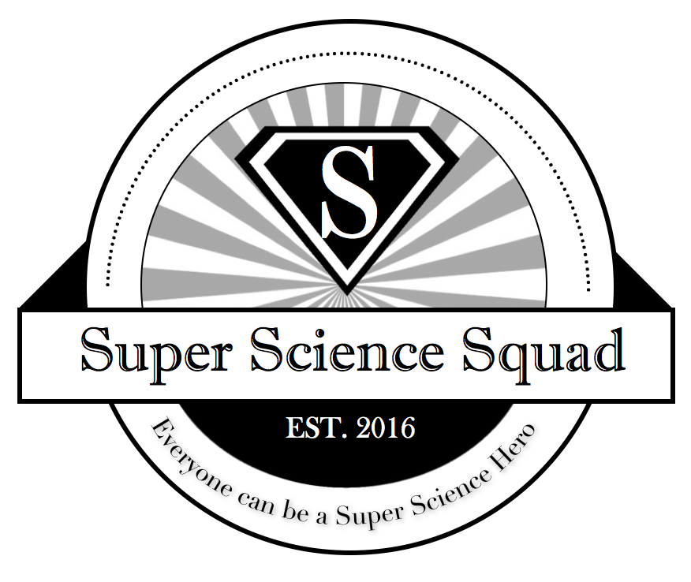

Visit us at SuperScienceSquad.com
Authors: David Liu, Algrae Gorospe, Alondra Villegas, Vanessa Comia, Sophia Nguyen, and Steven Vu
Last edited November 2017

Big Question: How do we engineer a design to improve our school ecosystem?

Overview: Students will describe a problem they see in their ecosystems video. Then students will propose a solution and use the engineering design process to prototype, test, and improve their design solutions.

IMPORTANT: It is important to note, that this curriculum builds from the Ecosystems lesson plans. In the previous curriculum, students created video documentaries of their school as an ecosystem.

Objectives:
-Students will be able to describe a problem in their school ecosystem
-Students will be able to create a prototype of their solution that addresses their problem
-Students will be able to test their prototype and make improvements

NGSS Standards Addressed:
3–5-ETS1-1. Define a simple design problem reflecting a need or a want that includes a specified criteria for success and constraints on materials, time, or cost.
3–5-ETS1-2. Generate and compare multiple possible solutions to a problem based on how well each is likely to meet the criteria and constraints of the problem.
3–5-ETS1-3. Plan and carry out fair tests in which variables are controlled and failure points are considered to identify aspects of a model or prototype that can be improved

Common Core Math Standards Addressed:
MP.2 Reason abstractly and quantitatively.
MP.4 Model with mathematics.
MP.5 Use appropriate tools strategically.
3-5.OA Operations and Algebraic Thinking

Common Core Literacy Standards Addressed:
W.5.7 Conduct short research projects that use several sources to build knowledge through investigation of different aspects of a topic.
W.5.8 Recall relevant information from experiences or gather relevant information from print and digital sources; summarize or paraphrase information in notes and finished work, and provide a list of sources.
W.5.9 Draw evidence from literary or informational texts to support analysis, reflection, and research.
RI.5.1 Quote accurately from a text when explaining what the text says explicitly and when drawing inferences from the text.
RI.5.1 Draw on information from multiple print or digital sources, demonstrating the ability to locate an answer to a question quickly or to solve a problem efficiently. RI.5.9 Integrate information from several texts on the same topic in order to write or speak about the subject knowledgeably.

Description of Lessons:
Lesson 1: Students will describe their school as an ecosystem by describing the living and nonliving things. They will use what they learned from the previous video project about their school as an ecosystem to identify the problems and possible solutions
Lesson 2: Students will describe their school as an ecosystem and describe problems in the ecosystem that prevents the living things from thriving. They will then create a timeline for their design solution, the steps necessary, and the materials needed.
Lesson 3: Students will create their solution with an initial prototype. Students will then test out their design and create changes.
Lesson 4: Students will evaluate their prototypes through testing out if the solution solves the problems. Students will then present their prototypes to important stakeholders such as teachers and administrators.

Engineering Design Cycle from NGSS
- Define an engineering problem
- Develop solutions to engineering problems
- Optimize the design solution [through iterations]

Our Model of Engineering Design that Expands on NGSS
- Ask what problems there are that can be solves with a solution
- Imagine what solutions are possible
- Research the feasibility, materials, and similar designs
- Create the initial porotype
- Test out the initial prototype
- Evaluate the solution and modify prototype
- Present solution to

Suggested Calendar
Monday | Tuesday | Wednesday | Thursday | Friday
Week 1  Lesson #1  Describe a problem in their school ecosystem. | Lesson #1  Brainstorm possible solutions | Lesson #2  Conduct research and find other solutions, budget etc. | Lesson #2  Continue researching | Lesson #3  Draft prototype proposal
Week 2  Lesson #3  Create prototype | Lesson #3  Create prototype and test | Lesson #3  Retest and modify | Lesson #3  Retest and modify | Lesson #3  Present to stakeholders

Lesson 1
Activity Name: Ask and Imagine
Overview: Students will describe their school as an ecosystem by describing the living and nonliving things. They will use what they learned from the previous video project about their school as an ecosystem to identify the problems and possible solutions

Goals: The goal of this lesson is for students to identify the problems within their school ecosystem. Students will begin to plan and design solutions to the problems they identify.

Materials:
- Printer Paper
- Colored pencils and markers

NGSS Standards:
3–5-ETS1-1. Define a simple design problem reflecting a need or a want that includes a specified criteria for success and constraints on materials, time, or cost.
3–5-ETS1-2. Generate and compare multiple possible solutions to a problem based on how well each is likely to meet the criteria and constraints of the problem.

NGSS Practices:
-Asking questions and defining problems in 3–5 builds on grades K–2 experiences and progresses to specifying qualitative relationships.
-Planning and carrying out investigations to answer questions or test solutions to problems in 3–5 builds on K–2 experiences and progresses to include investigations that control variables and provide evidence to support explanations or design solutions. (3-5-ETS1-3)
-A system can be described in terms of its components and their interactions. (5-LS2-1)

Procedure
- Class Discussion
  - Undergraduate teacher will discuss the videos that were presented in the previous class and explain that there are problems within each ecosystem.
    - What are some problems you (students) found in the community or in the classroom?
  - Students will discuss as a class some problems they saw within their community, Undergraduate teacher will write the problems on the board
  - Students will discuss possible solutions to the problems they have listed. Undergraduate teacher will write the problems on the board
    - Narrow down problems to 5 main problems, each Undergraduate teacher will be assigned a group.
- Brainstorm within Small Groups
  - Students will be split into 5 groups
    - Undergraduate teacher will ensure that students discuss problems within their assigned ecosystem and begin to plan/design a solution to the problem.
Lesson 2
Activity Name: Research
Overview: Students will describe their school as an ecosystem and describe problems in the ecosystem that prevents the living things from thriving. They will then create a timeline for their design solution, the steps necessary, and the materials needed.

Goals: The goal of this lesson is for students to create a feasible solution to their ecosystem problem.

Materials:
- Printer Paper
- Colored pencils and markers
- Papers of the problems chosen from each group

NGSS Standards:
3–5-ETS1-1. Define a simple design problem reflecting a need or a want that includes a specified criteria for success and constraints on materials, time, or cost.
3–5-ETS1-2. Generate and compare multiple possible solutions to a problem based on how well each is likely to meet the criteria and constraints of the problem.
3–5-ETS1-3. Plan and carry out fair tests in which variables are controlled and failure points are considered to identify aspects of a model or prototype that can be improved

NGSS Practices:
-Asking questions and defining problems in 3–5 builds on grades K–2 experiences and progresses to specifying qualitative relationships.
-Planning and carrying out investigations to answer questions or test solutions to problems in 3–5 builds on K–2 experiences and progresses to include investigations that control variables and provide evidence to support explanations or design solutions. (3-5-ETS1-3)
-A system can be described in terms of its components and their interactions. (5-LS2-1)

Procedure
- Class Discussion
  - Undergraduate teacher will discuss the problems within their community that the class had chosen in the previous week
  - Undergraduate teacher will model what the students will be doing by choosing a problem and creating a plan of action based off of one chosen solution
    - Undergraduate teacher will introduce the first step which will be to choose one solution to focus on
    - Undergraduate teacher will introduce the second step which will be to create a timeline of each step in their process
    - Undergraduate teacher will introduce the third step which will be to explain each step in their process and how they plan to implement each step
    - Undergraduate teacher will introduce the fourth step which will be to decide what materials will be necessary to implement their solution

- Brainstorm within Small Groups
  - Undergraduate teacher will be split into 5 groups
    - Undergraduate teacher will ensure that students are discussing each step of the process to plan/design/solve a solution to the problem.

Lesson 3
Activity Name: Create, Test, and Evaluate
Overview: Students will create their solution with an initial prototype. Students will then test out their design and create changes.

Goals: Students will finish planning and designing solutions to the problems they identified. Students will begin creating a prototype of their solution.

Materials:
- Printer Paper
- Colored pencils and markers
- Poster Paper
- Laptop or technology device to create a PowerPoint
- Papers of the problems chosen from each group

NGSS Standards:
3–5-ETS1-2. Generate and compare multiple possible solutions to a problem based on how well each is likely to meet the criteria and constraints of the problem.
3–5-ETS1-3. Plan and carry out fair tests in which variables are controlled and failure points are considered to identify aspects of a model or prototype that can be improved

NGSS Practices:
-Asking questions and defining problems in 3–5 builds on grades K–2 experiences and progresses to specifying qualitative relationships.
-Planning and carrying out investigations to answer questions or test solutions to problems in 3–5 builds on K–2 experiences and progresses to include investigations that control variables and provide evidence to support explanations or design solutions. (3-5-ETS1-3)
-A system can be described in terms of its components and their interactions. (5-LS2-1)

Procedure
- Class Discussion
  - Undergraduate teacher will give an overview of what was done in the previous lesson. Undergraduate teacher will discuss the expectations of this lesson:
    - Students will finish their plan of action: pros, cons, solution
    - Students will begin to create a prototype of their solution.
    - Next session presentations
  - Undergraduate teacher will model what the students will be doing by using a solution and beginning to create a prototype
    - Undergraduate teacher will introduce the solution [ex. Lunch Food, make more nutritious] through either a PowerPoint or a poster
      - What are the materials/skills needed to create the solution?
        - Contact information
        - Budget information
        - Research
        - Materials
b.) What model is being used to share the solution i.e. powerpoint, model of invention, etc. [ex. Powerpoint]
- Discussion with Small Groups
  - Students will be split into 5 groups from last week
    - Undergraduate teacher will ensure that students are discussing each step of the process to plan/design/solve a solution to the problem.

Lesson 4
Activity Name: Imagine, Research, Present
Overview: Students will evaluate their prototypes through testing out if the solution solves the problems. Students will then present their prototypes to important stakeholders such as teachers and administrators.
Goals: Students will present their designed solution as well as the process of designing their solution
NGSS Standards:
3–5-ETS1-2. Generate and compare multiple possible solutions to a problem based on how well each is likely to meet the criteria and constraints of the problem.
3–5-ETS1-3. Plan and carry out fair tests in which variables are controlled and failure points are considered to identify aspects of a model or prototype that can be improved

NGSS Practices:
-Asking questions and defining problems in 3–5 builds on grades K–2 experiences and progresses to specifying qualitative relationships.
-Planning and carrying out investigations to answer questions or test solutions to problems in 3–5 builds on K–2 experiences and progresses to include investigations that control variables and provide evidence to support explanations or design solutions. (3-5-ETS1-3)
-A system can be described in terms of its components and their interactions. (5-LS2-1)

Materials:
- ● Poster board
- ● Colored pencils and markers

Procedure
- Class Discussion (15 min)
- Undergraduate teachers will go over the main points that each group should include in their design and remind the students that they will be presenting today.
  - Problem
  - Research
  - Pros and Cons
  - Solution
- Undergraduate teachers will tell the class that they have 10 minutes to finalize their designs before they present
  - Each member of the group must speak during the presentation
- Presentations
  - Each group will present their designs to the class and the staff

