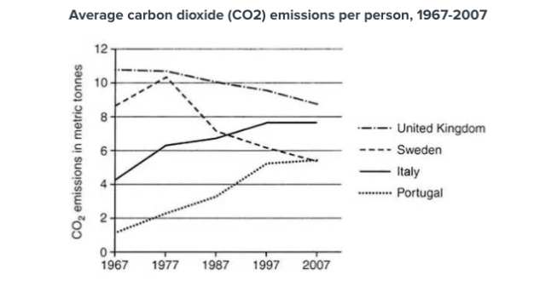
Hướng dẫn làm line graph: https://www.ieltstutor.me/blog/line-graph
Từ vựng dạng line graph (biểu đồ có thay đổi thời gian) https://www.ieltstutor.me/blog/cau-truc-diem-cao-writing-task-1-line-graph
Cách xác định chủ ngữ https://www.ieltstutor.me/blog/xac-dinh-subject-ielts-writing-task-1
The given line graph illustrates the number of carbon dioxide which was released by each individual in four countries from 1997 to 2007. Overall, there were upward trends in the number of CO2 emissions in Italy and Portugal, whereas the opposite patterns were true for other countries. In addition, while the highest quality of CO2 belongs to Sweden, Portugal was recorded for the lowest number.

Regarding Portugal and Italy, the number of Co2 for each person in Italy was greater, at 4 tonnes approximately, which was followed by Portugal, with 1 tonnes. In the next decade, while the figure for CO2 in Italy soared to 6 tonnes surdently, the number of CO2 fumes increased slightly to 2 tonnes in Portugal. From 1977 to 2007, both countries depicted a stable growth for the data of CO2, at roughly 8 tonnes in Italy and 5 tonnes in Portugal at the end of this period.

Concerning remaining countries, the number of CO2 emissions in the United Kingdom was the biggest, with 11 tonnes in 1967, while 8.5 tonnes of CO2 accounted for each Swede resident at the same time. After climbing considerably in 1977, the number of CO2 fumes in Sweden plummeted to 5 tonnes in 2007. In addition, there was a downward trend in the UK, and this figure dropped from 11 tonnes in 1967 to 9 tonnes in 2007.

229 words.

IELTS TUTOR lưu ý:
  - Overall:
    - The emissions of carbon dioxide in Italy and Portugal underwent a significant increase while those figures for the United Kingdom and Sweden plummeted swiftly over the period shown (IELTS TUTOR gợi ý cách diễn đạt khác: average CO2 emissions of individuals in the UK and Sweden generally dropped, whereas emissions per person in Italy and Portugal rose significantly) >> IELTS TUTOR hướng dẫn Cách dùng từ "average" tiếng anh
    - Despite the steady reduction, average emissions in the UK were the highest in the given period.
  - Body 1: Viết về số liệu tăng (Italy + Portugal)
    - Italy
      - Italy’s CO2 emissions nearly doubled, starting at just above 4 metric tonnes in 1967 and ending at almost 8 metric tonnes four decades later. >> IELTS TUTOR hướng dẫn Paraphrase"average"(Diễn đạt"trung bình, làng nhàng, bì...
    - Portugal
      - Portugal’s CO2 emissions, however, nearly quadrupled.
      - The per capita average in 1967 was just 1.5 metric tonnes, but in 2007, the emissions had reached 5.5 metric tonnes, matching Sweden's average.
  - Body 2: Viết về số liệu giảm (UK + Sweden)
    - UK
      - In 1967, the average emissions per person in the UK were nearly 11 metric tonnes, but by 2007, that had fallen to roughly 9 metric tonnes. (IELTS TUTOR gợi ý cách diễn đạt khác: In the first ten years, the amount of carbon dioxide emitted in the United Kingdom stabilised at nearly 11 metric tonnes) >> IELTS TUTOR hướng dẫn Paraphrase về "thu nhập"(income) & "chi tiêu"(expenditure ...
    - Sweden
      - The average CO2 emissions in Sweden were almost 9 metric tonnes per person in 1967. The emissions spiked, however, to nearly 11 metric tonnes in 1977 though from there, emissions continuously fell, dropping to just 5.5 metric tonnes in 2007. >> IELTS TUTOR hướng dẫn "Tất tần tật" về "SO SÁNH" IELTS Writing Task 1

